Postal address:
Christ the King Church
Trenchard Avenue
TS17 0EG
www.ctkthornaby.co.uk
St Patrick’s Church
Westbury Street
TS17 6NW
www.stpatrickschurch.co.uk
Christ the King House
Trenchard Avenue, Thornaby.
TS17 0EG
T: 01642 750467
Email: thornaby@rcdmidd.org.uk

32nd Sunday of Ordinary Time (A) November 12th, 2023
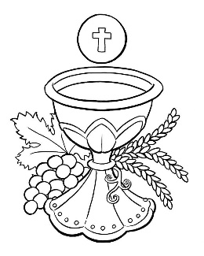
SUNDAY MASS TIMES

Saturday 6.00pm St. Patrick’s church
Sunday 9.30am Christ the King church
Sunday 11.00am St. Patrick’s church
WEEKDAY LITURGY TIMES
Tuesday 7.00pm Christ the King
Wednesday 10.00am St. Patrick’s
Thursday 10.00am Christ the King church
Friday 10.00am St. Patrick’s
MASS INTENTIONS RECEIVED: Special Intention, Betty McLaughlin, Henley Gillan R.I.P., Dennis George,
ANNIVERSARIES: November 12th – 18th:
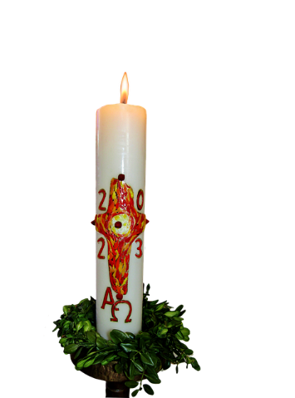
Simon Paterson, Albert Edward Stewart, Dennis Crossley, Kenny Heslop, Thomas Aquinas Taylor, Keith Lambert, Katherine Murphy, Teddy Martin, Ernest Macaulay, James Alexander Robson, Helen Frances May Mosley, Irene Guy, Anne Clement, Olga Gaynor, Norman Russell, Tony Caunce, Doreen Mary Wood, Tommy Wappett, David Thomas Brown, John Joseph Waters, Christopher Mulqueen, George William Nicholson, James Barnes, Frank Monaghan, Madeleine Dawkins, Christopher Thompson.
PLEASE REMEMBER in your prayers all our sick and housebound brothers and sisters.
The word this week
Wisdom 6:12–16 Rise before dawn and watch for wisdom’s appearance and you will not be
disappointed.
Psalm 62 ‘For you my soul is thirsting, O God, my God.’
1 Thessalonians 4:13–14 We do not mourn death as those who have no hope
Matthew 25:1–13 The wise bridesmaids were prepared for the coming of the bridegroom
O
ur first reading has some encouraging words, asserting that wisdom can be found by anyone who looks for it. Our second reading uses wisdom to console us, reasoning that if God raised Jesus from the dead, through him we will be brought home as well. The parable in the Gospel tells of the ten bridesmaids who waited for the bridegroom, though only five had the wisdom to bring oil for their lamps. May God’s word enlighten us as we too wait faithfully upon the Lord.
AT MASS TODAY WE PRAY Eucharistic Prayer 2 with Preface 1 for the Dead
We sing a song of joy in the house of the Lord. Our souls shall be satisfied by the rich banquet at this sacred table of the Eucharist.
RECENTLY DECEASED: Please remember in your prayers Betty McLaughlin, aged 96, who died recently. Her Funeral Mass will take place in Billingham. ALSO, Mr. Kevin Champley, aged 63, from Thornaby. His Funeral Service will take place at St. Patrick’s church on Tuesday, November 21st, at 12 midday. May they rest in peace.
NOVEMBER IS THE MONTH OF THE HOLY SOULS: Traditionally in the life of the Church the month of November is when we particularly pray for the Holy Souls in purgatory. All Masses celebrated in this month will be offered for the Holy Souls.
CHRIST THE KING CHRISTMAS PARTY on Thursday, November 30th, 7.00pm – 10.00pm in Parish Hall.
Buffet Supper and Dessert. Bring your own drinks. Entertainment by Darren G and others. Tickets £10.00
CHRIST THE KING ‘CHURCH CLEANING’ this Monday, November 13th, at 10.00am – 10.45am. All volunteers very welcome in order to make our Church really presentable for all attending the Mind Mass for Canon Dan Spaight the following evening on Tuesday, November 14th, at 7.00pm. Bishop Drainey will lead this celebration.
CHRISTMAS HAMPERS 2023: Its that time for sharing where your help is needed to support our local area. Over the years we drive a Christmas hamper and present event. We have raised £30k plus, provided in excess 2000 hampers and over 7k presents for nominated families. Again, we are working to see what can be done in 2023. This year it will take place on 11th December. How can you help us?
Monetary Donations to Christmas Hamper Fundraising, 20-82-18 Account 53294919
Add your name in the reference field or pass to Liz Maw, Mary Goodwin, Fr Pat
Christmas hampers – we need as much food as you can provide. Think of the nice things that you would like at Christmas, sweets, chocolate, crisps, Christmas puddings etc. At the back of Asda, they have a trolley for toys that they are collecting for us
Presents – Mams and dads gifts, children of any age group from baby up over. Please provide new gifts. There is no need to wrap as we have plenty of elves supporting on the day. All need to be in no later than 5th December so we can sort in readiness for the big day.

32nd Sunday of The Year (A)
November 12th, 2023

First reading Wisdom 6:12-16

Wisdom is bright, and does not grow dim.
By those who love her she is readily seen,
and found by those who look for her.
Quick to anticipate those who desire her, she makes herself known to them.
Watch for her early and you will have no trouble;
you will find her sitting at your gates.
Even to think about her is understanding fully grown;
be on the alert for her and anxiety will quickly leave you.
She herself walks about looking for those who are worthy of her
and graciously shows herself to them as they go,
in every thought of theirs coming to meet them.

Second reading 1 Thessalonians 4:13-14

We want you to be quite certain, brothers, about those who have died, to make sure that you do not grieve about them, like the other people who have no hope. We believe that Jesus died and rose again, and that it will be the same for those who have died in Jesus: God will bring them with him.

Gospel Acclamation

Alleluia, alleluia!
Stay awake and stand ready,
because you do not know the hour
when the Son of Man is coming.
Alleluia!

Gospel Reading Matthew 25:1-13

Jesus told this parable to his disciples: ‘The kingdom of heaven will be like this: Ten bridesmaids took their lamps and went to meet the bridegroom. Five of them were foolish and five were sensible: the foolish ones did take their lamps, but they brought no oil, whereas the sensible ones took flasks of oil as well as their lamps. The bridegroom was late, and they all grew drowsy and fell asleep. But at midnight there was a cry, “The bridegroom is here! Go out and meet him.” At this, all those bridesmaids woke up and trimmed their lamps, and the foolish ones said to the sensible ones, “Give us some of your oil: our lamps are going out.” But they replied, “There may not be enough for us and for you; you had better go to those who sell it and buy some for yourselves.” They had gone off to buy it when the bridegroom arrived. Those who were ready went in with him to the wedding hall and the door was closed. The other bridesmaids arrived later. “Lord, Lord,” they said “open the door for us.” But he replied, “I tell you solemnly, I do not know you.” So stay awake, because you do not know either the day or the hour.’

