Postal address:
Christ the King Church
Trenchard Avenue
TS17 0EG
www.ctkthornaby.co.uk
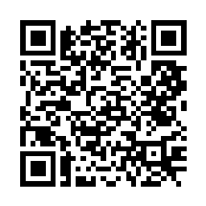
St Patrick’s Church
Westbury Street
TS17 6NW
www.stpatrickschurch.co.uk
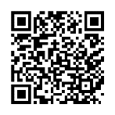
Christ the King House
Trenchard Avenue, Thornaby.
TS17 0EG
T: 01642 750467
Email: thornaby@rcdmidd.org.uk

2nd Sunday of Easter April 7th, 2024

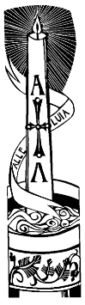
SUNDAY MASS TIMES
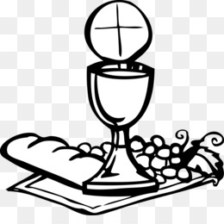
Saturday 6.00pm St. Patrick’s
Sunday 9.30am Christ the King church
Sunday 11.00am St. Patrick’s church

Weekday Mass Times
Tuesday 10.00am Christ the King
Wednesday 10.00am St. Patrick’s
Thursday 10.00am Christ the King
Friday 10.00am St. Patrick’s
Saturday 10.00am Christ the King (Pilgrims setting off to Medjugorje)
MASS INTENTIONS RECEIVED: Special Intention, William Pepper (Anni.), Dorothy Luck (Anni), John McBride (Anni.),
ANNIVERSARIES: April 7th – 13th:
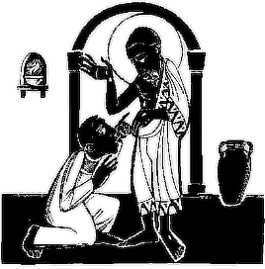
John Robert Ernest Ward, Leonard James Wright, Francis Andrew Seymour, Ernest Ward, John Mossop, Thomas Hopkins, David Crofton, Karen Latham, Nora Wallace, Reg Morgan, Michael Gott, Alfred Wherly, Jessie Barnes, Theresa Hall, Edward (Ted) Devlin, Irene Coughlan,

PLEASE REMEMBER in your prayers all our sick and housebound brothers and sisters
THE WORD THIS WEEK
Acts 4:32–35 The community was of one heart and mind.
Psalm 118 Give thanks to the Lord for he is good, for his love has no end.
1 John 5:1–6 All who believe that Jesus is the Christ are begotten by God.
John 20:19–31 Jesus came and stood in their midst.
O
ften people forget that Easter is not just a day, but a season – the longest in the Church’s year, in fact! We are given fifty glorious days of Spring and Summer to prolong our baptismal joy, fifty glorious days of basking in the light of the risen Saviour. On the Sundays we hear who Jesus is, and on weekdays hear about Baptism and the Eucharist. This “teaching through the Scripture Readings” is to help all of us deepen our life in the risen Lord Jesus. This Sunday we are with the disciples in the Upper Room, where eight days after the Resurrection Jesus comes among them – as he comes among us.
AT MASS TODAY WE PRAY Eucharistic Prayer 1 and Preface 1 for Easter
Blessed are those who have not seen and have believed. Our hearts brimming with belief, let us offer this prayer of praise and thanksgiving to God who raised Jesus from the dead.
RECENTLY DECEASED: Please remember in your prayers Miss Kelly Jane Jobson, aged 49, from Yarm (formerly Thornaby). Her Funeral Service will take place at St. Patrick’s Church this Wednesday, April 10th, at 1.00pm. May she rest in peace.
SATURDAY SOCIAL AT ST.PATRICK’S HALL: 12NOON – 2.00pm, on Saturday, 13th April. Bingo, raffle etc. Tickets £1 from Kath or Carol in Church Porch.
PILGIMAGE TO MEDJUGORJE starts on Saturday next, April 13th. About 30 Pilgrims in all are taking part with most going from our Parishes here in Thornaby. They begin with the Celebration of Mass on Saturday morning at 10.00am in Christ the King Church and anyone can attend. The Pilgrims will also receive “THE BLESSING OF PILGIMS” on their departure at the end of this Mass.
“The Blessing of Pilgrims”
All powerful God,
you always show mercy toward those who love you and you are never far away for those who seek you.
Remain with your servants on this holy pilgrimage and guide their way in accord with your will.
Shelter them with your protection by day, give them the light of your grace by night,
and, as their companion on the journey, bring them to their destination in safety.
We ask this through Christ our Lord.

ALLELUIA ALLELUIA ALLELUIA
2nd SUNDAY OF EASTER (B)
April 7th, 2024

First reading Acts 4:32-35

The whole group of believers was united, heart and soul; no one claimed for his own use anything that he had, as everything they owned was held in common.
The apostles continued to testify to the resurrection of the Lord Jesus with great power, and they were all given great respect.
None of their members was ever in want, as all those who owned land or houses would sell them, and bring the money from them, to present it to the apostles; it was then distributed to any members who might be in need.

Second reading 1 John 5:1-6

Whoever believes that Jesus is the Christ has been begotten by God;
and whoever loves the Father that begot him loves the child whom he begets.
We can be sure that we love God’s children
if we love God himself and do what he has commanded us;
this is what loving God is –
keeping his commandments;
and his commandments are not difficult,
because anyone who has been begotten by God has already overcome the world;
this is the victory over the world – our faith.
Who can overcome the world?
Only the man who believes that Jesus is the Son of God:
Jesus Christ who came by water and blood, not with water only, but with water and blood;
with the Spirit as another witness – since the Spirit is the truth.

Gospel Acclamation
Alleluia, alleluia!
Jesus said: ‘You believe because you can see me.
Happy are those who have not seen and yet believe.’
Alleluia!

Gospel Reading John 20:19-31

In the evening of that same day, the first day of the week, the doors were closed in the room where the disciples were, for fear of the Jews. Jesus came and stood among them. He said to them, ‘Peace be with you’, and showed them his hands and his side. The disciples were filled with joy when they saw the Lord, and he said to them again, ‘Peace be with you.
‘As the Father sent me,
so am I sending you.’
After saying this he breathed on them and said:
‘Receive the Holy Spirit.
For those whose sins you forgive,
they are forgiven;
for those whose sins you retain,
they are retained.’
Thomas, called the Twin, who was one of the Twelve, was not with them when Jesus came. When the disciples said, ‘We have seen the Lord’, he answered, ‘Unless I see the holes that the nails made in his hands and can put my finger into the holes they made, and unless I can put my hand into his side, I refuse to believe.’ Eight days later the disciples were in the house again and Thomas was with them. The doors were closed, but Jesus came in and stood among them. ‘Peace be with you’ he said. Then he spoke to Thomas, ‘Put your finger here; look, here are my hands. Give me your hand; put it into my side. Doubt no longer but believe.’ Thomas replied, ‘My Lord and my God!’ Jesus said to him:
‘You believe because you can see me.
Happy are those who have not seen and yet believe.’
There were many other signs that Jesus worked and the disciples saw, but they are not recorded in this book. These are recorded so that you may believe that Jesus is the Christ, the Son of God, and that believing this you may have life through his name.

