St. Patrick’s church, 39 Westbury St. TS17 6NW Christ the King church, Trenchard Ave. TS17 0EG
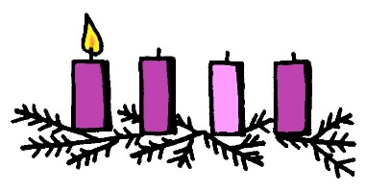
Postal address: Christ the King House, Trenchard Avenue, TS17 0EG
Telephone: 01642 750467
EMAIL: thornaby@rcdmidd.org.uk
Christ the King Website: www.ctkthornaby.co.uk St. Patrick’s Website: www.stpatrickschurch.co.uk 1st Sunday of Advent November 28th, 2021
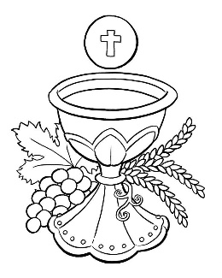
SUNDAY MASS TIMES
6.00pm {Saturday} St. Patrick’s church
9.30am Christ the King church
11.00am St. Patrick’s church
WEEKDAY MASSES
Tuesday: 10.00am Christ the King
Wednesday: 10.00am St Patrick’s
Thursday: 10.00am Christ the King {Funeral Mass}
Friday: 10.00am St. Patrick’s
SACRAMENT OF RECONCILIATION any time on request
MASS INTENTIONS RECEIVED: Special Intention,
ANNIVERSARIES November 28th – December 4th.
Thomas Devine, Charles Elliott, Thomas Hurley, Gladys Lenaghan, Ruth Crawford, Mary Russell, Stan Bradshaw,
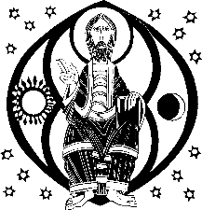
Lilly Howe, Desmond Vernon, Maria Jane Jones, Elizabeth Leyden, Maureen Hall, Ken Hall.
PLEASE REMEMBER in your prayers all our sick and housebound brothers and sisters.
The word this week
Jeremiah 33:14–16 I will make a virtuous branch grow for David.
Psalm 24/25 ‘To you, O Lord, I lift up my soul.’
1 Thessalonians 3:12 — 4:2 May the Lord make you abound in love.
Luke 21:25–28, 34–36 Stay awake, praying at all times.
As usual, the great Season of Advent begins, not by talking about Christmas, but about the Second Coming. We’ve had this theme already for the past two weeks, but there is a slight change of emphasis in the Scripture readings offered for this Sunday. Here the tone is positive. It is the “promise” of what is to come that we contemplate. Even in the Gospel, though it talks of the dreadful signs that mark the end times, we hear of a promise – “Liberation”. For this we should stand erect and hold our heads high. The central theme is that we welcome the coming of a person – Jesus Christ, the promised Messiah, and this is what links this Sunday to the coming feast of his birth. We are now preparing to celebrate how he once came. May these preparations also help us to prepare for him when he comes again.
AT MASS TODAY WE PRAY Eucharistic Prayer 2 and Preface 1 for Advent
Around this sacred altar we lift our hearts in a prayer of everlasting thanksgiving. As we pray, we humbly ask God to give us a foretaste of the heavenly banquet in the life to come.

RECENTLY DECEASED: Please remember in your prayers Sheila McReddie, age 83, from Thornaby. Her Funeral Mass will take place at Christ the King church on Thursday, December 2nd, at 10.00am. ALSO, Mr. Frank Hudson, aged 88, from Thornaby, who died on Thursday. No Funeral arrangement just yet. May they rest in peace.
SOCIAL NIGHT – Saturday 27th November in St Patrick’s parish hall, with live music from Eagle Ukes. Tickets £3 available from Carol or Dan Woodgate. Doors open 7pm, feel free to bring your own food & drink.
TEA/COFFEE ETC after Sunday morning Masses at both Christ the King and St. Patrick’s in Parish Hall.

PARISH SACRAMENT OF RECONCILIATION FOR ADVENT:
At Christ the King church at 6.30pm on Tuesday, December 14th.
At. St. Patrick’s church after 10.00am Mass on Wednesday, December 15th.
“CHRISTMAS HAMPERS”: Please see ‘Yellow Page’ for information from Liz Maw about how to help with the contribution to the Christmas Hampers this year.

"ST PATRICK'S CATHOLIC COLLEGE look forward to welcoming the parish community back into school to celebrate an Advent Liturgy & Carol Service. The event will take place in the school hall on Tuesday, 7th December, at 6.00pm. The evening will be filled with reflection, prayer and of course, singing! All washed down with a glass of mulled wine and a mince pie. Please come along if you are free."
ST. PATRICK'S PRIMARY SCHOOL ADVENT RETREAT
All parishioners are invited each day to join classes in St Patrick’s church for Advent prayer and song. Each service will begin at 2.00pm and finish at 2.45pm each day. All are welcome!
Monday 6th December – Hope; Tuesday 7th December – Peace; Wednesday 8th December – Joy;
Thursday 9th December – Love; Friday 10th December – Justice

READINGS for November 28th.
First Sunday of Advent (C)

First reading Jeremiah 33:14-16 See, the days are coming – it is the Lord who speaks – when I am going to fulfil the promise I made to the House of Israel and the House of Judah:
‘In those days and at that time,
I will make a virtuous Branch grow for David,
who shall practise honesty and integrity in the land.
In those days Judah shall be saved
and Israel shall dwell in confidence.
And this is the name the city will be called:
The-Lord-our-integrity.

Second reading 1 Thessalonians 3:12-4:2

May the Lord be generous in increasing your love and make you love one another and the whole human race as much as we love you. And may he so confirm your hearts in holiness that you may be blameless in the sight of our God and Father when our Lord Jesus Christ comes with all his saints.
Finally, we urge you and appeal to you in the Lord Jesus to make more and more progress in the kind of life that you are meant to live: the life that God wants, as you learnt from us, and as you are already living it. You have not forgotten the instructions we gave you on the authority of the Lord Jesus.

Gospel Acclamation

Alleluia, alleluia!
Let us see, O Lord, your mercy
and give us your saving help.
Alleluia!

Gospel Luke 21:25-28,34-36

Jesus said to his disciples: ‘There will be signs in the sun and moon and stars; on earth nations in agony, bewildered by the clamour of the ocean and its waves; men dying of fear as they await what menaces the world, for the powers of heaven will be shaken. And then they will see the Son of Man coming in a cloud with power and great glory. When these things begin to take place, stand erect, hold your heads high, because your liberation is near at hand.
‘Watch yourselves, or your hearts will be coarsened with debauchery and drunkenness and the cares of life, and that day will be sprung on you suddenly, like a trap. For it will come down on every living man on the face of the earth. Stay awake, praying at all times for the strength to survive all that is going to happen, and to stand with confidence before the Son of Man.’

