Postal address:
Christ the King Church
Trenchard Avenue
TS17 0EG
www.ctkthornaby.co.uk
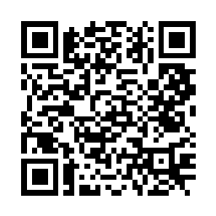
St Patrick’s Church
Westbury Street
TS17 6NW
www.stpatrickschurch.co.uk
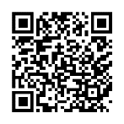
Christ the King House
Trenchard Avenue, Thornaby.
TS17 0EG
T: 01642 750467
Email: thornaby@rcdmidd.org.uk

2nd Sunday of Easter April 16th, 2023
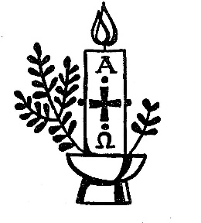
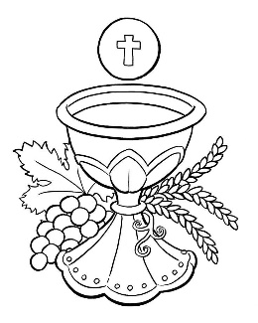
SUNDAY MASS TIMES
Saturday 6.00pm St. Patrick’s church
Sunday 9.30am Christ the King church
Sunday 11.00am St. Patrick’s church WEEKDAY LITURGY TIMES
Tuesday No liturgy
Wednesday No liturgy
Thursday: No liturgy
Friday: 10.00am St. Patrick’s
MASS INTENTIONS RECEIVED: Special Intention, In Thanksgiving for joyful outcome, Ann Nolan, Jimmy Reilly R.I.P. (Co Longford), William and Alice Pepper (Anni.), Margery Devlin (Anni.),
ANNIVERSARIES: April 16th 22nd:
John McBride, David Morgan, Ann Nolan, Betty Oates, Alice T. Ruddy, Michael Mulqueen, Margery Devlin, Ellen Curtis, Monsignor Thomas Breen, Henry Crossley, Malcolm Forgan, Francis Saunders, Patricia Anne Crossen, Pat Swalwell, Marie Farrer, Walter Fleming, Alan Ling, William Cross, Tom Haycock, Margaret O'Boyle, Bill Crossley, David Carter, Rita Baker, Irene Cumiskey.
PLEASE REMEMBER in your prayers all our sick and housebound brothers and sisters.
The word this week
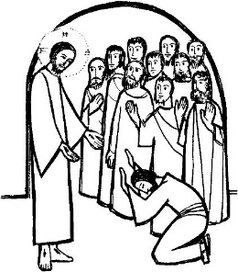
Acts 2:42–47 Those who believed shared all things in common.
Psalm 118 ‘Give thanks to the Lord for he is good, for his love has no end.’
1 Peter 1:3–9 God has given us new birth.
John 20:19–31 How blessed are those who have not seen but have believed
Today we hear the familiar story of doubting Thomas, who refused to believe until he saw the risen Lord with his own eyes and touched his wounds with his own hands. However, as soon as he did see Jesus and hear his voice, he immediately realized that his friends’ incredible testimony was true. May Jesus’ words to Thomas, “Blessed are those who have not seen and have believed,” touch us as we struggle with doubt and uncertainty ourselves.

AT MASS TODAY WE PRAY Eucharistic Prayer 2 and Preface 1 for Easter.
Jesus Christ is soon to be made known to us in the breaking of the bread. With hearts full of Easter joy, we offer this prayer of praise and thanksgiving.
THORNABY FOODBANK COLLECTION THIS WEEKEND: items can be left in the church porch
SACRAMENT OF CONFIRMATION will be celebrated on Thursday, May 11th, at 7.00pm at St. Therese church, Ingleby Barwick. Any candidates, from Thornaby, choosing to be Confirmed in the Faith of the Church please give me your names.
Candidates must be 14 years or older.
PLEASE REMEMBER IN YOUR PRAYERS Mrs. Joyce Mary Lyth, aged 82, from Thornaby, who died recently. Her Funeral Service will take place at Christ the King church on Tuesday, April 25th, at 11.00am. May she rest in peace.
ST. VINCENT de PAUL SOCIETY: We warmly welcome Sharon Pemberton, from St. Bernadette’s Parish, who will speak at Masses this weekend about the work of the St. Vincent de Paul Society.
CELEBRATING CORONATION OF KING CHARLES on Monday, May 8th, in Christ the King parish hall 1.00pm – 4.00pm. Bring your own drinks. Tea, Coffee, Cakes, Scones, Strawberries and cream all provided. Raffle and Bingo as well. Surprise entertainment !!. Tickets available £6.00. Proceeds to Thornaby Food Bank.
“EASTER”
“This is the Feast of the year for which we long, the beginnings of life-giving realities. Here is given us the grace of the heavenly mysteries, the gift of our Redemption. Here the Church, gathered in unity, is nourished. Adoring the substance of the one God and the powerful name of the Three Persons, they join with the prophet in singing the psalm of the annual feast: ‘This is the day that the Lord has made. Let us be glad and rejoice in it.’ What is this day? It is he who is the source of life, the beginning of brightness, the author of life – our Lord Jesus Christ, who said of himself: ‘I am the day: he who walks by daylight does not stumble.’ That is to say, if a person follows Christ in all things, he will cross over in Christ’s steps to the very throne of eternal light. While Christ was still in this bodily life, he prayed to the Father for us in these words: ‘Father, I desire that those who have believed in me may be with me where I am, that even as you are in me, and I in you, so they too may remain in us.’”

2nd SUNDAY OF EASTER(A)
April 16th, 2023

First reading Acts 2:42-47

The whole community remained faithful to the teaching of the apostles, to the brotherhood, to the breaking of bread and to the prayers.
The many miracles and signs worked through the apostles made a deep impression on everyone.
The faithful all lived together and owned everything in common; they sold their goods and possessions and shared out the proceeds among themselves according to what each one needed.
They went as a body to the Temple every day but met in their houses for the breaking of bread; they shared their food gladly and generously; they praised God and were looked up to by everyone. Day by day the Lord added to their community those destined to be saved.

Second reading 1 Peter 1:3-9

Blessed be God the Father of our Lord Jesus Christ, who in his great mercy has given us a new birth as his sons, by raising Jesus Christ from the dead, so that we have a sure hope and the promise of an inheritance that can never be spoilt or soiled and never fade away, because it is being kept for you in the heavens. Through your faith, God’s power will guard you until the salvation which has been prepared is revealed at the end of time. This is a cause of great joy for you, even though you may for a short time have to bear being plagued by all sorts of trials; so that, when Jesus Christ is revealed, your faith will have been tested and proved like gold – only it is more precious than gold, which is corruptible even though it bears testing by fire – and then you will have praise and glory and honour. You did not see him, yet you love him; and still without seeing him, you are already filled with a joy so glorious that it cannot be described, because you believe; and you are sure of the end to which your faith looks forward, that is, the salvation of your souls.

Gospel Acclamation
Alleluia, alleluia!
Jesus said: ‘You believe because you can see me.
Happy are those who have not seen and yet believe.’
Alleluia!

Gospel Reading John 20:19-31

In the evening of that same day, the first day of the week, the doors were closed in the room where the disciples were, for fear of the Jews. Jesus came and stood among them. He said to them, ‘Peace be with you’, and showed them his hands and his side. The disciples were filled with joy when they saw the Lord, and he said to them again, ‘Peace be with you.
‘As the Father sent me,
so am I sending you.’
After saying this he breathed on them and said:
‘Receive the Holy Spirit.
For those whose sins you forgive,
they are forgiven;
for those whose sins you retain,
they are retained.’
Thomas, called the Twin, who was one of the Twelve, was not with them when Jesus came. When the disciples said, ‘We have seen the Lord’, he answered, ‘Unless I see the holes that the nails made in his hands and can put my finger into the holes they made, and unless I can put my hand into his side, I refuse to believe.’ Eight days later the disciples were in the house again and Thomas was with them. The doors were closed, but Jesus came in and stood among them. ‘Peace be with you’ he said. Then he spoke to Thomas, ‘Put your finger here; look, here are my hands. Give me your hand; put it into my side. Doubt no longer but believe.’ Thomas replied, ‘My Lord and my God!’ Jesus said to him:
‘You believe because you can see me.
Happy are those who have not seen and yet believe.’
There were many other signs that Jesus worked and the disciples saw, but they are not recorded in this book. These are recorded so that you may believe that Jesus is the Christ, the Son of God, and that believing this you may have life through his name.

