Postal address:
Christ the King Church
Trenchard Avenue
TS17 0EG
www.ctkthornaby.co.uk
St Patrick’s Church
Westbury Street
TS17 6NW
www.stpatrickschurch.co.uk
Christ the King House
Trenchard Avenue, Thornaby.
TS17 0EG
T: 01642 750467
Email: thornaby@rcdmidd.org.uk

4th Sunday of Easter April 30th, 2023
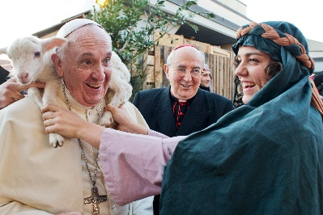
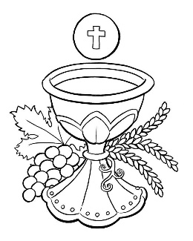
SUNDAY MASS TIMES
Saturday 6.00pm St. Patrick’s church
Sunday 9.30am Christ the King church
Sunday 11.00am St. Patrick’s church WEEKDAY LITURGY TIMES
Tuesday 10.00am Christ the King
Wednesday 10.00am St. Patrick’s
Thursday: 10.00am Christ the King
Friday: 10.00am St. Patrick’s
MASS INTENTIONS RECEIVED: Special Intention, Julia Gallagher R.I.P., Michael Hobson (Annni.), Special Intention
ANNIVERSARIES: April 30th – May 6th:
Eileen Jackson, Michael Hobson, Susan Marie O'Brien, Winifred Padley, James Donegan, James Gallagher, Michael Dick, Ronald Harbottle, Sean Michael Lynch, Margaret Fleming, Mary Ann Frew, Laura Eddy, Stella Mary Hartley, Anthony Porch, Laurence Wherly.

PLEASE REMEMBER in your prayers all our sick and housebound brothers and sisters.
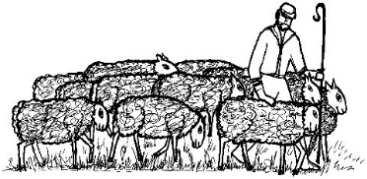
The word this week
Acts 2:14a, 36–41 The promise is made to all.
Psalm 23 ‘The Lord is my shepherd; there is nothing I shall want.’
1 Peter 2:20b–25 Jesus bore our sins upon the cross.
John 10:1–10 Jesus is the gate for the sheep.
This Sunday is traditionally called “Good Shepherd Sunday”, because of the Gospel references to Jesus as the Good Shepherd. On this Sunday we hear one of the great “I am” statements of Jesus from Saint John’s Gospel today “I am the gate of the sheepfold”.
Through Jesus we enter into life and safety, and we “go through Jesus, the gate” by baptism. This image is implied in all today’s readings. The people listening to Peter find this gateway and enter through it. Peter writes to remind us that we have come back to the Good Shepherd, who heals us by his wounds.
AT MASS TODAY WE PRAY Eucharistic Prayer 3 and Preface 3 for Easter.
Brothers and Sisters, in holy remembrance, we now pray in thanksgiving for the wonders of salvation.
SACRAMENT OF CONFIRMATION will be celebrated on Thursday, May 11th, at 7.00pm at St. Therese church, Ingleby Barwick.
PASTORAL LETTER TODAY: Our Bishop – Bishop Drainey – has given us a Pastoral Letter to read out at all Masses on this Good Shepherd Sunday.
SVP MEETING at Christ the King Hall on Tuesday, May 9th, at 6.30pm. All welcome.
BEREAVEMENT GROUP meeting in Christ the King hall on Wednesday, May 3rd, at 7pm. All welcome.
CELEBRATING CORONATION OF KING CHARLES on Monday, May 8th, in Christ the King parish hall 1.00pm – 4.00pm. Bring your own drinks. Tea, Coffee, Cakes, Scones, Strawberries and cream all provided. Raffle and Bingo as well. Surprise entertainment !!. Tickets available £6.00. Proceeds to Thornaby Food Bank.
WATCH AND CELEBRATE THE KING’S CORONATION IN ST PATRICK’S HALL from 10:30am on Saturday, 6th May. Tickets £1, including refreshments, available from Kath Hall or Carol Woodgate. Anyone wishing to be involved, please meet in the hall after Mass on Sunday
A TOTAL OF £537.45 has been raised this year from Sunday morning teas at St. Patrick’s and has been donated to the restoration fund.
Thank you very much to all that pop in the hall on Sundays for a cuppa and natter.
CHURCH CLEANING THIS FRIDAY, MAY 5th, at St. Patrick’s church after 10am Mass. If you would like to help just turn up on the morning please.
ST. PATRICK’S PRIMARY SCHOOL got “OUTSTANDING IN ALL AREAS” in the OFSTED inspection held recently in the school. Congratulations and well done to all involved in the School. Governors, Teachers, Pupils and families.
‘THE CALL’
Come, my Way, my Truth, my Life; Such a Way, as gives us breath: Such a Truth, as ends all strife: Such a Life, as killeth death.
Come, my Light, my Feast, my Strength:
Such a Light, as shows a feast: Such a Feast, as mends in length: Such a strength, as makes his guest.
Come, my Joy, my Love, my Heart:
Such a Joy, as none can move: Such a love, as none can part, Such a Heart, as joys in Love. {George Herbert}

4th SUNDAY OF EASTER(A)
April 30th, 2023

First reading Acts 2:14,36-41

On the day of Pentecost Peter stood up with the Eleven and addressed the crowd in a loud voice: ‘The whole House of Israel can be certain that God has made this Jesus whom you crucified both Lord and Christ.’
Hearing this, they were cut to the heart and said to Peter and the apostles, ‘What must we do, brothers?’ ‘You must repent,’ Peter answered ‘and every one of you must be baptised in the name of Jesus Christ for the forgiveness of your sins, and you will receive the gift of the Holy Spirit. The promise that was made is for you and your children, and for all those who are far away, for all those whom the Lord our God will call to himself.’ He spoke to them for a long time using many arguments, and he urged them, ‘Save yourselves from this perverse generation.’ They were convinced by his arguments, and they accepted what he said and were baptised. That very day about three thousand were added to their number.

Second reading 1 Peter 2:20-25

The merit, in the sight of God, is in bearing punishment patiently when you are punished after doing your duty.
This, in fact, is what you were called to do, because Christ suffered for you and left an example for you to follow the way he took. He had not done anything wrong, and there had been no perjury in his mouth. He was insulted and did not retaliate with insults; when he was tortured he made no threats but he put his trust in the righteous judge. He was bearing our faults in his own body on the cross, so that we might die to our faults and live for holiness; through his wounds you have been healed. You had gone astray like sheep but now you have come back to the shepherd and guardian of your souls.

Gospel Acclamation
Alleluia, alleluia!
I am the good shepherd, says the Lord;
I know my own sheep and my own know me.
Alleluia!

Gospel Reading John 10:1-10

Jesus said:
‘I tell you most solemnly, anyone who does not enter the sheepfold through the gate, but gets in some other way is a thief and a brigand. The one who enters through the gate is the shepherd of the flock; the gatekeeper lets him in, the sheep hear his voice, one by one he calls his own sheep and leads them out. When he has brought out his flock, he goes ahead of them, and the sheep follow because they know his voice. They never follow a stranger but run away from him: they do not recognise the voice of strangers.’
Jesus told them this parable but they failed to understand what he meant by telling it to them.
So Jesus spoke to them again:
‘I tell you most solemnly,
I am the gate of the sheepfold.
All others who have come
are thieves and brigands;
but the sheep took no notice of them.
I am the gate.
Anyone who enters through me will be safe:
he will go freely in and out
and be sure of finding pasture.
The thief comes
only to steal and kill and destroy.
I have come
so that they may have life and have it to the full.’

