Postal address:
Christ the King Church
Trenchard Avenue
TS17 0EG
www.ctkthornaby.co.uk
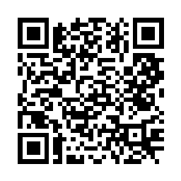
St Patrick’s Church
Westbury Street
TS17 6NW
www.stpatrickschurch.co.uk
Christ the King House
Trenchard Avenue
TS17 0EG
T: 01642 750467
Email: thornaby@rcdmidd.org.uk

4th SUNDAY OF THE YEAR (A) January 29th, 2023
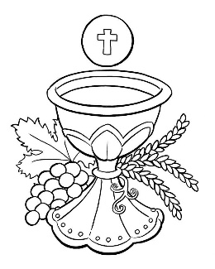
SUNDAY MASS TIMES
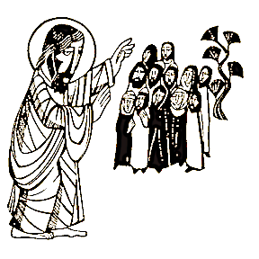
Saturday 6.00pm St. Patrick’s church
Sunday 9.30am Christ the King church
Sunday 11.00am St. Patrick’s church
WEEKDAY LITURGY TIMES
Tuesday 10.30am St. Patrick’s (Funeral Service)
Wednesday 10.00am St. Patrick’s
Thursday: 1.00pm Christ the King (Funeral Mass)
Friday: 10.00am St. Patrick’s
SACRAMENT OF RECONCILIATION any time on request
MASS INTENTIONS RECEIVED: Special Intention, Jim Goodwin, In Thanksgiving,
ANNIVERSARIES: January 29th – February 4th:
Heather Pybus, Daniel McCann (aged 5), Louis James Simpson, Carol Wilkinson, Michael Dixon, Dennis Devine,
Norman Chesser, William Purvis, Florence Speight, Michael Joseph Cavanagh, Mary Hudson, Eileen O'Neill,
Mary Battison, Nancy McGill, James Crossen, Patrick O'Leary, Monsignor Liam Carson, Joseph Brian Vernon,
Eileen Henderson, Michael Coughlan, Patrick Rafferty, Kevin Dea, Mary Hopkins (nee Kelly), Robert Notman.
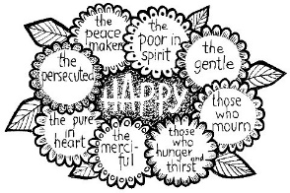
PLEASE REMEMBER in your prayers all our sick and housebound brothers and sisters.
The word this week
Zephaniah 2:3; 3:12–13 Seek the Lord, all you humble of the earth.
Psalm 146 How happy are the poor in spirit; theirs is the kingdom of heaven.
1 Corinthians 1:26–31 God chose the foolish of the world to shame the wise.
Matthew 5:1–12 Blessed are the lowly, the sorrowing, the poor in spirit.
Ordinary Time gives us the opportunity to focus on the ordinary aspects of our faith and realize their continuity through history. Take the value of humility. Centuries before Jesus, Zephaniah told the people of Judah to seek humility. In the early years of Christianity, Paul explained that God chose the lowly to show that the arrogant are nothing before God. It is essential to understand the Beatitudes in today’s Gospel if we are to understand what we will read in Saint Matthew during the rest of this year. The key, as underlined by the First Reading, is that the values of this world are not the values of the Kingdom of God – the Kingdom will see things turned upside down. Happiness and blessing belong to those whom this world would ignore or mistreat.
AT MASS TODAY WE PRAY Eucharistic Prayer 1for Reconciliation and Preface 8 for Sundays in Ordinary Time
The Beatitudes describe those who will gather around the table of the heavenly banquet. There, the poor in spirit, those who mourn, the merciful, and peacemakers will eat and be satisfied. At this table, we are given a glimpse of that heavenly banquet. With hearts filled with thanksgiving, we echo the prayer offered by the angels and saints.
RECENTLY DECEASED: Please remember in your prayers Mrs Laura Dunn, aged 93, from Thornaby, who died recently. Her Funeral Service will take place at St. Patrick’s church this Tuesday, January 31st, at 10.30am ALSO, Mr. Jim Goodwin, aged 82, from Thornaby, who died recently. His Funeral Mass will take place at Christ the King church this Thursday, February 2nd, at 1.00pm.
ALSO, Mrs. Eileen Wolleter, aged 80, from Thornaby, who died recently. Her Funeral Mass will take place at St. Patrick’s church on Thursday, February 16th, at 10.00am. May they rest in peace.
BEREAVEMENT GROUP will meet this Wednesday in Christ the King Parish hall at 7.00pm. All Welcome.
THORNABY FOODBANK COLLECTION WEEKEND: Items can be left in church porch and they will be delivered to the Foodbank.
RACE-DAY AFTERNOON AT CHRIST THE KING PARISH HALL on Saturday, February 11th, starting at 1.00pm and finishing at 4.00pm. Teas, Coffees and Biscuits. Tickets £4.00 each are now available. All proceeds go to charity.
FEAST OF ST. BLAISE ON FRIDAY: “Through the intercession of St. Blaise may the Lord free you from all ailments of the throat and from every other evil in the name of The Father, Son and Holy Spirit.”

“Father of all
Teach me to feel another’s woe,
To hide the fault I see;
That mercy I to others show,
That mercy show to me.”
Alexander Pope (English Poet)
Fourth Sunday of the Year (A)
January 29th, 2023

First reading Zephaniah 2:3,3:12-13

Seek the Lord,
all you, the humble of the earth,
who obey his commands.
Seek integrity,
seek humility:
you may perhaps find shelter
on the day of the anger of the Lord.
In your midst I will leave
a humble and lowly people,
and those who are left in Israel will seek refuge in the name of the Lord.
They will do no wrong,
will tell no lies;
and the perjured tongue will no longer
be found in their mouths.
But they will be able to graze and rest
with no one to disturb them.

Second reading 1 Corinthians 1:26-31

Take yourselves for instance, brothers, at the time when you were called: how many of you were wise in the ordinary sense of the word, how many were influential people, or came from noble families? No, it was to shame the wise that God chose what is foolish by human reckoning, and to shame what is strong that he chose what is weak by human reckoning; those whom the world thinks common and contemptible are the ones that God has chosen – those who are nothing at all to show up those who are everything. The human race has nothing to boast about to God, but you, God has made members of Christ Jesus and by God’s doing he has become our wisdom, and our virtue, and our holiness, and our freedom. As scripture says: if anyone wants to boast, let him boast about the Lord.

Gospel Acclamation
Alleluia, alleluia!
Blessed are you, Father,
Lord of heaven and earth,
for revealing the mysteries of the kingdom
to mere children.
Alleluia!

Gospel Reading Matthew 5:1-12

Seeing the crowds, Jesus went up the hill. There he sat down and was joined by his disciples. Then he began to speak. This is what he taught them: ‘How happy are the poor in spirit; theirs is the kingdom of heaven.
Happy the gentle: they shall have the earth for their heritage.
Happy those who mourn: they shall be comforted.
Happy those who hunger and thirst for what is right: they shall be satisfied.
Happy the merciful: they shall have mercy shown them.
Happy the pure in heart: they shall see God.
Happy the peacemakers: they shall be called sons of God.
Happy those who are persecuted in the cause of right: theirs is the kingdom of heaven.
‘Happy are you when people abuse you and persecute you and speak all kinds of calumny against you on my account. Rejoice and be glad, for your reward will be great in heaven.’

