Postal address:
Christ the King Church
Trenchard Avenue
TS17 0EG
www.ctkthornaby.co.uk
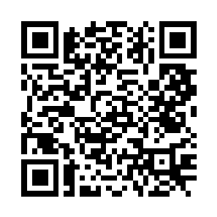
St Patrick’s Church
Westbury Street
TS17 6NW
www.stpatrickschurch.co.uk
Christ the King House
Trenchard Avenue, Thornaby.
TS17 0EG
T: 01642 750467
Email: thornaby@rcdmidd.org.uk

4th Sunday of Lent (A) March 19th, 2023
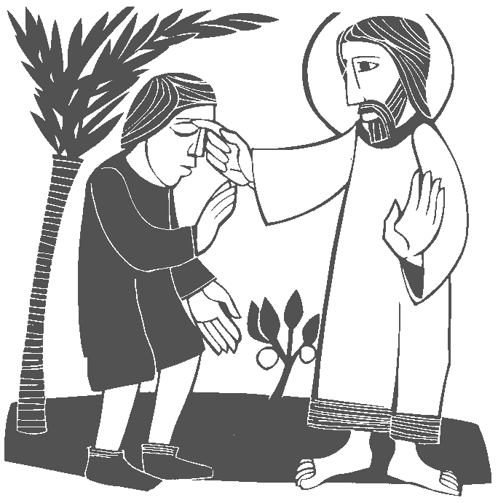
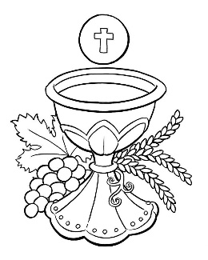
SUNDAY MASS TIMES
Saturday 6.00pm St. Patrick’s church
Sunday 9.30am Christ the King church
Sunday 11.00am St. Patrick’s church
WEEKDAY LITURGY TIMES
Tuesday 10.00am Christ the King
Wednesday 10.30am Christ the King {Funeral Service}
Thursday: 10.00am Christ the King
Friday: 10.00am St. Patrick’s
SACRAMENT OF RECONCILIATION any time on request
MASS INTENTIONS RECEIVED: Special Intention, Mrs. Kathleen Key (2nd Anni.), Ernie Roberts (Anni.),
ANNIVERSARIES: March 19th – 25th:
James McBride, Jim Smith, Baby Maureen Hackett, George Peacock, Norma Reyes, John Allison, Eddie Walsh,
Francis Leo Donoghue, Margaret Killeen, John Eddy, Elizabeth Nicholas, Robert Bryan, Mary Hobson, John Riordan,
Malcolm Eddy, Thomas Buckle, Mary Heatley, Anne McCrea, Michael Jones, Ernie Roberts
PLEASE REMEMBER in your prayers all our sick and housebound brothers and sisters.
The word this week
1 Samuel 16:6–7,10–13 Samuel anointed David to be king of Israel.
Psalm 23 ‘The Lord is my shepherd; there is nothing I shall want.’
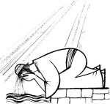
Ephesians 5:8–14 Rise from the dead, children of light.
John 9:1, 6–9, 13–17, 34–38) I know this much: I was blind, but now I see.
Today’s readings explore the theme of blindness, both literal and metaphorical. The man born literally blind receives his eyesight by Jesus’ action in the Gospel, but we also witness Samuel’s metaphorical blindness to David’s fitness for kingship, the Pharisees’ blindness to Jesus’ holiness. May God’s word help us examine our own blindnesses as we welcome the light of Christ.

AT MASS TODAY WE PRAY Eucharistic Prayer 2 and Preface for 4th Sunday of Lent
Grateful for the gift of light entrusted to us at baptism, we offer our great prayer of thanksgiving.

PARISH RECONCILIATION SERVICE FOR LENT at Christ the King church on Monday, March 27th, at 6.30pm
At St. Patrick’s church on Wednesday, March 29th, after 10.00am Mass
PLEASE REMEMBER IN YOUR PRAYERS Mrs Catherine Mary McKay, aged 91, from Thornaby, who died recently. Her Funeral Service will take place at Christ the King church on Wednesday, March 22nd, at 10.30am. May she rest in peace.
WORLD DOWN SYNDROME DAY is this Tuesday, 21st March. To raise awareness and support people with Down Syndrome and other learning difficulties, it would be great if you could wear your “ODD SOCKS” on this day.
STATIONS OF THE CROSS 20 minutes before Mass on Wednesdays and Thursdays (small chapel) during Lent
LENTEN HUNGER LUNCHES (SOUP AND BREAD): On Fridays at Christ the King Parish Hall from 12.00 noon to 1.30pm.
Full list of ‘Soup Makers’ on notice board in Parish Hall. Extra volunteers very welcome. All Donations to CAFOD.
THANK YOU FROM BARBARA AND JULIE: “Thank you to all Parishioners for making Julie’s birthday so very special recently. Also, the Sewing Group ladies for the big party, friends who took Julie out for meals, the cards and gifts.
God Bless you all.”
EASTER EGG TOMBOLA AT ST. PATRICK’S:
Would be very grateful for any donations for the Easter Egg tombola to be held on Palm Sunday, April 2nd.
i.e. Easter eggs, chocs, Easter gifts, etc. etc. These can be handed in at the back of church.
ST. PATRICK’S OFFERTORY GIVING – Thanks to all parishioners who have set up standing orders and are now using the card reader, this is the most efficient way of giving your offering to the parish. For those who wish to continue using envelopes, they will be available over the coming weeks. If you are new to the parish and want to give regularly, you can speak to Dan Woodgate after Mass or contact him on 07843237070 for more information. Thank you for your ongoing generosity.
HAPPY MOTHER’S DAY TO ALL MOTHERS
4th Sunday of Lent (A)
March 19th, 2023

First reading 1 Samuel 16:1,6-7,10-13

The Lord said to Samuel, ‘Fill your horn with oil and go. I am sending you to Jesse of Bethlehem, for I have chosen myself a king among his sons.’ When Samuel arrived, he caught sight of Eliab and thought, ‘Surely the Lord’s anointed stands there before him,’ but the Lord said to Samuel, ‘Take no notice of his appearance or his height, for I have rejected him: God does not see as man sees: man looks at appearances but the Lord looks at the heart.’ Jesse presented his seven sons to Samuel, but Samuel said to Jesse, ‘The Lord has not chosen these.’ He then asked Jesse, ‘Are these all the sons you have?’ He answered, ‘There is still one left, the youngest; he is out looking after the sheep.’ Then Samuel said to Jesse, ‘Send for him; we will not sit down to eat until he comes.’ Jesse had him sent for, a boy of fresh complexion, with fine eyes and pleasant bearing. The Lord said, ‘Come, anoint him, for this is the one.’ At this, Samuel took the horn of oil and anointed him where he stood with his brothers; and the spirit of the Lord seized on David and stayed with him from that day on.

Second reading Ephesians 5:8-14

You were darkness once, but now you are light in the Lord; be like children of light, for the effects of the light are seen in complete goodness and right living and truth. Try to discover what the Lord wants of you, having nothing to do with the futile works of darkness but exposing them by contrast. The things which are done in secret are things that people are ashamed even to speak of; but anything exposed by the light will be illuminated and anything illuminated turns into light. That is why it is said:
Wake up from your sleep,
rise from the dead,
and Christ will shine on you.

Gospel Acclamation
Glory to you, O Christ, you are the Word of God!
I am the light of the world, says the Lord;
whoever follows me will have the light of life.
Glory to you, O Christ, you are the Word of God!

Gospel Reading John 9:1-41

As Jesus went along, he saw a man who had been blind from birth. He spat on the ground, made a paste with the spittle, put this over the eyes of the blind man, and said to him, ‘Go and wash in the Pool of Siloam’ (a name that means ‘sent’). So the blind man went off and washed himself, and came away with his sight restored.
His neighbours and people who earlier had seen him begging said, ‘Isn’t this the man who used to sit and beg?’ Some said, ‘Yes, it is the same one.’ Others said, ‘No, he only looks like him.’ The man himself said, ‘I am the man.’
They brought the man who had been blind to the Pharisees. It had been a sabbath day when Jesus made the paste and opened the man’s eyes, so when the Pharisees asked him how he had come to see, he said, ‘He put a paste on my eyes, and I washed, and I can see.’ Then some of the Pharisees said, ‘This man cannot be from God: he does not keep the sabbath.’ Others said, ‘How could a sinner produce signs like this?’ And there was disagreement among them. So they spoke to the blind man again, ‘What have you to say about him yourself, now that he has opened your eyes?’ ‘He is a prophet’ replied the man.
‘Are you trying to teach us,’ they replied ‘and you a sinner through and through, since you were born!’ And they drove him away.
Jesus heard they had driven him away, and when he found him he said to him, ‘Do you believe in the Son of Man?’ ‘Sir,’ the man replied ‘tell me who he is so that I may believe in him.’ Jesus said, ‘You are looking at him; he is speaking to you.’ The man said, ‘Lord, I believe’, and worshipped him.

