Postal address:
Christ the King Church
Trenchard Avenue
TS17 0EG
www.ctkthornaby.co.uk
St Patrick’s Church
Westbury Street
TS17 6NW
www.stpatrickschurch.co.uk
Christ the King House
Trenchard Avenue, Thornaby.
TS17 0EG
T: 01642 750467
Email: thornaby@rcdmidd.org.uk

11th Sunday of the Year (A) June 18th, 2023
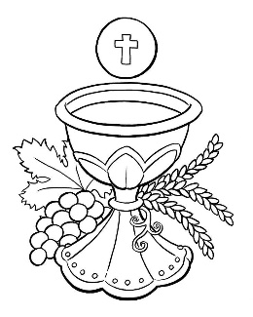
SUNDAY MASS TIMES
Saturday 6.00pm St. Patrick’s church
Sunday 9.30am Christ the King church
Sunday 11.00am St. Patrick’s church WEEKDAY LITURGY TIMES
Tuesday 10.00am Christ the King
Wednesday 10.00am St. Patrick’s
Thursday: 10.00am Christ the King
Friday: 10.00am St. Patrick’s
MASS INTENTIONS RECEIVED: Special Intention, Mr. Frank Allison (1st Anni.),
ANNIVERSARIES: June 18th – 24th:
William McReddie, Isabella Mary Allison, Frank Allison, Agnes Moody (nee Malcolm), Thomas Maleary, Patrick Joseph Lynch, Hilda Ansell, Monsignor William Carroll, Fr. Tom Brophy, Joe Musgrove, Margaret Hellerman, Irene Silver Harding, John Reginald Tipton, Thora (Betty) Kitson, Terry Carberry,
PLEASE REMEMBER in your prayers all our sick and housebound brothers and sisters.
The word this week
Exodus 19:2-6 God makes the Israelites a holy nation.
Psalm 99 “We are his people, the sheep of his flock.”
Romans 5:6-11 Through Christ we have received reconciliation.
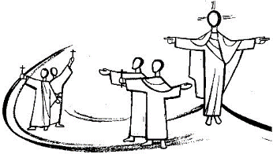
Matthew 9:36-10:8 Jesus summoned the Twelve and sent them out.
R
unning through today’s readings is the theme of dedication. In Exodus, God dedicates the Chosen People as a holy nation. Paul points out that Christ died for us sinners, in the ultimate act of dedication to his formidable mission. In the Gospel, Jesus sends the Twelve out for the first time, instructing them to dedicate themselves to doing all the things they’d seen him do. May today’s readings inspire us to dedicate ourselves in the same way.
AT MASS TODAY WE PRAY Eucharistic Prayer 2 and Preface 1of Apostles
Renewing the covenant that Christ made through the blood of the cross, we now lift up our hearts and voices in this great prayer of thanksgiving.
FIRST HOLY COMMUNION in the Parish this Sunday, June 18th, at both Christ the King and St. Patrick’s. We continue with First Holy Communion this Sunday at the 9.30am and 11.00am Masses. Of course, it would be nice to have all the First Communion children together in each Parish but then we would have to go for Saturday. I think, it is better to have all the Faithful people of God together on the Sunday.
RECENTLY DECEASED: Please remember in your prayers Mr. Brian Buckle, aged 83, from Thornaby, who died recently. His Funeral Mass will take place on Friday, June 30th, in St. Patrick’s church, at 10.00am. May he rest in peace.

FUNDRAISING EVENT FOR TEESSIDE HOSPICE in Christ the King Hall on Saturday, June 24th, 1.00pm – 4.00pm.
Entertainment, Raffle and Bingo. Also, includes Cod-Bites, Chips, Tea/Coffee. Tickets are available £10.00 each.
ITEMS NEEDED: Mother and two children moving into a property in Thornaby, but it needs finishing. Items such as Furniture, Cooker, Fridge, Curtains, Bedding etc. If you can help in any way, please call Bridie Hope on 01642 888987.

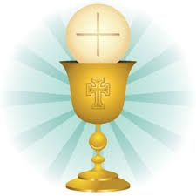
PANIS ANGELICUS (The bread of angels)
The Bread of Angels becomes the food for mankind.
The bread of heaven gives form to the imagination.
What a miracle, the Lord becomes food
for the needy, the burdened and the lowly.

We pray to you, Triune and One God,
that you come to us, as we hold you holy;
with your counsel, guide us to what we pursue:
to your light, your dwelling place. Amen.
{Thomas Aquinas}

11th Sunday in Ordinary Time (A)
June 18th, 2023

First reading Exodus 19:2-6

From Rephidim the sons of Israel set out again; and when they reached the wilderness of Sinai, there in the wilderness they pitched their camp; there facing the mountain Israel pitched camp.
Moses then went up to God, and the Lord called to him from the mountain, saying, ‘Say this to the House of Jacob, declare this to the sons of Israel, “You yourselves have seen what I did with the Egyptians, how I carried you on eagle’s wings and brought you to myself. From this you know that now, if you obey my voice and hold fast to my covenant, you of all the nations shall be my very own for all the earth is mine. I will count you a kingdom of priests, a consecrated nation.”’

Second reading Romans 5:6-11

We were still helpless when at his appointed moment Christ died for sinful men. It is not easy to die even for a good man – though of course for someone really worthy, a man might be prepared to die – but what proves that God loves us is that Christ died for us while we were still sinners. Having died to make us righteous, is it likely that he would now fail to save us from God’s anger? When we were reconciled to God by the death of his Son, we were still enemies; now that we have been reconciled, surely we may count on being saved by the life of his Son? Not merely because we have been reconciled but because we are filled with joyful trust in God, through our Lord Jesus Christ, through whom we have already gained our reconciliation.

Gospel Acclamation
Alleluia, alleluia!
The sheep that belong to me listen to my voice,
says the Lord,
I know them and they follow me.
Alleluia!

Gospel Reading Matthew 9:36-10:8

When Jesus saw the crowds he felt sorry for them because they were harassed and dejected, like sheep without a shepherd. Then he said to his disciples, ‘The harvest is rich but the labourers are few, so ask the Lord of the harvest to send labourers to his harvest.’
He summoned his twelve disciples, and gave them authority over unclean spirits with power to cast them out and to cure all kinds of diseases and sickness.
These are the names of the twelve apostles: first, Simon who is called Peter, and his brother Andrew; James the son of Zebedee, and his brother John; Philip and Bartholomew; Thomas, and Matthew the tax collector; James the son of Alphaeus, and Thaddaeus; Simon the Zealot and Judas Iscariot, the one who was to betray him. These twelve Jesus sent out, instructing them as follows:
‘Do not turn your steps to pagan territory, and do not enter any Samaritan town; go rather to the lost sheep of the House of Israel. And as you go, proclaim that the kingdom of heaven is close at hand. Cure the sick, raise the dead, cleanse the lepers, cast out devils. You received without charge, give without charge.’

