St. Patrick’s church, 39 Westbury St. TS17 6NW Christ the King church, Trenchard Ave. TS17 0EG
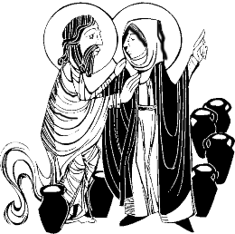
Postal address: Christ the King House, Trenchard Avenue, TS17 0EG
Telephone: 01642 750467
EMAIL: thornaby@rcdmidd.org.uk
Christ the King Website: www.ctkthornaby.co.uk St. Patrick’s Website: www.stpatrickschurch.co.uk
2nd Sunday in Ordinary Time (c) January 16th, 2022
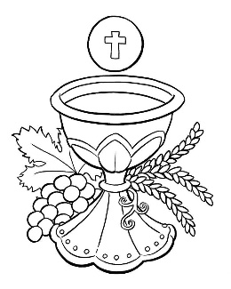
SUNDAY MASS TIMES

6.00pm (Saturday) St. Patrick’s church
9.30am Christ the King church
11.00am St. Patrick’s church
WEEKDAY MASSES
Tuesday: 10.00am Christ the King
Wednesday: 10.00am Christ the King
Thursday: 10.00am Christ the King
Friday: 10.00am Christ the King
PLEASE NOTE: Face coverings / Face masks must now be worn in church for all liturgies.
SACRAMENT OF RECONCILIATION any time on request

MASS INTENTIONS RECEIVED: Special Intention, Deceased members of Wherly and McWilliams families,
John Hellerman R.I.P., Hary and Cecelia Belbin, Benny McMahon (Anni.), Cecelia Belbin (Anni.),
Special Intention (Birthday),

ANNIVERSARIES: 16th – 22nd JANUARY:
John Musgrove, Hope Lynch, David Macaulay, Edward Devlin, Maureen Durham, Stuart Pickering, Ann Shannon, Mavis Howe, Mary Legg, Margaret McCann, Tom Greenfield, Mary Shelley, Sarah E Musgrove, Maud Halsey (Canavan),
Nancy and Susanne Foster, James Canavan, Hilda Jackson, Albert McGill, Margaret Hackett, Pauline Mallon, Harry Vokes.

PLEASE REMEMBER in your prayers all our sick and housebound brothers and sisters.
The word this week
Isaiah 62:1–5 All shall behold your vindication.
Psalm 96 ‘Proclaim the wonders of the Lord among all the peoples.’
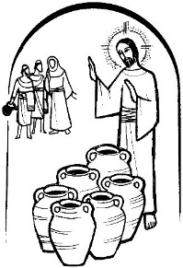
1 Corinthians 12:4–11 The Spirit distributes gifts to each person.
John 2:1–11 Jesus transforms water into wine.
The Bishops of England and Wales invite us to make today a day of prayer for peace and to reflect on the theme Pope Francis has chosen for the annual World Day of Peace: ‘Education, Work and Dialogue between Generations: Tools for Building Lasting Peace’. What could be a better image of the meeting of the generations than a wedding celebration, where young and old mingle, both at the meal-table and on the dancefloor; when old loves and hopes are re-awakened by the joy of seeing the bride and groom publicly pledge their love? It is at such a wedding party that we meet the Lord today, at Cana in Galilee.
As we gather for the Eucharist, we share in the joy of divine and human love but we also acknowledge that at times our wells of love run dry. Like the hosts of that ancient wedding feast ‘we have no wine’. And so, we rely on Christ's mercy to renew our love, our peace and our joy.
RECENTLY DECEASED: Please remember in your prayers Mr. Neil Terence Wren, aged 65, from Thornaby, who died recently. His Funeral Service will take place at Christ the King church on Wednesday, January 26th, at 12. 30pm. ALSO, Mr. John Hellerman {Michael’s brother} who died in Wales recently. May they rest in peace.

AT MASS TODAY WE PRAY Eucharistic Prayer 2 for Reconciliation with its own Preface
Gathered around this banquet table, we eagerly await the transformation of these holy gifts. Let us humbly offer our great prayer of thanksgiving.
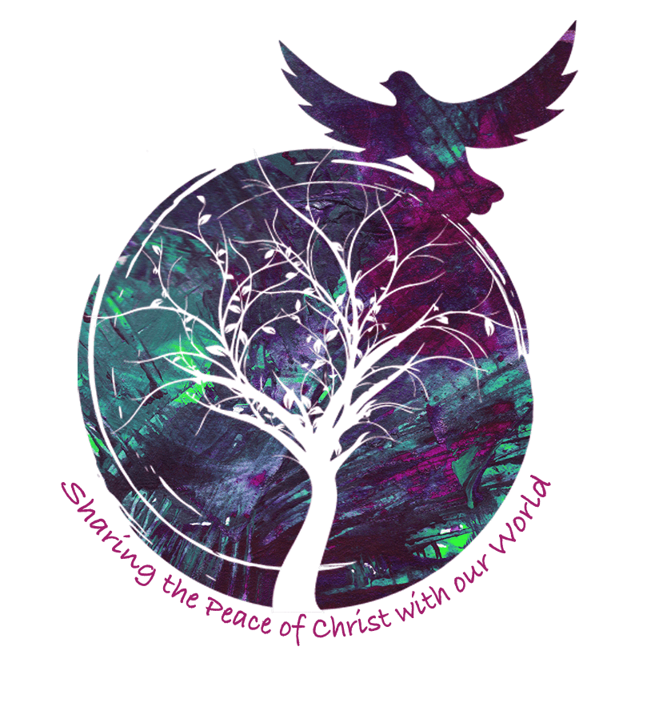
TEA/COFFEE ETC after Sunday morning Mass at Christ the King

PEACE SUNDAY: This Sunday, January 16th, is ‘Peace Sunday’. Pope Francis has chosen the theme for this year’s Peace Sunday: “Dialogue between generations, education and work: tools for building lasting peace”.
Prayer for Peace
O God of peace, who are peace itself and whom a spirit of discord cannot grasp, nor a violent mind receive, grant that those who are one in heart may persevere in what is good and that those in conflict may forget evil and so be healed. Amen

READINGS FOR 2nd SUNDAY IN ORDINARY TIME {C}
January 16th, 2022

First reading Isaiah 62:1-5

About Zion I will not be silent, about Jerusalem I will not grow weary, until her integrity shines out like the dawn
and her salvation flames like a torch.
The nations then will see your integrity, all the kings your glory, and you will be called by a new name,
one which the mouth of the Lord will confer.
You are to be a crown of splendour in the hand of the Lord, a princely diadem in the hand of your God;
no longer are you to be named ‘Forsaken’, nor your land ‘Abandoned’, but you shall be called ‘My Delight’
and your land ‘The Wedded’; for the Lord takes delight in you and your land will have its wedding.
Like a young man marrying a virgin, so will the one who built you wed you, and as the bridegroom rejoices in his bride,
so will your God rejoice in you.

Second reading 1 Corinthians 12:4-11

There is a variety of gifts but always the same Spirit; there are all sorts of service to be done, but always to the same Lord; working in all sorts of different ways in different people, it is the same God who is working in all of them. The particular way in which the Spirit is given to each person is for a good purpose. One may have the gift of preaching with wisdom given him by the Spirit; another may have the gift of preaching instruction given him by the same Spirit; and another the gift of faith given by the same Spirit; another again the gift of healing, through this one Spirit; one, the power of miracles; another, prophecy; another the gift of recognising spirits; another the gift of tongues and another the ability to interpret them. All these are the work of one and the same Spirit, who distributes different gifts to different people just as he chooses.

Gospel Acclamation
Alleluia, alleluia!
Speak, Lord, your servant is listening:
you have the message of eternal life.
Alleluia!

Gospel Reading John 2:1-11

There was a wedding at Cana in Galilee. The mother of Jesus was there, and Jesus and his disciples had also been invited. When they ran out of wine, since the wine provided for the wedding was all finished, the mother of Jesus said to him, ‘They have no wine.’ Jesus said ‘Woman, why turn to me? My hour has not come yet.’ His mother said to the servants, ‘Do whatever he tells you.’ There were six stone water jars standing there, meant for the ablutions that are customary among the Jews: each could hold twenty or thirty gallons. Jesus said to the servants, ‘Fill the jars with water’, and they filled them to the brim. ‘Draw some out now’ he told them ‘and take it to the steward.’ They did this; the steward tasted the water, and it had turned into wine. Having no idea where it came from – only the servants who had drawn the water knew – the steward called the bridegroom and said, ‘People generally serve the best wine first, and keep the cheaper sort till the guests have had plenty to drink; but you have kept the best wine till now.’
This was the first of the signs given by Jesus: it was given at Cana in Galilee. He let his glory be seen, and his disciples believed in him.

