Postal address:
Christ the King Church
Trenchard Avenue
TS17 0EG
www.ctkthornaby.co.uk
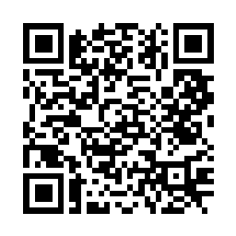
St Patrick’s Church
Westbury Street
TS17 6NW
www.stpatrickschurch.co.uk
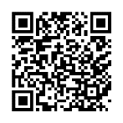
Christ the King House
Trenchard Avenue
TS17 0EG
T: 01642 750467
Email: thornaby@rcdmidd.org.uk

2nd SUNDAY OF THE YEAR (A) January 15th, 2023
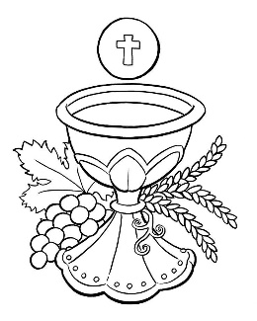
SUNDAY MASS TIMES
Saturday 6.00pm St. Patrick’s church
Sunday 9.30am Christ the King church
Sunday 11.00am St. Patrick’s church
WEEKDAY LITURGY TIMES
Tuesday 10.00am Christ the King
Wednesday 10.00am St. Patrick’s
Thursday: 10.00am Christ the King
Friday: 10.00am St. Patrick’s
SACRAMENT OF RECONCILIATION any time on request
MASS INTENTIONS RECEIVED: Special Intention, Jimmy Goodwin,

ANNIVERSARIES: January 15th – 21st:
Martha Moffatt, Alfred Wherly, John Musgrove, Hope Lynch, David Macaulay, Edward Devlin, Maureen Durham,
Stuart Pickering, Ann Shannon, Mavis Howe, Mary Legg, Margaret McCann, Tom Greenfield, Mary Shelley,
Sarah E. Musgrove, Maud Halsey (Canavan), Susanne Foster, James Canavan, Hilda Jackson.
PLEASE REMEMBER in your prayers all our sick and housebound brothers and sisters.
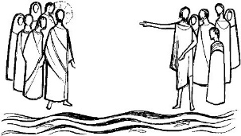
The word this week
Isaiah 49:3, 5–6 From my mother’s womb, I am God’s servant.
Psalm 39 (40) “Here am I, Lord; I come to do your will.’
1 Corinthians 1:1–3 Greetings to you, a holy people in Christ.
John 1:29–34 Behold, the Lamb of God!
Before we receive the Lord in the Eucharist, we hear the words, “Behold, the Lamb of God, who takes away the sin of the world.” We will hear these words in today’s Gospel, for they were first proclaimed by John the Baptist. John, Isaiah, and Paul all testify to how the Lord has called them and changed their lives. May we be inspired by them and take to heart what we proclaim in the responsorial psalm: Here am I, Lord; I come to do your will.

AT MASS TODAY WE PRAY Eucharistic Prayer 2 and Preface for The Baptism of The Lord
Each week we lift our voices with praise and thanksgiving over these gifts. As this new year unfolds, let us renew our commitment to bring what we receive here to our world of hunger.
RECENTLY DECEASED: Please remember in your prayers Mary Isabella Allison, aged 94, from Thornaby, who died recently. Her Funeral Mass will take place on Friday, January 27th, at St. Patrick’s church at 10.00am. ALSO, Mrs Laura Dunn, aged 93, from Thornaby, who died recently. Her Funeral Service will take place at St. Patrick’s church on Tuesday, January 31st, at 10.00am ALSO, Mr. Jim Goodwin, aged 82, from Thornaby, who died this last week. No Funeral arrangements yet.
ALSO, Mr. Martin Knob, formerly from Czech Republic, who died suddenly while visiting family back in his homeland. His five-year-old daughter attends St. Patrick’s Primary School. May they rest in peace.

THIS SUNDAY, 15th JANUARY, IS “PEACE SUNDAY” and this year the message from Pope Francis tells us: ‘No one can be saved alone. Combatting Covid-19 together, embarking together on paths of peace’.
He asks us: ‘What signs of life and hope can we see, to help us move forward and try to make our world a better place?’
A vaccine has been found for Covid-19, says the Holy Father, but we still need to tackle the virus of war, and of inequality, and this can only be done together.
MESSAGE FROM ST. PATRICK’S: If anyone has any items left over from Christmas – Gift sets, boxed chocs or boxed biscuits that we could use for our up and coming future events we would be very grateful.
Thank you very much for all the donations and gifts we have received in the past from all our generous parishioners.

WHIST (CARD GAME) –enjoyable & friendly small social gatherings. Our Friday evening whist sessions, on alternate Fridays 7.30pm in Linthorpe Community Centre, 466 Linthorpe Road TS56JG, are now well established (admission £2 incl. tea/biscuits); current players are aged 17 – 80+. We are now looking to begin sessions on alternate Tuesdays 2pm at the Centre (admission £2 incl. tea/biscuits). Also at the Centre are our learning/practise sessions every Tuesday & Wednesday 10am - 12 noon (free). Possible help with transport locally, if needed. Contact Edna Hunneysett 01642 813277

Second Sunday of the Year (A)
January 15th, 2023

First reading Isaiah 49:3,5-6

The Lord said to me, ‘You are my servant, Israel,
in whom I shall be glorified’;
I was honoured in the eyes of the Lord,
my God was my strength.
And now the Lord has spoken,
he who formed me in the womb to be his servant,
to bring Jacob back to him,
to gather Israel to him:
‘It is not enough for you to be my servant,
to restore the tribes of Jacob and bring back the survivors of Israel;
I will make you the light of the nations
so that my salvation may reach to the ends of the earth.’

Second reading 1 Corinthians 1:1-3

I, Paul, appointed by God to be an apostle, together with brother Sosthenes, send greetings to the church of God in Corinth, to the holy people of Jesus Christ, who are called to take their place among all the saints everywhere who pray to our Lord Jesus Christ; for he is their Lord no less than ours. May God our Father and the Lord Jesus Christ send you grace and peace.

Gospel Acclamation
Alleluia, alleluia!
Blessings on the King who comes,
in the name of the Lord!
Peace in heaven
and glory in the highest heavens!
Alleluia!

Gospel Reading John 1:29-34

Seeing Jesus coming towards him, John said, ‘Look, there is the lamb of God that takes away the sin of the world. This is the one I spoke of when I said: A man is coming after me who ranks before me because he existed before me. I did not know him myself, and yet it was to reveal him to Israel that I came baptising with water.’ John also declared, ‘I saw the Spirit coming down on him from heaven like a dove and resting on him. I did not know him myself, but he who sent me to baptise with water had said to me, “The man on whom you see the Spirit come down and rest is the one who is going to baptise with the Holy Spirit.” Yes, I have seen and I am the witness that he is the Chosen One of God.’

