Postal address:
Christ the King Church
Trenchard Avenue
TS17 0EG
www.ctkthornaby.co.uk
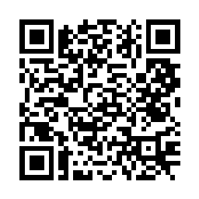
St Patrick’s Church
Westbury Street
TS17 6NW
www.stpatrickschurch.co.uk
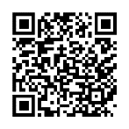
Christ the King House
Trenchard Avenue
TS17 0EG
T: 01642 750467
Email: thornaby@rcdmidd.org.uk

THE ASSUMPTION OF OUR LADY INTO HEAVEN August 14th, 2022
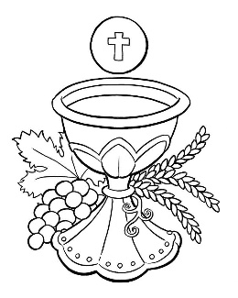
SUNDAY MASS TIMES
Saturday 6.00pm St. Patrick’s church
9.30am Christ the King church
11.00am St. Patrick’s church
WEEKDAY LITURGIES
10.30am St. Patrick’s church {Funeral Mass}
Wednesday No Liturgy
Thursday No Liturgy
Friday No Liturgy
SACRAMENT OF RECONCILIATION any time on request
MASS INTENTIONS RECEIVED: Special Intention,
ANNIVERSARIES: August 14th – 20th.
Hilda Mary Purvis, Joseph Greenan, Hannah Elizabeth Bonner, Margaret Deaton, Lawrence Close, Terry Morgan,
Nicholas Ward, May Jones, Norah Grant, John Gerard Clarke, Rose Ann Saunders, Philip Lee Elder, Patrick Frew.
PLEASE REMEMBER in your prayers all our sick and housebound brothers and sisters.
The word this week
Apocalypse 11:19a; 12:1–6a, 10ab A woman adorned with the sun and crowned with stars.
Psalm 45 ‘On your right stands the queen in garments of gold.’
1 Cor. 15:20–27 Christ is the first-fruits of those who have fallen asleep.
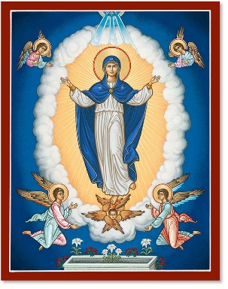
Luke 1:39–56 John leaps in his mother’s womb in the presence of the Lord in the womb of Mary.
T
his great feast is a twin to the Feast of the Ascension of the Lord. Then, if you recall, the preface of the Mass contained these words: “Christ is the beginning, the head of the Church; where he has gone, we hope to follow.” Today we celebrate the first of us to do just that, as we remember Mary following our Lord into heaven. She is the first to follow him – but not the last. This feast should help open our eyes to our final destination, heaven. So, this feast pushes us right back to Easter, to thoughts of death and resurrection. It is the second reading which underlines all this. It talks of the gradual resurrection of the dead. Christ first, then those who belong to him. Of these, the first is Mary, she who was without stain of original sin, she who was ‘most blessed of all women.’ In her, today, we see the fulfilment of the vision of the first reading – the end of death and the victory of life in Christ.

AT MASS TODAY WE PRAY Eucharistic Prayer 2 with Preface 1 for the Feast of the Assumption of Our Lady
The table of plenty is spread before us. Here we will have a foretaste of the heavenly banquet. Let us offer thanks to God who has done great things for us.

RECENTLY DECEASED: Please remember in your prayers Mr. Michael Ryan, aged 78, from Thornaby, who died recently. His Funeral Mass will take place at St. Patrick’s church this Tuesday, August 16th, at 10.30am.
May he rest in peace.

TEA/COFFEE ETC after Sunday morning Mass at Christ the King and St. Patrick’s
DIGITAL GIVING: You will notice we now have a QR code for each church at the top of the Newsletter. This means we can now receive donations remotely by scanning on a mobile phone {with the camera} and, then, follow the prompts.
MESAAGE FROM HENRI NOUWEN {1932 – 1996}
You are not what you do, although you do a lot. You are not what you have collected in terms of friendships and connections, although you might have many. You are not the popularity that you have received. You are not the success of your work. You are not what people say about you, whether they speak well or whether they speak poorly about you. All these things that keep you quiet busy, quiet occupied, and often quiet preoccupied, are not telling the truth of who you are.
I am here to remind you in the name of God that you are the beloved daughters and sons of God – and that God says to you,
“I have called you from all eternity and you are engraved from all eternity into the palms of my hands. You are mine. You belong to me, and I love you with an everlasting love.”

FEAST OF THE ASSUMPTION OF OUR LADY
August 14th, 2022

First reading Revelation 11:19; 12:1-6a,10ab

God’s temple in heaven was opened, and the ark of his covenant could be seen in the temple.
A great sign appeared in the sky, a woman clothed with the sun, with the moon under her feet,
and on her head a crown of twelve stars.
She was with child and wailed aloud in pain as she laboured to give birth. Then another sign appeared in the sky;
it was a huge red dragon, with seven heads and ten horns, and on its heads were seven diadems.
Its tail swept away a third of the stars in the sky and hurled them down to the earth.
Then the dragon stood before the woman about to give birth, to devour her child when she gave birth.
She gave birth to a son, a male child, destined to rule all the nations with an iron rod.
Her child was caught up to God and his throne.
The woman herself fled into the desert where she had a place prepared by God.
Then I heard a loud voice in heaven say: “Now have salvation and power come, and the Kingdom of our God
and the authority of his Anointed One.”

Second reading 1 Cor 15:20-27

Brothers and sisters:
Christ has been raised from the dead, the first-fruits of those who have fallen asleep.
For since death came through man, the resurrection of the dead came also through man.
For just as in Adam all die, so too in Christ shall all be brought to life, but each one in proper order:
Christ the first-fruits; then, at his coming, those who belong to Christ;
then comes the end, when he hands over the Kingdom to his God and Father,
when he has destroyed every sovereignty and every authority and power.
For he must reign until he has put all his enemies under his feet.
The last enemy to be destroyed is death, for “he subjected everything under his feet.”

Gospel Acclamation
Alleluia, alleluia!
Mary is taken up to heaven;
a chorus of angels exults
Alleluia!

Gospel Reading Lk 1:39-56
Mary set out and traveled to the hill country in haste to a town of Judah, where she entered the house of Zechariah
and greeted Elizabeth.
When Elizabeth heard Mary’s greeting, the infant leaped in her womb, and Elizabeth, filled with the Holy Spirit,
cried out in a loud voice and said, “Blessed are you among women, and blessed is the fruit of your womb.
And how does this happen to me, that the mother of my Lord should come to me?
For at the moment the sound of your greeting reached my ears, the infant in my womb leaped for joy.
Blessed are you who believed that what was spoken to you by the Lord would be fulfilled.”
And Mary said:
“My soul proclaims the greatness of the Lord; my spirit rejoices in God my Saviour for he has looked with favour on his lowly servant. From this day all generations will call me blessed: the Almighty has done great things for me
and holy is his Name.
He has mercy on those who fear him in every generation.
He has shown the strength of his arm, and has scattered the proud in their conceit.
He has cast down the mighty from their thrones, and has lifted up the lowly.
He has filled the hungry with good things, and the rich he has sent away empty.
He has come to the help of his servant Israel for he has remembered his promise of mercy,
the promise he made to our fathers, to Abraham and his children forever.”

Mary remained with her about three months and then returned to her home.

