Postal address:
Christ the King Church
Trenchard Avenue
TS17 0EG
www.ctkthornaby.co.uk
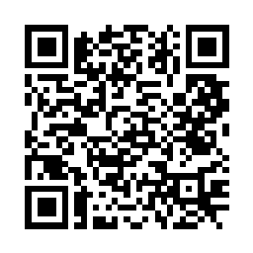
St Patrick’s Church
Westbury Street
TS17 6NW
www.stpatrickschurch.co.uk
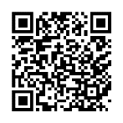
Christ the King House
Trenchard Avenue, Thornaby.
TS17 0EG
T: 01642 750467
Email: thornaby@rcdmidd.org.uk

6th Sunday of Easter May 14th, 2023
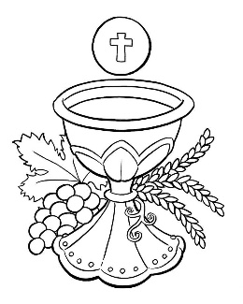
SUNDAY MASS TIMES
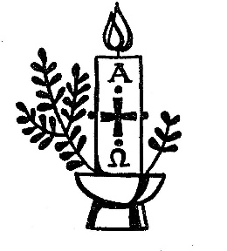
Saturday 6.00pm St. Patrick’s church
Sunday 9.30am Christ the King church
Sunday 11.00am St. Patrick’s church WEEKDAY LITURGY TIMES
Tuesday 10.00am Christ the King
Wednesday 6.00pm St. Patrick’s
Thursday: 10.00am Christ the King
Friday: 10.00am St. Patrick’s
MASS INTENTIONS RECEIVED: Special Intention, John and Bridget Reilly (Anni.), In memory of Jennifer Marie Barber’s birthday, Barbara McCoy R.I.P., Jim and Jane McWilliams (Anni.),

ANNIVERSARIES: May 14th – 20th:
Barbara McReddie, John Reilly, Audrey Devlin, Polly Devlin, Alice Bryan, Betty Burke, Ann Wesson, Peter Hughes,
Minnie Donoghue, Alwin Smithson, Fr. John Ryan, David Devlin, Annette McGregor, Catherine Ward.

PLEASE REMEMBER in your prayers all our sick and housebound brothers and sisters.
The word this week
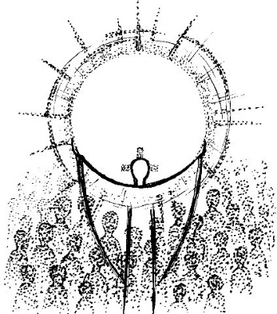
Acts 8:5–8, 14–17 Peter and John laid hands upon them.
Psalm 65 ‘Cry out with joy to God, all the earth .’
1 Peter 3:15–18 Christ suffered for sins to lead us to God.
John 14:15–21 I will give you another Advocate, the Spirit of truth.
Luke, the author of Acts, reports that when the people of Samaria heard Philip proclaim Christ and saw him perform wondrous signs, they reacted with great joy. By now we are some distance away from Easter, but the season is still filled with the Easter message: Christ is risen, we are baptised in him. But today a new dimension of the story comes out. Easter is not complete until the risen Lord has returned to the Father and sent the Holy Spirit. So in the Gospel today we begin two weeks of looking forward to the coming of that “Spirit of truth” which sets us apart from the world. May great joy come upon us as well as we listen to the Word of God proclaimed and then participate in the wondrous miracle of the bread and wine becoming the Body and Blood of our Lord.
AT MASS TODAY WE PRAY Eucharistic Prayer 3 and Preface 4 for Easter.
Friends, we stand humbly before our God, who transforms simple gifts of bread and wine into the body and blood of Christ. Father, Son, and Spirit become present in this place as we lift up our voices in thanksgiving.
CROWNING OF OUR LADY next Sunday, May 21st, at the 11.00am Mass at St. Patrick’s church
RECENTLY DECEASED: Please remember in your prayers Mrs. June Notman, {nee Young} aged 81, from Thornaby, who died recently. Her Funeral Service will take place at Christ the King church this Thursday, May 18th, at 12.30pm. May she rest in peace.
ASCENSION THURSDAY: This Thursday, May 18th, is the Feast of The Ascension of our Lord. Mass times are: 6.00pm on Wednesday (The Eve) at St. Patrick’s
10.00am on Thursday at Christ the King
SACRAMENT OF CONFIRMATION: We enjoyed a lovely liturgy of the Sacrament of Confirmation on Thursday evening last at the church of St. Therese of Lisieux in Ingleby Barwick. Twenty-seven people from five Parishes were Confirmed in the Faith of the Church by Bishop Drainey – including ten from Thornaby: Anissa Crossan, Obiajulu Agu, Chidubem Agu, Matthew Baige, Brooke-Alice McMullen, Chisom Akachukwu, Taliah-May Loughlin, Hayley Jobson, Stephen Barber, Patricia Onome Oghoma. Big ‘Thank You’ to Mrs. Alison Fisk and Miss Lynn Roberts for helping to prepare the students from St. Patrick’s College.

MASS OF THANKSGIVING: Mass on Friday morning at St. Patrick’s church at 10.00am is in ‘Thanks to God’
for the “OUTSTANDING OFSTED REPORT” after the recent Inspection. All pupils and staff will be present.
Parishioners very welcome

6th SUNDAY OF EASTER(A)
May 14th, 2023

First reading Acts 8:5-8,14-17

Philip went to a Samaritan town and proclaimed the Christ to them. The people united in welcoming the message Philip preached, either because they had heard of the miracles he worked or because they saw them for themselves. There were, for example, unclean spirits that came shrieking out of many who were possessed, and several paralytics and cripples were cured. As a result there was great rejoicing in that town.
When the apostles in Jerusalem heard that Samaria had accepted the word of God, they sent Peter and John to them, and they went down there, and prayed for the Samaritans to receive the Holy Spirit, for as yet he had not come down on any of them: they had only been baptised in the name of the Lord Jesus. Then they laid hands on them, and they received the Holy Spirit.

Second reading 1 Peter 3:15-18

Reverence the Lord Christ in your hearts, and always have your answer ready for people who ask you the reason for the hope that you all have. But give it with courtesy and respect and with a clear conscience, so that those who slander you when you are living a good life in Christ may be proved wrong in the accusations that they bring. And if it is the will of God that you should suffer, it is better to suffer for doing right than for doing wrong.
Why, Christ himself, innocent though he was, had died once for sins, died for the guilty, to lead us to God. In the body he was put to death, in the spirit he was raised to life.

Gospel Acclamation
Alleluia, alleluia!
Jesus said: ‘If anyone loves me he will keep my word,
and my Father will love him,
and we shall come to him.’
Alleluia!

Gospel Reading John 14:15-21

Jesus said to his disciples:
‘If you love me you will keep my commandments.
I shall ask the Father,
and he will give you another Advocate
to be with you for ever,
that Spirit of truth
whom the world can never receive
since it neither sees nor knows him;
but you know him,
because he is with you, he is in you.
I will not leave you orphans;
I will come back to you.
In a short time the world will no longer see me;
but you will see me,
because I live and you will live.
On that day you will understand that I am in my Father
and you in me and I in you.
Anybody who receives my commandments and keeps them
will be one who loves me;
and anybody who loves me will be loved by my Father,
and I shall love him and show myself to him.’

