Postal address:
Christ the King Church
Trenchard Avenue
TS17 0EG
www.ctkthornaby.co.uk
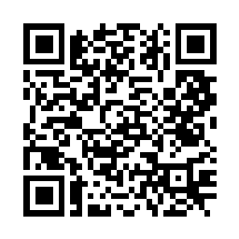
St Patrick’s Church
Westbury Street
TS17 6NW
www.stpatrickschurch.co.uk
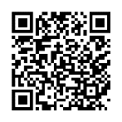
Christ the King House
Trenchard Avenue, Thornaby.
TS17 0EG
T: 01642 750467
Email: thornaby@rcdmidd.org.uk

The Most Holy Body & Blood of Christ June 11th, 2023
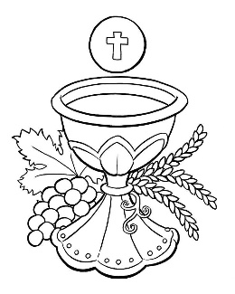
SUNDAY MASS TIMES
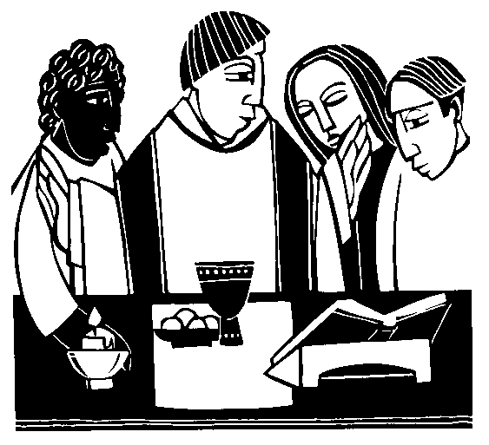
Saturday 6.00pm St. Patrick’s church
Sunday 9.30am Christ the King church
Sunday 11.00am St. Patrick’s church WEEKDAY LITURGY TIMES
Tuesday 10.00am Christ the King
Wednesday 10.00am St. Patrick’s
Thursday: 10.00am Christ the King
Friday: 10.00am St. Patrick’s
MASS INTENTIONS RECEIVED: Special Intention, Mrs. Pat Walton (Anni.),
ANNIVERSARIES: June 11th – 17th:
Patrick Ruddy, Jane Wright, John Robert Bell, Pat Walton, Patricia Noble, James Monaghan, Claire Gallagher,
Anthony Risbrough, Sophie Rebekah Izabelle Ellis, Ethel May Graham, Bernadette Gent, Catherine Waites (nee Walsh),
John Rafferty, Margaret Wright, Lucy Pinder, Bridget Goodwin.

PLEASE REMEMBER in your prayers all our sick and housebound brothers and sisters.

The word this week
Deuteronomy 8:2–3, 14–16 We live on every word that comes from the mouth of God.
Psalm 147 “O praise the Lord, Jerusalem.”
1 Cor 10:16–17 The cup we bless and the bread we break are a participation in the body of Christ.
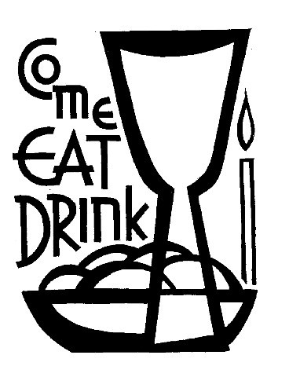
John 6:51–58 Jesus is the living bread come down from heaven.
The Eucharist – the Body and Blood of Christ – is a mystery with so many layers and a depth that takes more than a lifetime to penetrate. It is not just a ‘thing’ that we receive – however reverently - it is a person, a relationship, a belonging and a transformation that we consume, that becomes part of us. Receive what you are ‘the Body of Christ’. The readings invite us to reflect on how our celebration of the Eucharist brings Christ’s words to our reality. “Who eats my flesh and drink my blood lives in me and I live in him.” The people of the Old Testament had God living in their midst, walking with them on their journey, feeding and nourishing them with the gift of manna from heaven. Jesus walks with us, journeying in communion with us, living within us, as we eat and drink the gifts he extends from the Last Supper. And as Saint Paul reminds us, our communion with the One Christ is also a communion with each other – God lives in us as the people of the Church, as we become His Body.

AT MASS TODAY WE PRAY Eucharistic Prayer 2 and Preface 2 for The Most Holy Eucharist
My friends, on this day of holy remembrance, let us be attentive of the words of the Eucharistic Prayer. Let us be drawn into this prayer and offer thanks for the great gift of the Eucharist.
FIRST HOLY COMMUNION in the Parish this Sunday and next, June 11th and 18th, at both Christ the King and St. Patrick’s.
BEREAVEMENT GROUP will meet in Christ the King Parish Hall this Wednesday, June 7th, at 7.00pm. All welcome.
FUNDRAISING EVENT FOR TEESSIDE HOSPICE in Christ the King Hall on Saturday, June 24th, 1.00pm – 4.00pm.
Entertainment, Raffle and Bingo. Also, includes Cod-Bites, Chips, Tea/Coffee. Tickets are available £10.00 each.

ITEMS NEEDED: Mother and two children moving into a property in Thornaby, but it needs finishing. Items such as Furniture, Cooker, Fridge, Curtains, Bedding etc. If you can help in any way, please call Bridie Hope on 01642 888987.
“SOLEMN BLESSING FOR FEAST OF CORPUS CHRISTI”
May almighty God bless you in his kindness and pour out saving wisdom upon you. Amen
May he nourish you always with the teachings of the faith and make you persevere in holy deeds. Amen
May he turn your steps towards himself and show you the path of charity and peace. Amen

The Most Holy Body & Blood of Christ
June 11th, 2023

First reading Deuteronomy 8:2-3,14-16

Moses said to the people: ‘Remember how the Lord your God led you for forty years in the wilderness, to humble you, to test you and know your inmost heart – whether you would keep his commandments or not. He humbled you, he made you feel hunger, he fed you with manna which neither you nor your fathers had known, to make you understand that man does not live on bread alone but that man lives on everything that comes from the mouth of the Lord.
‘Do not become proud of heart. Do not forget the Lord your God who brought you out of the land of Egypt, out of the house of slavery: who guided you through this vast and dreadful wilderness, a land of fiery serpents, scorpions, thirst; who in this waterless place brought you water from the hardest rock; who in this wilderness fed you with manna that your fathers had not known.’

Second reading 1 Corinthians 10:16-17

The blessing-cup that we bless is a communion with the blood of Christ, and the bread that we break is a communion with the body of Christ. The fact that there is only one loaf means that, though there are many of us, we form a single body because we all have a share in this one loaf.

Gospel Acclamation
Alleluia, alleluia!
I am the living bread which has come down from heaven,
says the Lord.
Anyone who eats this bread will live for ever.
Alleluia!

Gospel Reading John 6:51-58

Jesus said to the crowd:
‘I am the living bread which has come down from heaven.
Anyone who eats this bread will live for ever;
and the bread that I shall give is my flesh,
for the life of the world.’
Then the Jews started arguing with one another: ‘How can this man give us his flesh to eat?’ they said. Jesus replied:
‘I tell you most solemnly,
if you do not eat the flesh of the Son of Man and drink his blood,
you will not have life in you.
Anyone who does eat my flesh and drink my blood
has eternal life,
and I shall raise him up on the last day.
For my flesh is real food
and my blood is real drink.
He who eats my flesh and drinks my blood
lives in me
and I live in him.
As I, who am sent by the living Father,
myself draw life from the Father,
so whoever eats me will draw life from me.
This is the bread come down from heaven;
not like the bread our ancestors ate:
they are dead,
but anyone who eats this bread will live for ever.’

