Postal address:
Christ the King Church
Trenchard Avenue
TS17 0EG
www.ctkthornaby.co.uk
St Patrick’s Church
Westbury Street
TS17 6NW
www.stpatrickschurch.co.uk
Christ the King House
Trenchard Avenue
TS17 0EG
T: 01642 750467
Email: thornaby@rcdmidd.org.uk

2nd Sunday of Advent (A) December 4th, 2022
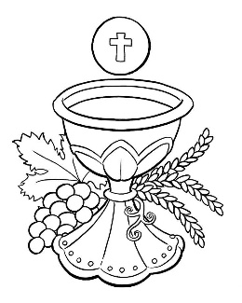
SUNDAY MASS TIMES
Saturday 6.00pm St. Patrick’s church
9.30am Christ the King church
11.00am St. Patrick’s church
WEEKDAY LITURGIES
Tuesday 10.00am Christ the King
Wednesday 10.00am St. Patrick’s
Thursday: 10.00am Christ the King
Friday: 10.00am St. Patrick’s
SACRAMENT OF RECONCILIATION any time on request
MASS INTENTIONS RECEIVED: Special Intention, Graham and Teresa Newman (Anni.), William and Mary Green (Anni.), Kath Donegan (Anni. 16th December),
ANNIVERSARIES December 4th – 10th:
Bruce Peirson, Susan Hart, Syd Elsey, Philip Donoghue, Mary Ellen Green, Raymond Crawford, Anne Lenehan,
Winifred Duffy, Denis Saunders, Elizabeth Jones, Maurice Edward Breckon.
PLEASE REMEMBER in your prayers all our sick and housebound brothers and sisters.
The word this week
Isaiah 11:1–10 The wolf shall be a guest of the lamb.
Psalm 71 (72) “In his days justice shall flourish in his time, and peace till the moon fails.’
Romans 15:4–9 God, the source of patience, enables us to live in harmony.
Matthew 3:1–12 Prepare the way of the Lord!
T
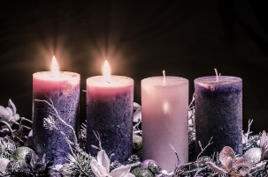
hroughout the first three weeks of Advent our focus is very clearly on the End of Time, and the Second Coming of the Lord - not on the run up to Christmas (that only comes in the last week). If we view Advent as a Season preparing for Christmas these readings will make little sense - and neither will the figure of John the Baptist who appears today: if it was about the preparation for Christmas, then John the Baptist, preaching after Jesus was born, becomes a confusing figure: his role is to preach to us, as he did of old, and to prepare us for the (second) coming of the Lord. Everything gets more specific today. What is being preached is not an event, but a person. Isaiah promises him, John welcomes him, Paul invites us to imitate him. We have here a thumbnail portrait of the Messiah – useful to refer to when we get to Christmas and he is revealed as a child in a manger!
AT MASS TODAY WE PRAY Eucharistic Prayer 1 for Reconciliation and Preface 1 for Advent
Isaiah has given us a glimpse of God’s holy mountain, where true justice reigns. In the mystery of the liturgy, we catch a glimpse of that holy mountain. At this table we receive a mere foretaste of the riches waiting for those who long for God’s revelation.
ROSARY AND ADORATION: The Rosary will be prayed at Christ the King church on Tuesdays at 9.00am followed by Exposition of The Blessed Sacrament until 9.50am
RECENTLY DECEASED: Please remember in your prayers Judith Ann Darbyshire, aged77, from Thornaby, who died recently. Her Funeral Service will take place at Christ the King church on Tuesday, December 13th at 10.00am.
May she rest in peace.
PARISH SACRAMENT OF RECONCILIATION SERVICE FOR ADVENT:
At Christ the King church on Monday, December 12th, at 6.30pm
At St. Patrick’s church on Wednesday, December 14th, at 10.00am before the start of Mass
TEA/COFFEE ETC after Sunday morning Mass at Christ the King and St. Patrick’s
CHRIST THE KING CHRISTMAS PARTY this Saturday, December 10th, 1pm – 4pm. Tickets on sale £5.00
MEMORIAL GARDEN AT ST PATRICK'S CATHOLIC COLLEGE:
As you know, our Memorial Garden at the College was blessed earlier this month. We would like to thank the Parishioners who attended this service, it was lovely to open our doors once more to receive visitors.
For those parishioners who would like to add the names of any loved ones who have died recently to our memorial benches please advise the name, year of birth and year of death. We are asking for a donation of £1 per name (or whatever you would like to give) for the upkeep of the garden and the plaques. Thank you for your continued support and prayers.

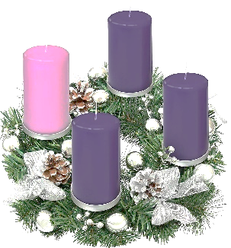
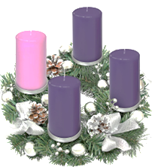
MASS TIMES FOR CHRISTMAS
Christmas Eve, Saturday, December 24th 5.00pm at St. Patrick’s church
Christmas Eve, Saturday, December 24th 7.00pm at Christ the King church
Christmas Day, Sunday, December 25th 10.30am at St. Patrick’s church

Second Sunday of Advent (A)
December 4th, 2022

First reading Isaiah 11:1-10

A shoot springs from the stock of Jesse, a scion thrusts from his roots:
on him the spirit of the Lord rests, a spirit of wisdom and insight, a spirit of counsel and power,
a spirit of knowledge and of the fear of the Lord. (The fear of the Lord is his breath.)
He does not judge by appearances, he gives no verdict on hearsay, but judges the wretched with integrity,
and with equity gives a verdict for the poor of the land.
His word is a rod that strikes the ruthless, his sentences bring death to the wicked.
Integrity is the loincloth round his waist, faithfulness the belt about his hips.
The wolf lives with the lamb, the panther lies down with the kid, calf and lion feed together, with a little boy to lead them.
The cow and the bear make friends, their young lie down together.
The lion eats straw like the ox.
The infant plays over the cobra’s hole; into the viper’s lair the young child puts his hand.
They do no hurt, no harm, on all my holy mountain,
for the country is filled with the knowledge of the Lord as the waters swell the sea.
That day, the root of Jesse shall stand as a signal to the peoples.
It will be sought out by the nations and its home will be glorious.

Second reading Romans 15:4-9

Everything that was written long ago in the scriptures was meant to teach us something about hope from the examples scripture gives of how people who did not give up were helped by God. And may he who helps us when we refuse to give up, help you all to be tolerant with each other, following the example of Christ Jesus, so that united in mind and voice you may give glory to the God and Father of our Lord Jesus Christ.
It can only be to God’s glory, then, for you to treat each other in the same friendly way as Christ treated you. The reason Christ became the servant of circumcised Jews was not only so that God could faithfully carry out the promises made to the patriarchs, it was also to get the pagans to give glory to God for his mercy, as scripture says in one place: For this I shall praise you among the pagans and sing to your name.

Gospel Acclamation
Alleluia, alleluia!
Prepare a way for the Lord,
make his paths straight,
and all mankind shall see the salvation of God.
Alleluia!

Gospel Reading Matthew 3:1-12

In due course John the Baptist appeared; he preached in the wilderness of Judaea and this was his message: ‘Repent, for the kingdom of heaven is close at hand.’ This was the man the prophet Isaiah spoke of when he said:
A voice cries in the wilderness:
Prepare a way for the Lord,
make his paths straight.
This man John wore a garment made of camel-hair with a leather belt round his waist, and his food was locusts and wild honey. Then Jerusalem and all Judaea and the whole Jordan district made their way to him, and as they were baptised by him in the river Jordan they confessed their sins. But when he saw a number of Pharisees and Sadducees coming for baptism he said to them, ‘Brood of vipers, who warned you to fly from the retribution that is coming? But if you are repentant, produce the appropriate fruit, and do not presume to tell yourselves, “We have Abraham for our father,” because, I tell you, God can raise children for Abraham from these stones. Even now the axe is laid to the roots of the trees, so that any tree which fails to produce good fruit will be cut down and thrown on the fire. I baptise you in water for repentance, but the one who follows me is more powerful than I am, and I am not fit to carry his sandals; he will baptise you with the Holy Spirit and fire. His winnowing-fan is in his hand; he will clear his threshing-floor and gather his wheat into the barn; but the chaff he will burn in a fire that will never go out.’

