Postal address:
Christ the King Church
Trenchard Avenue
TS17 0EG
www.ctkthornaby.co.uk
St Patrick’s Church
Westbury Street
TS17 6NW
www.stpatrickschurch.co.uk
Christ the King House
Trenchard Avenue, Thornaby.
TS17 0EG
T: 01642 750467
Email: thornaby@rcdmidd.org.uk

13th Sunday of the Year (A) July 2nd, 2023
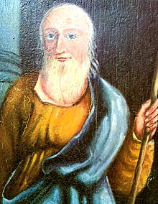
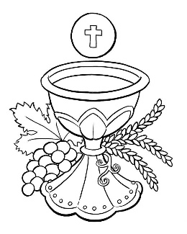
SUNDAY MASS TIMES
Saturday 6.00pm St. Patrick’s church
Sunday 9.30am Christ the King church
Sunday 11.00am St. Patrick’s church WEEKDAY LITURGY TIMES
Tuesday 10.00am Christ the King
Wednesday 10.00am St. Patrick’s
Thursday: 10.00am Christ the King
Friday: 10.00am St. Patrick’s
Nicholas Postgate
MASS INTENTIONS RECEIVED: Special Intention, Sarah and Morgan Jones (Anni.), Billy Goldsmith (2nd Anni),
ANNIVERSARIES: July 2nd – July 8th:
John Herrity, Helen Mills, Jane Elizabeth Cummings, Sarah Jones, Sister Mary Leonora Major, Florence Jones,
Nance Jones, Raymond Garthwaite, Patrick Joseph Hopkins, Amabile (Jim) Borg, Catherine Ann Shutt, Norman Baker,
John Bainbridge, Diane Sutcliffe, William James Glen Goldsmith.
PLEASE REMEMBER in your prayers all our sick and housebound brothers and sisters.

The word this week
2 Kings 4:8–11, 14–16 Genuine hospitality is highly praised.
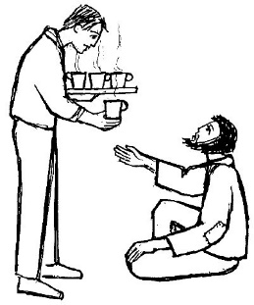
Psalm 88 I will sing for ever of your love, O Lord.
Romans 6:3–4, 8–11 We must consider ourselves dead to sin.
Matthew 10:37–42 Whoever does not take up the cross is not worthy of Christ
Three times in today’s Gospel Jesus explains how someone can receive a reward. Sounds great, right? In the first reading, a kind and generous woman receives an awesome reward from God for her hospitality to the prophet Elisha. The psalmist sings of the goodness of the Lord. Our greatest reward, though, has already been given to us. As Paul tells the Romans, when we are baptized into Christ, we are baptized into both his death and his new life. Let us listen for what Jesus asks us to do for his sake to receive our reward.
AT MASS TODAY WE PRAY Eucharistic Prayer 2 and Preface 5 for Sundays
Aware of the Lord’s call to embrace his cross once again, let us offer this great prayer of thanksgiving, which recounts for us the death and resurrection of Christ.

RAFFLE AT ST. PATRICK’S: Xavier & Martha Woodgate are raising money for sports equipment at St Patrick’s Primary School and they are holding a raffle in the church porch this weekend. Tickets are £1 per strip and the winners will be drawn in the Parish Hall after Sunday Mass today.

BEREAVEMENT GROUP will meet this Wednesday, July 5th, at 7.00pm in Christ the King Hall. All welcome.
FIRST HOLY COMMUNION CERTIFICATES will be given out today at Sunday Mass in both Christ the King and St. Patrick’s. It is Blessed Nicholas Postgate Day today and as all Catholic Schools on Teesside and North Yorkshire are in
The Nicholas Postgate Academy Trust it is appropriate to give out these Certificates today.
“POSTGATE RALLY” takes place this afternoon, July 2nd, in Egton Bridge. Mass outdoors begins 3.00pm

DONATIONS TO TEESSIDE HOSPICE IN MEMORY OF JULIA GALLAGHER: Fund raising event at Christ the King Hall recently - £1,450. Donations - £300. Total - £1,750. Funeral Day Collection for Teesside Hospice £2,000

BLESSING
May the God of all consolation bless you in every way and grant you peace all the days of your life. Amen.
May he free you from all anxiety and strengthen your hearts in his love. Amen.
May he enrich you with his gifts of faith, hope, and love, so that what you do in this life
will bring you to the happiness of everlasting life. Amen.

13th Sunday in Ordinary Time (A)
June 25th, 2023

First reading 2 Kings 4:8-11,13-16

One day as Elisha was on his way to Shunem, a woman of rank who lived there pressed him to stay and eat there. After this he always broke his journey for a meal when he passed that way. She said to her husband, ‘Look, I am sure the man who is constantly passing our way must be a holy man of God. Let us build him a small room on the roof, and put him a bed in it, and a table and chair and lamp; whenever he comes to us he can rest there.’ One day when he came, he retired to the upper room and lay down. ‘What can be done for her then?’ he asked. Gehazi, his servant, answered, ‘Well, she has no son and her husband is old.’ Elisha said, ‘Call her.’ The servant called her and she stood at the door. This time next year,’ he said ‘you will hold a son in your arms.’

Second reading Romans 6:3-4,8-11

When we were baptised in Christ Jesus we were baptised in his death; in other words, when we were baptised we went into the tomb with him and joined him in death, so that as Christ was raised from the dead by the Father’s glory, we too might live a new life.
But we believe that having died with Christ we shall return to life with him: Christ, as we know, having been raised from the dead will never die again. Death has no power over him any more. When he died, he died, once for all, to sin, so his life now is life with God; and in that way, you too must consider yourselves to be dead to sin but alive for God in Christ Jesus.

Gospel Acclamation
Alleluia, alleluia!
Open our heart, O Lord,
to accept the words of your Son.
Alleluia!

Gospel Reading Matthew 10:37-42

Jesus instructed the Twelve as follows: ‘Anyone who prefers father or mother to me is not worthy of me. Anyone who prefers son or daughter to me is not worthy of me. Anyone who does not take his cross and follow in my footsteps is not worthy of me. Anyone who finds his life will lose it; anyone who loses his life for my sake will find it.
‘Anyone who welcomes you welcomes me; and those who welcome me welcome the one who sent me.
‘Anyone who welcomes a prophet will have a prophet’s reward; and anyone who welcomes a holy man will have a holy man’s reward.
‘If anyone gives so much as a cup of cold water to one of these little ones because he is a disciple, then I tell you solemnly, he will most certainly not lose his reward.’

