Postal address:
Christ the King Church
Trenchard Avenue
TS17 0EG
www.ctkthornaby.co.uk
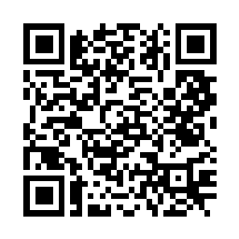
St Patrick’s Church
Westbury Street
TS17 6NW
www.stpatrickschurch.co.uk
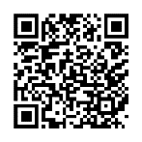
Christ the King House
Trenchard Avenue
TS17 0EG
T: 01642 750467
Email: thornaby@rcdmidd.org.uk

Feast of Mary, Mother of God January 1st, 2023
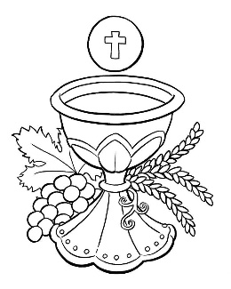
SUNDAY MASS TIMES
Saturday 6.00pm St. Patrick’s church
Sunday 9.30am Christ the King church
Sunday 11.00am St. Patrick’s church
WEEKDAY LITURGY TIMES
Tuesday 10.00am Christ the King
Wednesday 10.00am St. Patrick’s
Thursday: 11.00am St. Patrick’s (Funeral Service)
Thursday 6.00pm St. Patrick’s
Friday: 10.00am St. Christ the King
SACRAMENT OF RECONCILIATION any time on request
MASS INTENTIONS RECEIVED: Special Intention,
ANNIVERSARIES December 1st – 7th:
Martin Bainbridge, Samuel Butler, Mildred Smith, Cordelia Calder, Sheila Loveday Huggins, Mark Anderson, Frederick Middleton, Julia Elliott, Geraldine Cassidy, Patrick Duffy, Luke Williamson, David Frederick Harding, Henry Crossley, Eileen George, Fred Curtis, Maggie O'Donnell, Jim Machin, Joseph Brennan, Vincent Lawrence, James Duffy, Alice O'Neill, Peter McNamee, Joseph Mallon, Clifford Jordan, John Patrick McCallan, Maisie Veronica McReddie, Margaret Mary George, Veronica Kitson, Geraldine Mills.
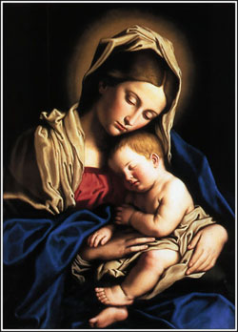
PLEASE REMEMBER in your prayers all our sick and housebound brothers and sisters.
The word this week
Numbers 6:22–27 The Lord bless you and keep you!
Psalm 66 ‘O God, be gracious and bless us.’
Galatians 4:4–7 We, too, are the sons and daughters of God.
Luke 2:16–21 Mary reflected on all these things in her heart.
A
s the new year dawns, we realize the blessings that we have been given. God blesses the Chosen People as they invoke God’s name. We are blessed as daughters and sons of God, able to call God, “Abba, Father!” Like the shepherds, who heard the message of the angels and went to find the word made flesh, let us listen to the word of God, then go forth praising and glorifying God.
AT MASS TODAY WE PRAY Eucharistic Prayer 2 for Reconciliation and Preface 2 of The Blessed Virgin Mary
In the company of the shepherds, the angels, and holy Mary, Mother of God, we give thanks and praise to God around this holy table.
RECENTLY DECEASED: Please remember in your prayers Constance (Connie) Rose Good, aged 74, from Thornaby, who died recently. Her Funeral Service will take place at St. Patrick’s church on Thursday, January 5th, at 11.00am. ALSO, Mr. John Scott, aged 75, from Thornaby, who died recently. His Funeral Service will take place at Christ the King church on Thursday, January 12th, at 10.00am. ALSO, Mr. Peter Willey, aged 61, from near Lincoln who died recently.
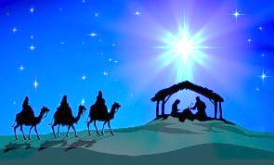
ALSO, Mary Allinson, aged 94, from Thornaby, who died on Thursday. No Funeral arrangements just yet. May they rest in peace.
FEAST OF THE EPIPHANY OF THE LORD
This Friday, January 6th, is the Feast of the Epiphany of the Lord and is a Holy Day.
Mass times are: Thursday 6.00pm at St. Patrick’s church
Friday 10.00am at Christ the King church
I.T. DIGITAL DEVICES – URGENTLY NEEDED, working or not – laptops, phones, tablets etc. If you have any devices you no longer need, they can be put to good use by disadvantaged families and children. Please contact Yacouba Traore on 07840 165462.
BLESSING FOR THE NEW YEAR
May God, the source and origin of all blessing grant you grace, pour out his blessing in abundance, and keep you safe from harm throughout this New Year. AMEN
May he give you integrity in the faith, endurance in hope, and perseverance in charity with holy patience to the end. AMEN
May he order your days and your deeds in his peace,
grant your prayers in this and in every place, and lead you happily to eternal life. AMEN

SOLEMNITY OF MARY, MOTHER OF GOD
January 1st, 2023

First reading Numbers 6:22-27

The Lord spoke to Moses and said, ‘Say this to Aaron and his sons: “This is how you are to bless the sons of Israel. You shall say to them:
May the Lord bless you and keep you.
May the Lord let his face shine on you and be gracious to you.
May the Lord uncover his face to you and bring you peace.”
This is how they are to call down my name on the sons of Israel, and I will bless them.’

Second reading Galatians 4:4-7

When the appointed time came, God sent his Son, born of a woman, born a subject of the Law, to redeem the subjects of the Law and to enable us to be adopted as sons. The proof that you are sons is that God has sent the Spirit of his Son into our hearts: the Spirit that cries, ‘Abba, Father’, and it is this that makes you a son, you are not a slave any more; and if God has made you son, then he has made you heir.

Gospel Acclamation
Alleluia, alleluia!
At various times in the past and in various different ways,
God spoke to our ancestors through the prophets;
but in our own time, the last days,
he has spoken to us through his Son.
Alleluia!

Gospel Reading Luke 2:16-21

The shepherds hurried away to Bethlehem and found Mary and Joseph, and the baby lying in the manger. When they saw the child they repeated what they had been told about him, and everyone who heard it was astonished at what the shepherds had to say. As for Mary, she treasured all these things and pondered them in her heart. And the shepherds went back glorifying and praising God for all they had heard and seen; it was exactly as they had been told.
When the eighth day came and the child was to be circumcised, they gave him the name Jesus, the name the angel had given him before his conception.

