Postal address:
Christ the King Church
Trenchard Avenue
TS17 0EG
www.ctkthornaby.co.uk
St Patrick’s Church
Westbury Street
TS17 6NW
www.stpatrickschurch.co.uk
Christ the King House
Trenchard Avenue, Thornaby.
TS17 0EG
T: 01642 750467
Email: thornaby@rcdmidd.org.uk

14th Sunday of the Year (A) July 9th, 2023
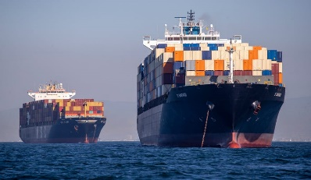
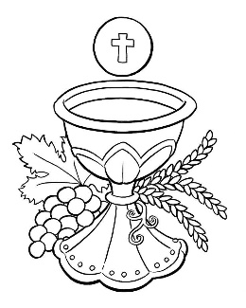
SUNDAY MASS TIMES
Saturday 6.00pm St. Patrick’s church
Sunday 9.30am Christ the King church
Sunday 11.00am St. Patrick’s church WEEKDAY LITURGY TIMES
Tuesday 10.00am Christ the King
Wednesday 4.00pm Lady Chapel, Osmotherley
Thursday: 10.00am Christ the King
Friday: 10.00am St. Patrick’s
MASS INTENTIONS RECEIVED: Special Intention, Kathleen Gibson (Anni.), In Thanksgiving,
ANNIVERSARIES: July 9th – 15th:
Margaret Presgrave, James Patrick Hammill, Clara Burrell, Martin Donegan, Thomas Lapsley, Patricia Nolan,
Mary Fitzpatrick, Santino Palleschi, Perla Valdez Delafu, Emma Crossen, Maureen Heslop, Frank Speight, Craig Scott,
James Crudas Leach, John Henry George, Mary Kathleen Good, Agnes Jones, Anthony Evans, Kathleen Gibson,
PLEASE REMEMBER in your prayers all our sick and housebound brothers and sisters.
The word this week
Zechariah 9:9–10 Our Saviour is a peacemaker, who rules to the ends of the earth.
Psalm 145 ‘I will bless your name for ever, O God, my King.’
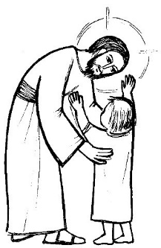
Romans 8:9, 11–13 Whoever does not have the Spirit of Christ does not belong to him.
Matthew 11:25–30 Take my yoke upon you and learn from me.
Z
echariah prophesies the Messiah coming as a peacemaker, not as a warrior, in today’s first reading, setting the stage for a saviour who reigns with mercy and kindness. Paul tells the Romans that the very Spirit of God dwells in us. Today’s Gospel in an answer to a very simple question: who is this Jesus we follow? What is he like? He tells us himself: he is gentle, and humble of heart. There is a simplicity about this Gospel which speaks very clearly to tired hearts. Indeed, it is often the case that we overlook the simplicity of the Gospel message – which is why it is valuable to be as children, constantly wondering and marvelling at the beauty and fascination of Jesus. How much God must love us: the message of salvation is so easy to receive, the promise is so welcome. This is a Sunday to wallow in the wonder of a God who is ‘kind and full of compassion.’
AT MASS TODAY WE PRAY Eucharistic Prayer 2 and Preface 4 for Sundays
Just as the Lord Jesus lifted his voice in praise to his heavenly Father, so too do we now raise our voices to the Father in an endless prayer of praise and thanksgiving.
LEAVERS MASSES: Mass on Thursday morning will be Leavers Mass for Christ the King pupils.
Mass on Friday morning will be Leavers Mass for St. Patrick’s pupils.
Mass on Wednesday is at The Lady Chapel, Osmotherley, 4.00pm, for the Staff of St. Patrick’s Primary School.
Parishioners very welcome at these Masses.

THE NATIONAL GRANDPARENTS' PILGRIMAGE takes place in Walsingham on Sunday July 23rd, the World Day for Grandparents and the Elderly. All are welcome for this celebration of family and faith through the generations. The Bishop of Northampton, David Oakley, will be the principal. Visit catholicgrandparentsassociation.org for more information.
“SEA SUNDAY”: This Sunday, July 9th, is “Sea Sunday” when we particularly remember and pray for all Seafarers and Fishers at Sea. A RETIRING COLLECTION will be taken at all Masses this weekend for the works of Stella Maris.

RAFFLE AT ST. PATRICK’S: Thank you to all who supported the raffle last week at St Patrick’s. Xavier and Martha took £400 into the school to help towards sports provision. A full list of winners is pinned to the notice board in the St. Patrick’s church porch.
“THANK YOU” to all Parishioners who gave various items such as household goods, furniture etc, in a recent appeal.
The benefactor wishes the say ‘Thank you’ for your kindness. (Bridie Hope)

14th Sunday in Ordinary Time (A)
July 9th, 2023

First reading Zechariah 9:9-10

The Lord says this:
Rejoice heart and soul, daughter of Zion!
Shout with gladness, daughter of Jerusalem!
See now, your king comes to you;
he is victorious, he is triumphant,
humble and riding on a donkey,
on a colt, the foal of a donkey.
He will banish chariots from Ephraim
and horses from Jerusalem;
the bow of war will be banished.
He will proclaim peace for the nations.
His empire shall stretch from sea to sea,
from the River to the ends of the earth.

Second reading Romans 8:9,11-13

Your interests are not in the unspiritual, but in the spiritual, since the Spirit of God has made his home in you. In fact, unless you possessed the Spirit of Christ you would not belong to him, and if the Spirit of him who raised Jesus from the dead is living in you, then he who raised Jesus from the dead will give life to your own mortal bodies through his Spirit living in you.
So then, my brothers, there is no necessity for us to obey our unspiritual selves or to live unspiritual lives. If you do live in that way, you are doomed to die; but if by the Spirit you put an end to the misdeeds of the body you will live.

Gospel Acclamation
Alleluia, alleluia!
Blessed are you, Father,
Lord of heaven and earth,
for revealing the mysteries of the kingdom
to mere children.
Alleluia!

Gospel Reading Matthew 11:25-30

Jesus exclaimed, ‘I bless you, Father, Lord of heaven and of earth, for hiding these things from the learned and the clever and revealing them to mere children. Yes, Father, for that is what it pleased you to do. Everything has been entrusted to me by my Father; and no one knows the Son except the Father, just as no one knows the Father except the Son and those to whom the Son chooses to reveal him.
‘Come to me, all you who labour and are overburdened, and I will give you rest. Shoulder my yoke and learn from me, for I am gentle and humble in heart, and you will find rest for your souls. Yes, my yoke is easy and my burden light.’

