Postal address:
Christ the King Church
Trenchard Avenue
TS17 0EG
www.ctkthornaby.co.uk
St Patrick’s Church
Westbury Street
TS17 6NW
www.stpatrickschurch.co.uk
Christ the King House
Trenchard Avenue, Thornaby.
TS17 0EG
T: 01642 750467
Email: thornaby@rcdmidd.org.uk

THE TRANSFIGURATION OF THE LORD August 6th, 2023

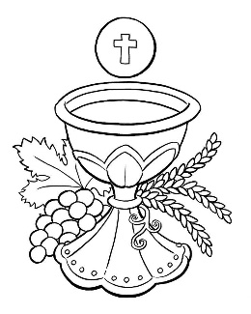
SUNDAY MASS TIMES

Sunday 9.30am Christ the King church
Sunday 11.00am St. Patrick’s church WEEKDAY LITURGY TIMES
Tuesday No liturgy
Wednesday No liturgy
Thursday: No liturgy
Friday: No liturgy
MASS INTENTIONS RECEIVED: Special Intention,

ANNIVERSARIES: August 6th – 12th:
Thomas Darragh, John Leonard, Joseph Frew, Betty Rafferty, James McQueeney (formerly Kevin James Brear),
Louisa Kelly, Susan Ritchie, Martin Ruddy, Veronica Bradley, Albert Kelly, Robert Leonard, Andrew Lynch,
Nicholas Confrey Ward, John Patrick Corr, Peter William Lynd.

PLEASE REMEMBER in your prayers all our sick and housebound brothers and sisters.
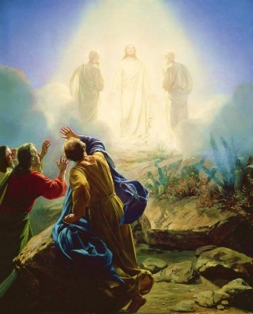
The word this week
Daniel 7:9–10, 13–14 Daniel sees One like a Son of man.
Psalm 97 The Lord is king, most high above all the earth’.
2 Peter 1:16–19 The beloved, in whom God is well pleased
Matthew 17:1–9 The beloved, in whom God is well pleased.
T
oday we hear three different accounts of the Transfiguration. The apocalyptic vision in Daniel foreshadows the event, featuring many of the same elements: clothing as bright as snow, clouds from heaven, and the Son of man. The author of the second letter of Peter writes as an eyewitness to the event. Matthew gives a descriptive account of that day. Let us heed Peter’s words and be attentive to God’s word and this prophetic message.

AT MASS TODAY WE PRAY Eucharistic Prayer 2 and Preface 4 for Sundays
Jesus is transformed before the eyes of the disciples. These simple gifts are spread before us. In joy we give thanks this day and pray for a transformation of these gifts as well as our lives.

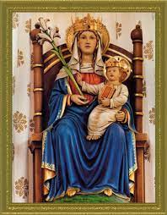
TODAY WE CELEBRATE THE FEAST OF THE TRANSFIGURATION, remembering the day when Jesus was transfigured before the eyes of his closest disciples. On that day, our Lord’s glory shone through him like the sun, his whole being shining with light. We recall that on the first day of creation, God transformed the world with light. Let us join Peter, James, and John on this holy mountain, where Jesus, who dwells within us, transforms every darkness in our lives to light.
ANNUAL DIOCESAN PILGRIMAGE TO WALSINGHAM is on Saturday, September 30th until Sunday October 1st.
If anyone would like a booking form, please contact Dawn Cummings at admin@rcdmidd.org.uk
PLEASE NOTE: NO SATURDAY EVENING MASS AUGUST 5th AND 12th.
Back to normal again on Saturday, August 19th.
NEW FUN DANCE CLASS in St. Patrick’s Parish Hall on Mondays and Wednesdays 6.00pm – 6.45pm. £6 per class

BLESSING
May the God of all consolation order your days in his peace and grant you the gifts of his blessing. Amen.
May he free you always from every distress and confirm your hearts in his love. Amen.
So that on this life’s journey you may be effective in good works,
rich in the gifts of hope, faith and charity, and may come happily to eternal life. Amen.
WELCOME TO FR. BILL RYAN: We warmly welcome back Fr. Bill Ryan this weekend and next to Celebrate the Eucharist with you here in Thornaby. He spent many years in St. Patrick’s from the late 1960s
until 1981. Now in retirement, he makes himself available to help out when needed. Thank you, Fr. Bill.

THE TRANSFIGURATION OF THE LORD (A)
August 6th, 2023

First reading Daniel 7:9-10, 13-14

As I watched:
Thrones were set up and the Ancient One took his throne.
His clothing was bright as snow, and the hair on his head as white as wool;
his throne was flames of fire, with wheels of burning fire.
A surging stream of fire flowed out from where he sat;
Thousands upon thousands were ministering to him, and myriads upon myriads attended him.
The court was convened and the books were opened.
As the visions during the night continued, I saw:
One like a Son of man coming, on the clouds of heaven;
When he reached the Ancient One and was presented before him,
The one like a Son of man received dominion, glory, and kingship;
all peoples, nations, and languages serve him.
His dominion is an everlasting dominion that shall not be taken away, his kingship shall not be destroyed.

Second reading 2 Pt 1:16-19

Beloved:
We did not follow cleverly devised myths
when we made known to you
the power and coming of our Lord Jesus Christ,
but we had been eyewitnesses of his majesty.
For he received honour and glory from God the Father
when that unique declaration came to him from the majestic glory,
"This is my Son, my beloved, with whom I am well pleased."
We ourselves heard this voice come from heaven
while we were with him on the holy mountain.
Moreover, we possess the prophetic message that is altogether reliable.
You will do well to be attentive to it,
as to a lamp shining in a dark place,
until day dawns and the morning star rises in your hearts.

Gospel Acclamation
Alleluia, alleluia!
This is my Son, the Beloved
he enjoys my favour;
listen to him
Alleluia!

Gospel Reading Matt 17:1-9

Jesus took Peter, James, and his brother John, and led them up a high mountain by themselves.
And he was transfigured before them;
his face shone like the sun and his clothes became white as light.
And behold, Moses and Elijah appeared to them, conversing with him.
Then Peter said to Jesus in reply,
“Lord, it is good that we are here. If you wish, I will make three tents here, one for you, one for Moses, and one for Elijah.”
While he was still speaking, behold, a bright cloud cast a shadow over them, then from the cloud came a voice that said,
“This is my beloved Son, with whom I am well pleased; listen to him.”
When the disciples heard this, they fell prostrate and were very much afraid.
But Jesus came and touched them, saying, “Rise, and do not be afraid.”
And when the disciples raised their eyes, they saw no one else but Jesus alone.

As they were coming down from the mountain, Jesus charged them,
“Do not tell the vision to anyone until the Son of Man has been raised from the dead.”

