Postal address:
Christ the King Church
Trenchard Avenue
TS17 0EG
www.ctkthornaby.co.uk
St Patrick’s Church
Westbury Street
TS17 6NW
www.stpatrickschurch.co.uk
Christ the King House
Trenchard Avenue, Thornaby.
TS17 0EG
T: 01642 750467
Email: thornaby@rcdmidd.org.uk

2nd Sunday of Advent (B) December 10th 2023
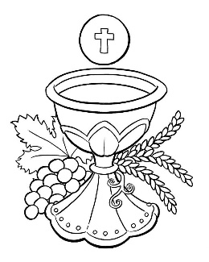
SUNDAY MASS TIMES
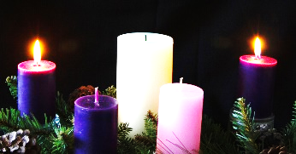
Saturday 6.00pm St. Patrick’s church
Sunday 9.30am Christ the King church
Sunday 11.00am St. Patrick’s church
WEEKDAY LITURGY TIMES
Tuesday 10.00am Christ the King
Wednesday 10.00am St. Patrick’s
Thursday 10.00am Christ the King
Friday 10.00am St. Patrick’s
MASS INTENTIONS RECEIVED: Special Intention, Stan Elsey, James and Catherine Dick and family, Paul and Patricia Dick.
ANNIVERSARIES: December 10th – 16th:
Denis Saunders, Elizabeth Jones, Maurice Edward Breckon, John Heatley, Denis Pybus, David Alfred Frost, Roland Robson, Dorothy Turner, Teresa Waine, William Purvis (Jnr.), Pat Nolan, Cissie Middleton, Mary Jones, Sean Joseph Merrick, Paul McNamara, Jim Crossen, Eleanor Ferguson, Enid Johnston, James Devlin, Bill Allan, John David Haycock (Jnr.), David Arthur Thwaites, Catherine Maleary, Margaret Morgan, Kathleen Mary Donegan.

PLEASE REMEMBER in your prayers all our sick and housebound brothers and sisters.
The word this week
Isaiah 40:1–5, 9–11 Console my people, console them.
Psalm 84 Let us see, O Lord, your mercy, and give us your saving help.
2 Peter 3:8–14 We await new heavens and a new earth.
Mark 1:1–8 Make straight the paths of the Lord.
T
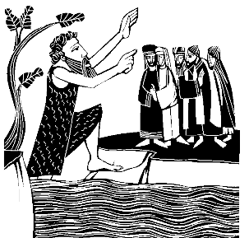
hroughout the first three weeks of Advent our focus is very clearly on the Second Coming of the Lord - not so much on the run up to Christmas (until the last week). If we view Advent as a preparation for Christmas these readings will make little sense - and neither will the figure of John the Baptist who appears today: if it’s about the preparation for Christmas, then John the Baptist, preaching after Jesus was born, is a confusing figure: but his role is to preach to us, as he did of old, and to prepare us for the (second) coming of the Lord. Today we have a very graphic reference to the end of time and the Second Coming in the reading from Saint Peter; it is a frightening picture, and so the first reading offers tender words of comfort to help us understand who is coming, and why we should be ready to meet him.
AT MASS TODAY WE PRAY Eucharistic Prayer 2 and Preface 1 for Advent
Each week the heavens open, and the Lord Jesus is made present on this sacred table. With hearts eager for his coming, we lift our prayer of thanksgiving.
ST PATRICK’S PARISH AND PRIMARY SCHOOL will be hosting a joint Christmas Concert in the church on Wednesday, 20th December, at 6pm. Everybody is most welcome. There will be a children’s tombola in the church porch beforehand and refreshments in the hall afterwards.
CHRISTMAS LUNCH AT “THE GRIFFIN” this Saturday, 16th December, please arrive after 12.30pm for lunch at 1.00

PASTORAL LETTER from Bishop Terry Drainey to be read at all Masses this weekend on the Second Sunday of Advent
MASS TIMES FOR CHRISTMAS
Christmas Eve, Sunday, December 24th 5.00pm at St. Patrick’s Church
Christmas Eve, Sunday, December 24th 7.00pm at Christ the King Church
Christmas Day, Monday, December 25th 10.30am at St. Patrick’s Church

CHRISTMAS HAMPERS 2023: Big ‘Thank you’ to everyone who contributed to Hampers for needy people this Christmas.
A huge amount of very valuable and useful items have been generously given as well as a lot of money that will be used to help fill in the gaps in the Hampers. Liz Maw, Thank you for spearheading this amazing effort and all your “Elves” for all they do as well.
Second Sunday of Advent (B)
December 10th, 2023

First reading Isaiah 40:1-5,9-11

‘Console my people, console them’ says your God.
‘Speak to the heart of Jerusalem and call to her that her time of service is ended, that her sin is atoned for,
that she has received from the hand of the Lord double punishment for all her crimes.’
A voice cries, ‘Prepare in the wilderness a way for the Lord.
Make a straight highway for our God across the desert.
Let every valley be filled in, every mountain and hill be laid low.
Let every cliff become a plain, and the ridges a valley;
then the glory of the Lord shall be revealed and all mankind shall see it;
for the mouth of the Lord has spoken.’
Go up on a high mountain, joyful messenger to Zion.
Shout with a loud voice, joyful messenger to Jerusalem.
Shout without fear, say to the towns of Judah,
‘Here is your God.’
Here is the Lord coming with power, his arm subduing all things to him.
The prize of his victory is with him, his trophies all go before him.
He is like a shepherd feeding his flock, gathering lambs in his arms,
holding them against his breast and leading to their rest the mother ewes.

Second reading 2 Peter 3:8-14

There is one thing, my friends, that you must never forget: that with the Lord, ‘a day’ can mean a thousand years, and a thousand years is like a day. The Lord is not being slow to carry out his promises, as anybody else might be called slow; but he is being patient with you all, wanting nobody to be lost and everybody to be brought to change his ways. The Day of the Lord will come like a thief, and then with a roar the sky will vanish, the elements will catch fire and fall apart, the earth and all that it contains will be burnt up.
Since everything is coming to an end like this, you should be living holy and saintly lives while you wait and long for the Day of God to come, when the sky will dissolve in flames and the elements melt in the heat. What we are waiting for is what he promised: the new heavens and new earth, the place where righteousness will be at home. So then, my friends, while you are waiting, do your best to live lives without spot or stain so that he will find you at peace.

Gospel Acclamation

Alleluia, alleluia!
Prepare a way for the Lord,
make his paths straight,
and all mankind shall see the salvation of God.
Alleluia!

Gospel Reading Mark 1:1-8

The beginning of the Good News about Jesus Christ, the Son of God. It is written in the book of the prophet Isaiah:
Look, I am going to send my messenger before you;
he will prepare your way.
A voice cries in the wilderness:
Prepare a way for the Lord, make his paths straight.
and so it was that John the Baptist appeared in the wilderness, proclaiming a baptism of repentance for the forgiveness of sins. All Judaea and all the people of Jerusalem made their way to him, and as they were baptised by him in the river Jordan they confessed their sins. John wore a garment of camel-skin, and he lived on locusts and wild honey. In the course of his preaching he said, ‘Someone is following me, someone who is more powerful than I am, and I am not fit to kneel down and undo the strap of his sandals. I have baptised you with water, but he will baptise you with the Holy Spirit.’

