Postal address:
Christ the King Church
Trenchard Avenue
TS17 0EG
www.ctkthornaby.co.uk
St Patrick’s Church
Westbury Street
TS17 6NW
www.stpatrickschurch.co.uk
Christ the King House
Trenchard Avenue, Thornaby.
TS17 0EG
T: 01642 750467
Email: thornaby@rcdmidd.org.uk

FEAST OF CHRIST THE KING (A) November 26th, 2023
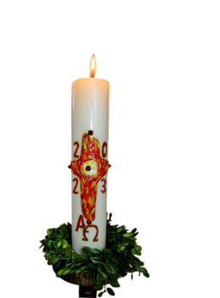
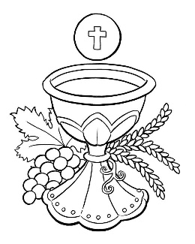
SUNDAY MASS TIMES

Saturday 6.00pm St. Patrick’s church
Sunday 9.30am Christ the King church
Sunday 11.00am St. Patrick’s church
WEEKDAY LITURGY TIMES
Tuesday 10.00am Christ the King
Wednesday 10.00am St. Patrick’s
Thursday 10.00am Christ the King
Friday 10.30am Christ the King “Funeral Mass”
MASS INTENTIONS RECEIVED: Special Intention, Frank Hudson (2nd Anni.), Jimmy McIntosh (48th Anni.) Martin Donegan
ANNIVERSARIES: November 26th – December 2nd:
Jimmy McIntosh, Bridget King, Ernie Jones, Thomas Devine, Charles Elliott, Thomas Hurley, Gladys Lenaghan, Ruth Crawford, Mary Russell, Stan Bradshaw, Lilly Howe, Desmond Vernon, Maria Jane Jones, Elizabeth Leyden, Steve Robinson.
PLEASE REMEMBER in your prayers all our sick and housebound brothers and sisters.
The word this week
Ezekiel 34:11–12, 15–17 The shepherd-king seeks the lost and heals the injured.
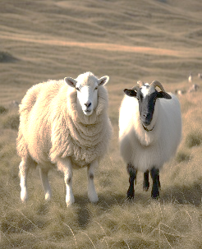
Psalm 23 ‘The Lord is my shepherd; there is nothing I shall want.’
1 Corinthians 15:20–26,28 Christ our king has conquered death.
Matthew 25:31–46 The Lord will come in glory to separate the virtuous from the wicked.
“Shepherd-King o’er mountain steep, homeward guide thy wand’ring sheep.” This hymn which we may sing today captures the readings perfectly: our King is not a cruel tyrant or despot, but a shepherd who loves his flock, who would (and did) give his life for them. Love for the flock means that he will have to judge them, separating the sheep from those who do not belong to him. Coming to the end of the Church’s year leads us to look to our final ending, the homecoming the hymn speaks of. The judgement of the end of time we do not view as a trial or a terror, but as a coming home.
AT MASS TODAY WE PRAY Eucharistic Prayer 3 and Preface for Christ the King
Throughout this month we have rejoiced in the communion of the saints. We are promised that we will share in the heavenly kingdom with them. Let us rejoice together with all the saints living and dead at this our banquet table of the body and blood of Christ.
RECENTLY DECEASED: Please remember in your prayers Mr. Martin Donegan, aged 72, from Thornaby, who died recently. His Funeral Mass will take place this Friday, December 1st, at Christ the King Church at 10.30am. May he rest in peace.
NOVEMBER IS THE MONTH OF THE HOLY SOULS: All Masses offered this month for The Holy Souls.
CHRIST THE KING CHRISTMAS PARTY this Thursday, November 30th, 7.00pm – 10.00pm in Parish Hall.
Buffet Supper and Dessert. Bring your own drinks. Entertainment by Darren G and others. Tickets £10.00
A Blessing
May Christ the universal King guide your steps in the ways of justice, guide your words with his wisdom, and guide your hearts towards his holiness.
May Christ the universal King be your leader, your light, and your peace both now and always.
May Christ the universal King grant this Church people a place in the kingdom he presents to the Father. Amen.
CHRISTMAS HAMPERS 2023: Its that time for sharing where your help is needed to support our local area. Over the years we drive a Christmas hamper and present event. We have raised £30k plus, provided in excess 2000 hampers and over 7k presents for nominated families. Again, we are working to see what can be done in 2023. This year it will take place on 11th December. How can you help us?
Monetary Donations to Christmas Hamper Fundraising, 20-59-43 Account 53294919
Add your name in the reference field or pass to Liz Maw, Mary Goodwin, Fr Pat
Christmas hampers – we need as much food as you can provide. Think of the nice things that you would like at Christmas, sweets, chocolate, crisps, Christmas puddings etc. At the back of Asda, they have a trolley for toys that they are collecting for us
Presents – Mams and dads gifts, children of any age group from baby up over. Please provide new gifts. There is no need to wrap as we have plenty of elves supporting on the day. All need to be in no later than 5th December so we can sort in readiness for the big day.
Feast of Christ the King (A)
November 26th, 2023

First reading Ezekiel 34:11-12,15-17

The Lord says this: I am going to look after my flock myself and keep all of it in view. As a shepherd keeps all his flock in view when he stands up in the middle of his scattered sheep, so shall I keep my sheep in view. I shall rescue them from wherever they have been scattered during the mist and darkness. I myself will pasture my sheep, I myself will show them where to rest – it is the Lord who speaks. I shall look for the lost one, bring back the stray, bandage the wounded and make the weak strong. I shall watch over the fat and healthy. I shall be a true shepherd to them.
As for you, my sheep, the Lord says this: I will judge between sheep and sheep, between rams and he-goats.

Second reading 1 Corinthians 15:20-26,28

Christ has been raised from the dead, the first-fruits of all who have fallen asleep. Death came through one man and in the same way the resurrection of the dead has come through one man. Just as all men die in Adam, so all men will be brought to life in Christ; but all of them in their proper order: Christ as the first-fruits and then, after the coming of Christ, those who belong to him. After that will come the end, when he hands over the kingdom to God the Father, having done away with every sovereignty, authority and power. For he must be king until he has put all his enemies under his feet and the last of the enemies to be destroyed is death, for everything is to be put under his feet. And when everything is subjected to him, then the Son himself will be subject in his turn to the One who subjected all things to him, so that God may be all in all.

Gospel Acclamation

Alleluia, alleluia!
Blessings on him who comes in the name of the Lord!
Blessings on the coming kingdom of our father David!
Alleluia!

Gospel Reading Matthew 25:31-46

Jesus said to his disciples: ‘When the Son of Man comes in his glory, escorted by all the angels, then he will take his seat on his throne of glory. All the nations will be assembled before him and he will separate men one from another as the shepherd separates sheep from goats. He will place the sheep on his right hand and the goats on his left.
‘Then the King will say to those on his right hand, “Come, you whom my Father has blessed, take for your heritage the kingdom prepared for you since the foundation of the world. For I was hungry and you gave me food; I was thirsty and you gave me drink; I was a stranger and you made me welcome; naked and you clothed me, sick and you visited me, in prison and you came to see me.” Then the virtuous will say to him in reply, “Lord, when did we see you hungry and feed you; or thirsty and give you drink? When did we see you a stranger and make you welcome; naked and clothe you; sick or in prison and go to see you?” And the King will answer, “I tell you solemnly, in so far as you did this to one of the least of these brothers of mine, you did it to me.”
‘Next he will say to those on his left hand, “Go away from me, with your curse upon you, to the eternal fire prepared for the devil and his angels. For I was hungry and you never gave me food; I was thirsty and you never gave me anything to drink; I was a stranger and you never made me welcome, naked and you never clothed me, sick and in prison and you never visited me.” Then it will be their turn to ask, “Lord, when did we see you hungry or thirsty, a stranger or naked, sick or in prison, and did not come to your help?” Then he will answer, “I tell you solemnly, in so far as you neglected to do this to one of the least of these, you neglected to do it to me.”
‘And they will go away to eternal punishment, and the virtuous to eternal life.’

