Postal address:
Christ the King Church
Trenchard Avenue
TS17 0EG
www.ctkthornaby.co.uk
St Patrick’s Church
Westbury Street
TS17 6NW
www.stpatrickschurch.co.uk
Christ the King House
Trenchard Avenue, Thornaby.
TS17 0EG
T: 01642 750467
Email: thornaby@rcdmidd.org.uk

2nd Sunday of the Year (B) January 14th, 2024
SUNDAY MASS TIMES
Saturday 6.00pm St. Patrick’s church
Sunday 9.30am Christ the King church
Sunday 11.00am St. Patrick’s church

WEEKDAY LITURGY TIME
Tuesday 10.00am Christ the King
Wednesday 10.00am St. Patrick’s
Thursday 10.00am Christ the King
Friday No Mass (Funeral Service at Stockton Crematorium)
MASS INTENTIONS RECEIVED: Special Intention, Jim Goodwin (Anni),
ANNIVERSARIES: January 14th – 20th:
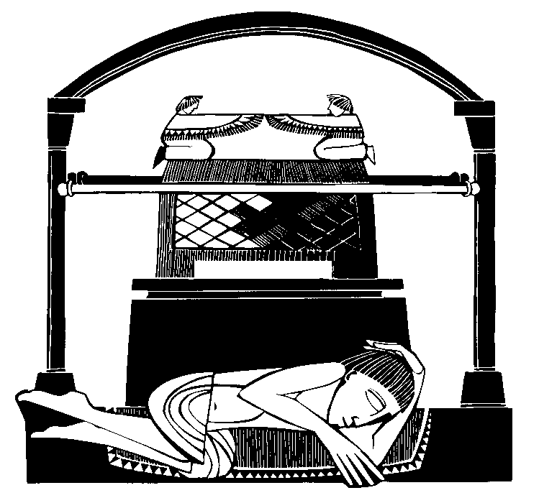
George McCann, Martha Moffatt, Alfred Wherly, John Musgrove, Hope Lynch, David Macaulay, Edward Devlin, Maureen Durham, Mavis Howe, Stuart Pickering, Ann Shannon, Mary Legg, Margaret McCann, Tom Greenfield, Mary Shelley, Sarah E. Musgrove, Maud Halsey (Canavan), Susanne Foster.
PLEASE REMEMBER in your prayers all our sick and housebound brothers and sisters.
The word this week
1 Samuel 3:3–10, 19 Samuel hears the Lord calling him.
Psalm 39 ‘Here am I, Lord; I come to do your will.’
1 Corinthians 6:13–15, 17–20 We are members of the Body of Christ.
John 1:35–42 We have found the Messiah.
W
hat does it mean to be a follower of the Lord Jesus? Surely to listen and hear his voice, and to go where he leads us. Today, as we enter the “ordinary” season of the year, we begin our story of Jesus’s life and ministry with the calling of the first disciples. John fulfils his ministry - pointing to the Lamb of God - and the disciples follow where he points. His word to them is simple and inviting: “Come and see.” This echoes the calling of Samuel - a simple call, by name, which Samuel does not understand: discipleship is about trust, which Samuel shows simply by saying “Speak, Lord; your servant is listening.” The Psalm also underlines this, as we (the disciples of the Lord) say together: “Here I am, Lord! I come to do your will.” We hear his call, and we freely go to him, to listen again to the words of the Master.
AT MASS TODAY WE PRAY Eucharistic Prayer 3 and Preface 2 for Sundays in Ordinary Time
Each week we lift our voices with praise and thanksgiving over these gifts. As this new year unfolds, let us pray that what we celebrate at this holy table will transform the world.
RECENTLY DECEASED: Please remember in your prayers Mrs. Rebacca Jean Umpleby, aged 37, from Stockton (formerly from Thornaby). Her Funeral Service will take place at Stockton Crematorium this Friday, January 19th, at 10.00am. May they rest in peace.
PEACE SUNDAY: , January 14th, is the annual “Peace Sunday.” Pope Francis has chosen the Theme: “Artificial Intelligence and Peace” for this year’s Peace Sunday. We have a message to read out on this particular theme today.
MESSAGE FROM OUR PRIMARY SCHOOLS: “Blue/Brew Monday: This Monday, January 15th, you are invited in for a ‘Brew’. Parishioners are more than welcome to join us in School for a brew and a biscuit. We are simply offering you the chance to have a hot drink and a few minutes during the day to catch up with yourself and your friends. The children would love to see you. Please come to St. Patrick’s Primary School from 8.30am – 10.00am and/or Christ the King School from 2.30pm – 3.00pm”
SALSA AEROBICS CLASSES have resumed in St Patrick’s parish hall - a fun way to burn off some calories in the new year. Classes are on a Monday and Wednesday evening at 6pm costing £6 per session.

THE CELEBRATION OF MASS ON SUNDAYS
"At Mass or the Lord’s Supper the People of God is called together, with a Priest presiding and acting in the person of Christ, to celebrate the memorial of the Lord or Eucharistic Sacrifice. In an outstanding way there applies to such a local gathering of the holy Church the promise of Christ: ‘Where two or three are gathered in my name, there am I in their midst’ (Mt 18: 20). For in the celebration of Mass, in which the Sacrifice of the Cross is maintained, Christ is really present in the very assembly gathered in his name, in the person of the minister, in his word, (Scriptures) and indeed substantially and uninterruptedly under the Eucharistic species." {more on the Sunday Mass in the next 4 weeks leading to Lent}

Second Sunday of the Year (B)
January 14th, 2024

First reading 1 Samuel 3:3-10,19

Samuel was lying in the sanctuary of the Lord, where the ark of God was, when the Lord called, ‘Samuel! Samuel!’ He answered, ‘Here I am.’ Then he ran to Eli and said, ‘Here I am, since you called me.’ Eli said, ‘I did not call. Go back and lie down.’ So he went and lay down. Once again the Lord called, ‘Samuel! Samuel!’ Samuel got up and went to Eli and said, ‘Here I am, since you called me.’ He replied, ‘I did not call you, my son; go back and lie down.’ Samuel had as yet no knowledge of the Lord and the word of the Lord had not yet been revealed to him. Once again the Lord called, the third time. He got up and went to Eli and said, ‘Here I am, since you called me.’ Eli then understood that it was the Lord who was calling the boy, and he said to Samuel, ‘Go and lie down, and if someone calls say, “Speak, Lord, your servant is listening.”’ So Samuel went and lay down in his place.
The Lord then came and stood by, calling as he had done before, ‘Samuel! Samuel!’ Samuel answered, ‘Speak, Lord, your servant is listening.’
Samuel grew up and the Lord was with him and let no word of his fall to the ground.

Second reading 1 Corinthians 6:13-15,17-20

The body is not meant for fornication: it is for the Lord, and the Lord for the body. God, who raised the Lord from the dead, will by his power raise us up too.
You know, surely, that your bodies are members making up the body of Christ; do you think I can take parts of Christ’s body and join them to the body of a prostitute? Never! But anyone who is joined to the Lord is one spirit with him.
Keep away from fornication. All the other sins are committed outside the body; but to fornicate is to sin against your own body. Your body, you know, is the temple of the Holy Spirit, who is in you since you received him from God. You are not your own property; you have been bought and paid for. That is why you should use your body for the glory of God.
.

Gospel Acclamation
Alleluia, alleluia!
We have found the Messiah – which means the Christ –
grace and truth have come through him.
Alleluia!

Gospel Reading John 1:35-42

As John stood with two of his disciples, Jesus passed, and John stared hard at him and said, ‘Look, there is the lamb of God.’ Hearing this, the two disciples followed Jesus. Jesus turned round, saw them following and said, ‘What do you want?’ They answered, ‘Rabbi,’ – which means Teacher – ‘where do you live?’ ‘Come and see’ he replied; so they went and saw where he lived, and stayed with him the rest of that day. It was about the tenth hour.
One of these two who became followers of Jesus after hearing what John had said was Andrew, the brother of Simon Peter. Early next morning, Andrew met his brother and said to him, ‘We have found the Messiah’ – which means the Christ – and he took Simon to Jesus. Jesus looked hard at him and said, ‘You are Simon son of John; you are to be called Cephas’ – meaning Rock.

