St. Patrick’s church, 39 Westbury St. TS17 6NW Christ the King church, Trenchard Ave. TS17 0EG
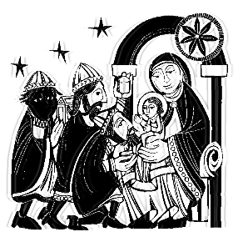
Postal address: Christ the King House, Trenchard Avenue, TS17 0EG
Telephone: 01642 750467
EMAIL: thornaby@rcdmidd.org.uk
Christ the King Website: www.ctkthornaby.co.uk St. Patrick’s Website: www.stpatrickschurch.co.uk
Feast of The Epiphany of the Lord January 2nd, 2022
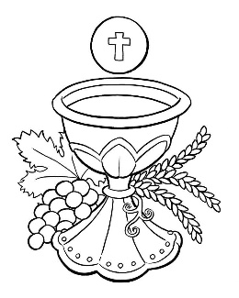
SUNDAY MASS TIMES

9.30am Christ the King church
11.00am St. Patrick’s church
WEEKDAY MASSES
Tuesday: 10.00am Christ the King
Wednesday: 10.00am St Patrick’s
Thursday: 10.00am Christ the King
Friday: 10.00am St. Patrick’s
PLEASE NOTE: Face coverings / Face masks must now be worn in church for all liturgies.
SACRAMENT OF RECONCILIATION any time on request

MASS INTENTIONS RECEIVED: Special Intention, Kevin Green (Anni.), Elsey and Dick families, Mass of Thanksgiving for Baby Eddy born 12 – 12 – 2021, Amanda Hudson, In Thanksgiving, Frank Hudson, In Thanksgiving to St. Theresa, Thanksgiving to St. Jude, In Thanksgiving to St. Pio, Chesser family, Spayne family,
Betty & Jimmy Cuthbert, Tommy McCartan, Leo Murray, Frank Hudson, All who have no one to pray for them,
Andy and Paul Lynch, James Devlin (33rd Anni.),
ANNIVERSARIES: January 2nd – 8th.
Jim Machin, David Stott, Joseph Brennan, Francis Michael Nicholson, Vincent Lawrence, James Duffy, Alice O’Neill,
Peter McNamee, Joseph Mallon, Clifford Jordan, John Patrick McCallan, Patrick Duffy, James Fleming, Eileen George, Geraldine Mills, Luke Williamson, Maud Greenan, David Frederick Harding, Percy Smith, Henry Crossley, Anna Mulhern,
Fred Curtis, Annie Burton, Maggie O’Donnell, Hugh McCann

PLEASE REMEMBER in your prayers all our sick and housebound brothers and sisters.
The word this week
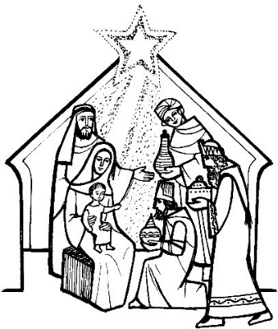
Isaiah 60:1–6 The glory of the Lord shines on all people.
Psalm 72 (71) ‘All nations shall fall prostrate before you, O Lord.’
Ephesians 3:2–3, 5–6 The Pagans share the same inheritance.
Matthew 2:1–12 The magi (Wise men) come with gifts of gold, frankincense and myrrh.
T
hough Jerusalem had been laid waste by the invading Babylonian army and the Israelites were just beginning to return there, Isaiah foresaw the day when it would draw people and riches from near and far. The psalmist proclaims that all nations will adore God, for justice and peace will flower throughout the land. People of every nation, says Paul, are members
of the same body of Christ as those who heard the gospel from Jesus directly. In the Gospel,
the magi from the east are led by the wondrous star to the humble stable where Jesus lay. By this feast of Epiphany we proclaim God’s plan was to extend his salvation to men and women of every nation, of every time and every place – including us. In many ways this is our Christmas Feast, when we celebrate the Good News of the Saviour’s birth revealed at last to us.

RECENTLY DECEASED: Please remember in your prayers Mrs. Patricia Rowntree, from Stockton (formerly Thornaby), aged 93, who died recently. Her Funeral Service will take place at St. Patrick’s church on Tuesday, January 4th, at 1.00pm. Also, Mr. Martin Edward Bainbridge, aged 60, from Thornaby, who died recently. His Funeral Service will take place at Christ the King church on Thursday, January 13th, at 12 noon. May they rest in peace.
AT MASS TODAY WE PRAY Eucharistic Prayer 2 and Preface for Epiphany
As children of the light, we raise our voices in a prayer of praise and thanksgiving around this holy table.

TEA/COFFEE ETC after Sunday morning Mass at Christ the King
BLESSING FOR NEW YEAR
May God, the source and origin of all blessing, grant you grace, pour out his blessings in abundance,
and keep you safe from harm throughout this New Year. Amen.
May he order your days and your deeds in his peace, grant your prayers in this and in every place
and lead you happily to eternal life. Amen.

READINGS FOR THE FEAST OF THE EPIPHANY OF THE LORD

First reading Isaiah 60:1-6

Arise, shine out, Jerusalem, for your light has come, the glory of the Lord is rising on you,
though night still covers the earth and darkness the peoples.
Above you the Lord now rises and above you his glory appears.
The nations come to your light and kings to your dawning brightness.

Lift up your eyes and look round:
all are assembling and coming towards you, your sons from far away and your daughters being tenderly carried.
At this sight you will grow radiant, your heart throbbing and full; since the riches of the sea will flow to you, the wealth of the nations come to you;
camels in throngs will cover you, and dromedaries of Midian and Ephah; everyone in Sheba will come, bringing gold and incense and singing the praise of the Lord.

Responsorial Psalm: All nations shall fall prostrate before you, O Lord.

Second reading Ephesians 3:2-3,5-6

You have probably heard how I have been entrusted by God with the grace he meant for you, and that it was by a revelation that I was given the knowledge of the mystery. This mystery that has now been revealed through the Spirit to his holy apostles and prophets was unknown to any men in past generations; it means that pagans now share the same inheritance, that they are parts of the same body, and that the same promise has been made to them, in Jesus Christ, through the gospel.

Alleluia
Alleluia, alleluia!
We saw his star as it rose
and have come to do the Lord homage.
Alleluia!

Gospel Reading Matthew 2:1-12

After Jesus had been born at Bethlehem in Judaea during the reign of King Herod, some wise men came to Jerusalem from the east. ‘Where is the infant king of the Jews?’ they asked. ‘We saw his star as it rose and have come to do him homage.’ When King Herod heard this he was perturbed, and so was the whole of Jerusalem. He called together all the chief priests and the scribes of the people, and enquired of them where the Christ was to be born. ‘At Bethlehem in Judaea,’ they told him ‘for this is what the prophet wrote:
And you, Bethlehem, in the land of Judah,
you are by no means least among the leaders of Judah,
for out of you will come a leader
who will shepherd my people Israel.’
Then Herod summoned the wise men to see him privately. He asked them the exact date on which the star had appeared, and sent them on to Bethlehem. ‘Go and find out all about the child,’ he said ‘and when you have found him, let me know, so that I too may go and do him homage.’ Having listened to what the king had to say, they set out. And there in front of them was the star they had seen rising; it went forward, and halted over the place where the child was. The sight of the star filled them with delight, and going into the house they saw the child with his mother Mary, and falling to their knees they did him homage. Then, opening their treasures, they offered him gifts of gold and frankincense and myrrh. But they were warned in a dream not to go back to Herod, and returned to their own country by a different way.

