St. Patrick’s church, 39 Westbury St. TS17 6NW Christ the King church, Trenchard Ave. TS17 0EG
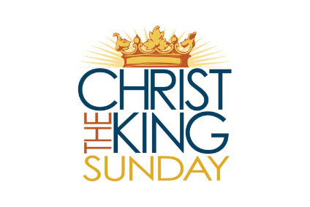
Postal address: Christ the King House, Trenchard Avenue, TS17 0EG
Telephone: 01642 750467
EMAIL: thornaby@rcdmidd.org.uk
Christ the King Website: www.ctkthornaby.co.uk St. Patrick’s Website: www.stpatrickschurch.co.uk FEAST OF CHRIST THE KING (B) November 21st, 2021

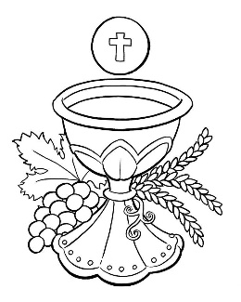
SUNDAY MASS TIMES
6.00pm {Saturday} St. Patrick’s church
9.30am Christ the King church
11.00am St. Patrick’s church
WEEKDAY MASSES
Tuesday: 10.30am Christ the King {Funeral Service}
Wednesday: 10.00am Christ the King
Thursday: 10.00am Christ the King
Friday: 7.00pm Christ the King
SACRAMENT OF RECONCILIATION any time on request
MASS INTENTIONS RECEIVED: Special Intention, Nicholas Dodinson, Sheila McReddie
ANNIVERSARIES November 21st – 27th:
Apolinario G. Valdez, Elizabeth Govan, Christine Anne Voules, Rita Boyd, David Smith, Bill Porteous, James Betts, John David Haycock, Peter Sewell, Ada Hill, Mary Fairlie, Bridget King, Ernie Jones.

ANNUAL MEMORIAL MASS will be held in Christ the King church this Friday, November 26th, at 7.00pm.
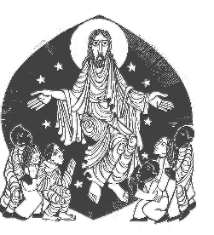
During the Mass there will be the opportunity to place a “Named Candle” on the Altar for your loved ones. Names for inclusion can be given to members of the Bereavement Group after any Mass in the coming weeks.

PLEASE REMEMBER in your prayers all our sick and housebound brothers and sisters.
The word this week
Daniel 7:13–14 His dominion is an everlasting dominion.
Psalm 93 “The Lord is king, with majesty enrobed.’
Revelation 1:5–8 The Lord God is the Alpha and the Omega.
John 18:33b–37 Are you the King of the Jews?
E
very time we complete the cycle of the liturgical year, there is a seamless blending into the new year. So, just as this week we hear of the King who is to come, next week, we begin a New Year and the Season of Advent by more meditation on the end of time, and the One who is to come again, as he once came among us. This feast affirms that Christ is King, that he is Judge, that he is Ruler of the kings of the earth. By his own words we know that this is true, as he stands before Pilate and says, “Yes, I am a king”. But his kingship is different. It is not of the same kind as earthly kings, whose empires fade and pass away. His kingship is eternal, and holy until the end of time. Through his love for us, we share in this sovereignty – this holiness – as priests and kings who serve his God and Father. We end our year in simple, awefilled praise of the One who is, who was, and who is to come – the Almighty. Alleluia! Amen!
AT MASS TODAY WE PRAY Eucharistic Prayer 3 and Preface for Christ the King.
Everyone who belongs to the truth listens to the voice of Christ the King. As we offer this prayer of thanksgiving over these gifts, let us listen for the voice of Christ, who calls us out of the darkness of this world and into the splendour of his kingly light.
RECENTLY DECEASED: Please remember in your prayers Mrs. Maureen (Biddy) Aithwaite, aged 94, from Thornaby, who died recently. Her Funeral Service will take place this Tuesday, November 23rd, at 10.30am in Christ the King church. Also, Mr. Peter Vickers, aged 79, from Thornaby who died recently. His Funeral Service is this Wednesday, November 24th, at Acklam Crematorium. Also, Sheila McReddie, age 83, from Thornaby. Her Funeral Mass will take place at Christ the King church on Thursday, December 2nd, at 10.00am. May they rest in peace.
SOCIAL NIGHT – Saturday 27th November in St Patrick’s parish hall, with live music from Eagle Ukes. Tickets £3 available from Carol or Dan Woodgate. Doors open 7pm, feel free to bring your own food & drink.
TEA/COFFEE ETC after Sunday morning Masses at both Christ the King and St. Patrick’s in Parish Hall.
The Universe Catholic Weekly is thrilled to announce that we have launched our new online newspaper with the full support of our first subscriber none other than His Eminence Cardinal Vincent Nichols.
Order your Digital copy by going to www.universecatholicweekly.co.uk or call us on 0743661 7650 and ask for Michelle.
Special offer: Only £20 for 3 months.
“CHRISTMAS HAMPERS”: Please see ‘Yellow Page’ for information from Liz Maw about how to help with the contribution to the Christmas Hampers this year.

READINGS for November 21st.
Feast of Christ the King

First reading Daniel 7:13-14

I gazed into the visions of the night.
And I saw, coming on the clouds of heaven,
one like a son of man.
He came to the one of great age
and was led into his presence.
On him was conferred sovereignty,
glory and kingship,
and men of all peoples, nations and languages became his servants.
His sovereignty is an eternal sovereignty
which shall never pass away,
nor will his empire ever be destroyed.

Second reading Apocalypse 1:5-8

Grace and peace to you from Jesus Christ, the faithful witness, the First-Born from the dead, the Ruler of the kings of the earth. He loves us and has washed away our sins with his blood, and made us a line of kings, priests to serve his God and Father; to him, then, be glory and power for ever and ever. Amen. It is he who is coming on the clouds; everyone will see him, even those who pierced him, and all the races of the earth will mourn over him. This is the truth. Amen. ‘I am the Alpha and the Omega’ says the Lord God, who is, who was, and who is to come, the Almighty.

Gospel Acclamation

Alleluia, alleluia!
Blessings on him who comes in the name of the Lord!
Blessings on the coming kingdom of our father David!
Alleluia!

Gospel John 18:33-37

‘Are you the king of the Jews?’ Pilate asked. Jesus replied, ‘Do you ask this of your own accord, or have others spoken to you about me?’ Pilate answered, ‘Am I a Jew? It is your own people and the chief priests who have handed you over to me: what have you done?’ Jesus replied, ‘Mine is not a kingdom of this world; if my kingdom were of this world, my men would have fought to prevent my being surrendered to the Jews. But my kingdom is not of this kind.’ ‘So you are a king then?’ said Pilate. ‘It is you who say it’ answered Jesus. ‘Yes, I am a king. I was born for this, I came into the world for this: to bear witness to the truth; and all who are on the side of truth listen to my voice.’

