St. Patrick’s church, 39 Westbury St. TS17 6NW Christ the King church, Trenchard Ave. TS17 0EG
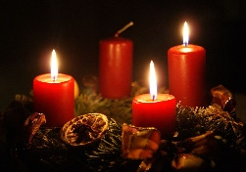
Postal address: Christ the King House, Trenchard Avenue, TS17 0EG
Telephone: 01642 750467
EMAIL: thornaby@rcdmidd.org.uk
Christ the King Website: www.ctkthornaby.co.uk St. Patrick’s Website: www.stpatrickschurch.co.uk 3rd Sunday of Advent (C) December 12th, 2021
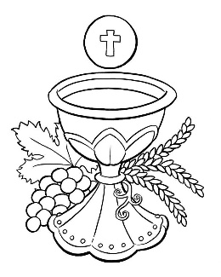
SUNDAY MASS TIMES
6.00pm {Saturday} St. Patrick’s church
9.30am Christ the King church
11.00am St. Patrick’s church
WEEKDAY MASSES
Tuesday: 10.00am Christ the King
Wednesday: 10.00am St Patrick’s
Thursday: 10.00am Christ the King
Friday: 10.00am St. Patrick’s
SACRAMENT OF RECONCILIATION any time on request

MASS INTENTIONS RECEIVED: Special Intention, Mary Ann Hunt (A), John Carpenter R.I.P., Ernest, Mary and Kathleen Gibson, Betty and Benny McMahon, Kathleen Donegan (Anni.), William Green and Mary Green (Anni),
Mary Veronica Spayne (2nd Anni.), Margaret Tatters (2nd Anni.), Bob England,

ANNIVERSARIES: December 12th – 18th:
Teresa Waine, William Purvis (Jnr.), Pat Nolan, Cissie Middleton, Sean Joseph Merrick, Paul McNamara, Eleanor Ferguson, Enid Johnston, John David Haycock(Jnr.), David Arthur Thwaites, Catherine Maleary, Mary Jones, Jim Crossen, Margaret Morgan, Maud McCallan, Cyril (Jimmy)Higgins, Harold Ernest Good, William John Hartley, Ann Harbord, Betty Cuthbert.

PLEASE REMEMBER in your prayers all our sick and housebound brothers and sisters.
The word this week
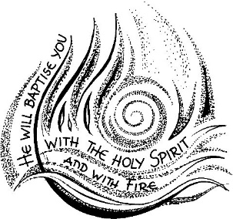
Zephaniah 3:14–18a The Lord will sing joyfully because of you. Psalm 12 ‘Sing and shout for joy: for great in your midst is the Holy One of Israel.’ Philippians 4:4–7 Rejoice in the Lord always, for the Lord is near. Luke 3:10–18 They all asked whether John might be the Christ.
T
oday we have the opportunity to hear John the Baptist’s counsel to the crowds of people filled with expectation of the imminent coming of the long-awaited Messiah. Three times in today’s Gospel they ask John, ‘What must we do?’ Let us heed John’s responses, for who better to prepare us for his coming into our world than the one who first prepared the world for his coming?

AT MASS TODAY WE PRAY Eucharistic Prayer 2 and Preface 1 for Advent
As we offer our prayer of thanksgiving around this holy table, let our hearts be filled with gladness and exultation.

TEA/COFFEE ETC after Sunday morning Mass at Christ the King

PARISH SACRAMENT OF RECONCILIATION FOR ADVENT
At Christ the King church at 6.30pm this Tuesday, December 14th.
At. St. Patrick’s church after 10.00am Mass this Wednesday, December 15th.

COLLECTION FOR NOVEMBER: St. Patrick’s £2,354.31
Christ the King £2,262.31

MASS TIMES FOR CHRISTMAS
Christmas Eve, Friday, December 24th 5.00pm at St. Patrick’s church.
Christmas Eve, Friday, December 24th 7.00pm at Christ the King church
Christmas Day, Saturday, December 25th 10.30am at St. Patrick’s church.

Boxing Day, Sunday, December 26th 9.30am at Christ the King church
Boxing Day, Sunday, December 26th 10.30am at St. Patrick’s church

READINGS for December 12th.
3rd Sunday of Advent (C)

First reading Zephaniah 3:14-18

Shout for joy, daughter of Zion,
Israel, shout aloud!
Rejoice, exult with all your heart,
daughter of Jerusalem!
The Lord has repealed your sentence;
he has driven your enemies away.
The Lord, the king of Israel, is in your midst;
you have no more evil to fear.
When that day comes, word will come to Jerusalem:
Zion, have no fear,
do not let your hands fall limp.
The Lord your God is in your midst,
a victorious warrior.
He will exult with joy over you,
he will renew you by his love;
he will dance with shouts of joy for you
as on a day of festival.

Second reading Philippians 4:4-7

I want you to be happy, always happy in the Lord; I repeat, what I want is your happiness. Let your tolerance be evident to everyone: the Lord is very near.
There is no need to worry; but if there is anything you need, pray for it, asking God for it with prayer and thanksgiving, and that peace of God, which is so much greater than we can understand, will guard your hearts and your thoughts, in Christ Jesus.

Gospel Acclamation

Alleluia, alleluia!
The spirit of the Lord has been given to me.
He has sent me to bring the good news to the poor.
Alleluia!

Gospel Luke 3:10-18

When all the people asked John, ‘What must we do?’ he answered, ‘If anyone has two tunics he must share with the man who has none, and the one with something to eat must do the same.’ There were tax collectors too who came for baptism, and these said to him, ‘Master, what must we do?’ He said to them, ‘Exact no more than your rate.’ Some soldiers asked him in their turn, ‘What about us? What must we do?’ He said to them, ‘No intimidation! No extortion! Be content with your pay!’
A feeling of expectancy had grown among the people, who were beginning to think that John might be the Christ, so John declared before them all, ‘I baptise you with water, but someone is coming, someone who is more powerful than I am, and I am not fit to undo the strap of his sandals; he will baptise you with the Holy Spirit and fire. His winnowing-fan is in his hand to clear his threshing-floor and to gather the wheat into his barn; but the chaff he will burn in a fire that will never go out.’ As well as this, there were many other things he said to exhort the people and to announce the Good News to them.

