Postal address:
Christ the King Church
Trenchard Avenue
TS17 0EG
www.ctkthornaby.co.uk
St Patrick’s Church
Westbury Street
TS17 6NW
www.stpatrickschurch.co.uk
Christ the King House
Trenchard Avenue, Thornaby.
TS17 0EG
T: 01642 750467
Email: thornaby@rcdmidd.org.uk

5th Sunday of Easter May 7th, 2023
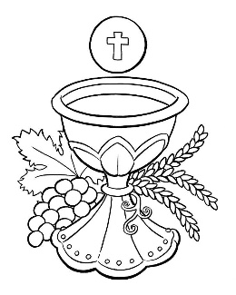
SUNDAY MASS TIMES
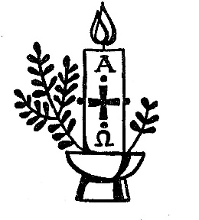
Saturday 6.00pm St. Patrick’s church
Sunday 9.30am Christ the King church
Sunday 11.00am St. Patrick’s church WEEKDAY LITURGY TIMES
Tuesday 10.00am Christ the King
Wednesday 10.00am St. Patrick’s
Thursday: 10.00am Christ the King
Friday: 10.00am St. Patrick’s
MASS INTENTIONS RECEIVED: Special Intention, Rosemary Ford (Anni.), David Devlin (Anni.),
Audrey Devlin (Anni.), Peter Macaulay (Anni.),
ANNIVERSARIES: May 7th – 13th:
Doreen Barnes, Terry Hughes, Michael Eddy, David Zadrozny, Agnes Pybus, Olive Greenan, Annie Lapsley,
Katherine Murphy, Terry Sawdon, Peter Macaulay, Walter Shelley, Dominique Hammill, Vincent Hemblade, Agnes Carton, Laura Frances Gourlay, Maurice Deaton.

PLEASE REMEMBER in your prayers all our sick and housebound brothers and sisters.
The word this week
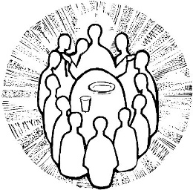
Acts 6:1–7 They chose Stephen.
Psalm 33 ‘May your love be upon us, O Lord, as we place all our hope in you.’
1 Peter 2:4–9 The stone the builders rejected has become the cornerstone.
John 14:1–12 I am the way, the truth, and the life
During the Easter season, we are invited to reflect on all the wonderful implications of the Resurrection. The early Church grew and expanded to the extent that more leaders were needed to minister to everyone. We are, as Peter puts it, “living stones,” built upon the cornerstone who is Jesus. In the Gospel, Jesus assures his disciples that he is preparing dwelling places for them in his Father’s house. Let us place our trust in the Lord, that we will one day reach God’s dwelling place.

AT MASS TODAY WE PRAY Eucharistic Prayer 2 and Preface 3 for Easter.
With Christ, our eternal high priest, we offer this prayer of thanksgiving, a prayer thatgives us a glimpse of the glory to come.
SACRAMENT OF CONFIRMATION will be celebrated this Thursday, May 11th, at 7.00pm at St. Therese church, Ingleby Barwick.
SVP MEETING at Christ the King Hall this Tuesday, May 9th, at 6.30pm. All welcome.
RECENTLY DECEASED: Please remember in your prayers Mrs. June Notman, aged 81, who died recently. Her Funeral Service will take place at Christ the King church on Thursday, May 18th, at 12.30pm. May she rest in peace.
PRAYER FOR THE KING
O God, to whom every human power is subject,
grant to your servant our sovereign Charles success in the exercise of his high office,
so that, always revering you and striving to please you, he may constantly secure and preserve
for the people entrusted to his care the freedom that comes from civil peace.
Through our Lord Jesus Christ, your Son,
who lives and reigns with you in the unity of the Holy Spirit, God, for ever and ever. Amen.

EASTER
Most glorious Lord of life, that on this day didst make thy triumph over death and sin;
And having harrowed hell didst bring away Captivity thence captive, us to win:
This joyous day, dear Lord, with joy begin, And grant that we for whom thou didst die
Being with thy dear blood clean washed from sin, may live forever in felicity.
And that thy love we weighing worthily, May likewise love thee for the same again;
And for thy sake that all like dear didst buy, With love may one another entertain.
So let us love, dear love, like as we ought. Love is the lesson which the Lord has taught.
{Edward Spenser}
5th SUNDAY OF EASTER(A)
May 7th, 2023

First reading Acts 6:1-7

About this time, when the number of disciples was increasing, the Hellenists made a complaint against the Hebrews: in the daily distribution their own widows were being overlooked. So the Twelve called a full meeting of the disciples and addressed them, ‘It would not be right for us to neglect the word of God so as to give out food; you, brothers, must select from among yourselves seven men of good reputation, filled with the Spirit and with wisdom; we will hand over this duty to them, and continue to devote ourselves to prayer and to the service of the word.’ The whole assembly approved of this proposal and elected Stephen, a man full of faith and of the Holy Spirit, together with Philip, Prochorus, Nicanor, Timon, Parmenas, and Nicolaus of Antioch, a convert to Judaism. They presented these to the apostles, who prayed and laid their hands on them.
The word of the Lord continued to spread: the number of disciples in Jerusalem was greatly increased, and a large group of priests made their submission to the faith.

Second reading 1 Peter 2:4-9

The Lord is the living stone, rejected by men but chosen by God and precious to him; set yourselves close to him so that you too, the holy priesthood that offers the spiritual sacrifices which Jesus Christ has made acceptable to God, may be living stones making a spiritual house. As scripture says: See how I lay in Zion a precious cornerstone that I have chosen and the man who rests his trust on it will not be disappointed. That means that for you who are believers, it is precious; but for unbelievers, the stone rejected by the builders has proved to be the keystone, a stone to stumble over, a rock to bring men down. They stumble over it because they do not believe in the word; it was the fate in store for them.
But you are a chosen race, a royal priesthood, a consecrated nation, a people set apart to sing the praises of God who called you out of the darkness into his wonderful light.

Gospel Acclamation
Alleluia, alleluia!
Jesus said: ‘I am the Way, the Truth and the Life.
No one can come to the Father except through me.’
Alleluia!

Gospel Reading John 14:1-12

Jesus said to his disciples:
‘Do not let your hearts be troubled.
Trust in God still, and trust in me.
There are many rooms in my Father’s house;
if there were not, I should have told you.
I am going now to prepare a place for you,
and after I have gone and prepared you a place,
I shall return to take you with me;
so that where I am you may be too.
You know the way to the place where I am going.’
Thomas said, ‘Lord, we do not know where you are going, so how can we know the way?’ Jesus said:
‘I am the Way, the Truth and the Life.
No one can come to the Father except through me.
If you know me, you know my Father too.
From this moment you know him and have seen him.’
Philip said, ‘Lord, let us see the Father and then we shall be satisfied.’ ‘Have I been with you all this time, Philip,’ said Jesus to him ‘and you still do not know me?
‘To have seen me is to have seen the Father, so how can you say, “Let us see the Father”?
Do you not believe that I am in the Father and the Father is in me?
The words I say to you I do not speak as from myself:
it is the Father, living in me, who is doing this work.
You must believe me when I say that I am in the Father and the Father is in me;
believe it on the evidence of this work, if for no other reason.
I tell you most solemnly, whoever believes in me
will perform the same works as I do myself,
he will perform even greater works,
because I am going to the Father.’

