Postal address:
Christ the King Church
Trenchard Avenue
TS17 0EG
www.ctkthornaby.co.uk
St Patrick’s Church
Westbury Street
TS17 6NW
www.stpatrickschurch.co.uk
Christ the King House
Trenchard Avenue
TS17 0EG
T: 01642 750467
Email: thornaby@rcdmidd.org.uk

18th Sunday of the year (C) July 31st, 2022
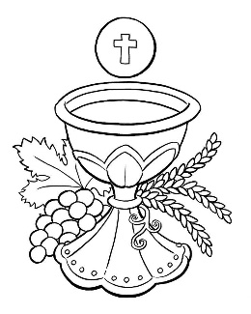
SUNDAY MASS TIMES
Saturday 6.00pm St. Patrick’s church
9.30am Christ the King church
11.00am St. Patrick’s church

WEEKDAY LITURGIES
Tuesday 10.00am Christ the King
Wednesday 10.00am St. Patrick’s
Thursday 10.00am Christ the King
Friday 10.00am St. Patrick’s
SACRAMENT OF RECONCILIATION any time on request
MASS INTENTIONS RECEIVED: Special Intention, Elizabeth (Betty) McIntosh (27th Anni.), Dorothy Dellipiani,
Prayer to St Pio, St. Jude, St. Theresa the Little Flower, Our Lady, Joseph Frew (15th Anni.),
ANNIVERSARIES: July 31st – August 6th:
Elsie Hutchinson, Christopher John Kelly, Joyce Larsen, Ray Heald, Helena Smailes, Kathleen Roberts, Walter Hobson,
Owen Evans, Paul Andrew Lynch, Richard McKenzie, Kenneth Pounder, Fred Oates, Henry Malcolm, John Cross,
Audrey Dea, Thomas Darragh, John Leonard, Joseph Frew.
PLEASE REMEMBER in your prayers all our sick and housebound brothers and sisters.
The word this week
Ecclesiastes 1:2; 2:21–23 All things are vanity!
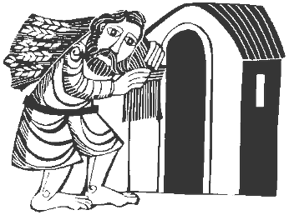
Psalm 95 (94) ‘O that today you would listen to his voice! Harden not your hearts.
Colossians 3:1–5, 9–11 In Christ you have died. In Christ you have been raised up.
Luke 12:13–21 Avoid greed in all its forms.
Today’s readings are a wonderful antidote to our culture’s attitude that the accumulation of material wealth should be everyone’s goal. This notion is ‘Vanity of vanities,’ for what guarantee is there that you will ever be able to enjoy all the wealth you worked for? Greed is idolatry, Paul says in the next reading; instead seek what is above. After all, Jesus points out in the Gospel, the rich man is a fool for thinking he can control the rest of his life through wealth. May today’s readings offer a strong argument against the worship of material possessions.
AT MASS TODAY WE PRAY Eucharistic Prayer 3 with Preface 5 for Sundays
St. Paul tells us today that we have been formed anew in the image of our Creator. The differences among us are reflections of the diversity of Christ, because, as Paul says, Christ is everything in all of us. And for this we give thanks this Lord’s Day.
TEA/COFFEE ETC after Sunday morning Mass at Christ the King and St. Patrick’s

DIGITAL GIVING: You will notice we now have a QR code for each church at the top of the Newsletter. This means we can now receive donations remotely by scanning on a mobile phone {with the camera} and, then, follow the prompts.
APOSTLESHIP OF THE COLLECTION: St. Patrick’s church £241.95
Christ the King church £144.15
“THANK YOU”: Dr. Alex Dellipiani and family wish to convey their sincere “Gratitude” to all Parishioners for your support and prayers in recent weeks on the death of Dorothy. The donations for Dementia UK came to £250
FEAST OF THE ASSUMPTION OF OUR LADY IN TO HEAVEN: Diocesan Pilgrimage to The Shrine of Our Lady of Mount Grace on Sunday, August 14th. Rosary at 2.30pm followed by Mass at 3.00pm. See poster on Notice Board.
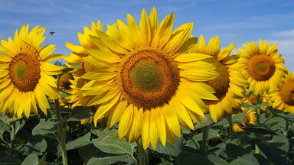
In Praise of Sunday
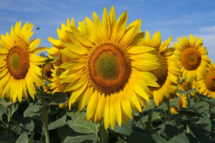
This day, at thy creating Word first o’er the earth the light was poured,
O Lord, this day upon us shine, and fill our souls with light divine.
This day the Lord, for sinners slain, in might victorious rose again:
O Jesu, may we raisēd be from death of sin to life in thee.
This day the Holy Spirit came with fiery tongues of cloven flame:
O Spirit, fill our hearts this day with grace to hear and grace to pray.
O Day of light, and life, and grace, from earthly toil a resting-place!
The hallowed hours, best gift of love, give we again to God above.
All praise to God the Father be, All praise, eternal Son, to thee,
Whom with the Spirit we adore for ever and for evermore.
18th Sunday of the Year (C)
July 31st, 2022

First reading Ecclesiastes 1:2,2:21-23

Vanity of vanities, the Preacher says. Vanity of vanities. All is vanity!
For so it is that a man who has laboured wisely, skilfully and successfully must leave what is his own to someone who has not toiled for it at all. This, too, is vanity and great injustice; for what does he gain for all the toil and strain that he has undergone under the sun? What of all his laborious days, his cares of office, his restless nights? This, too, is vanity.

Second reading Colossians 3:1-5,9-11

Since you have been brought back to true life with Christ, you must look for the things that are in heaven, where Christ is, sitting at God’s right hand. Let your thoughts be on heavenly things, not on the things that are on the earth, because you have died, and now the life you have is hidden with Christ in God. But when Christ is revealed – and he is your life – you too will be revealed in all your glory with him.
That is why you must kill everything in you that belongs only to earthly life: fornication, impurity, guilty passion, evil desires and especially greed, which is the same thing as worshipping a false god; and never tell each other lies. You have stripped off your old behaviour with your old self, and you have put on a new self which will progress towards true knowledge the more it is renewed in the image of its creator; and in that image there is no room for distinction between Greek and Jew, between the circumcised or the uncircumcised, or between barbarian and Scythian, slave and free man. There is only Christ: he is everything and he is in everything.

Gospel Acclamation
Alleluia, alleluia!
Your word is truth, O Lord:
consecrate us in the truth.
Alleluia!

Gospel Reading Luke 12:13-21

A man in the crowd said to Jesus, ‘Master, tell my brother to give me a share of our inheritance.’ ‘My friend,’ he replied, ‘who appointed me your judge, or the arbitrator of your claims?’ Then he said to them, ‘Watch, and be on your guard against avarice of any kind, for a man’s life is not made secure by what he owns, even when he has more than he needs.’
Then he told them a parable: ‘There was once a rich man who, having had a good harvest from his land, thought to himself, “What am I to do? I have not enough room to store my crops.” Then he said, “This is what I will do: I will pull down my barns and build bigger ones, and store all my grain and my goods in them, and I will say to my soul: My soul, you have plenty of good things laid by for many years to come; take things easy, eat, drink, have a good time.” But God said to him, “Fool! This very night the demand will be made for your soul; and this hoard of yours, whose will it be then?” So it is when a man stores up treasure for himself in place of making himself rich in the sight of God.’

