Postal address:
Christ the King Church
Trenchard Avenue
TS17 0EG
www.ctkthornaby.co.uk
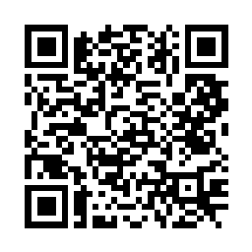
St Patrick’s Church
Westbury Street
TS17 6NW
www.stpatrickschurch.co.uk
Christ the King House
Trenchard Avenue, Thornaby.
TS17 0EG
T: 01642 750467
Email: thornaby@rcdmidd.org.uk

PENTECOST SUNDAY May 28th, 2023
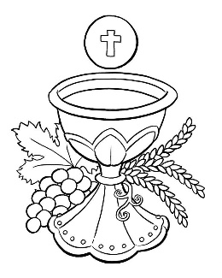
SUNDAY MASS TIMES
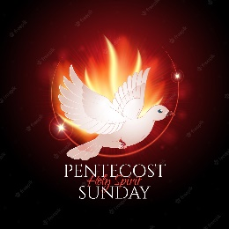
Saturday 6.00pm St. Patrick’s church
Sunday 9.30am Christ the King church
Sunday 11.00am St. Patrick’s church WEEKDAY LITURGY TIMES
Tuesday 10.00am Christ the King
Wednesday 10.00am St. Patrick’s
Thursday: 10.00am Christ the King
Friday: 10.00am St. Patrick’s
MASS INTENTIONS RECEIVED: Special Intention, Marie Pickering (3rd Anni.), Heather and Kristoffer (getting married on Wednesday in Essex)
ANNIVERSARIES: May 28th – June 3rd:
Mary O'Dea, Charles Greenfield, Doris Ludley, David Hughes, Mary Clare Gowling, Teresa Mary Watson, Paul Harbottle, Theresa Crossley, James Cuthbert, Maureen Stott, Marjorie Gascoyne, Anthony L. Del Nevo, Peter Osbourne, John Dick, John Frew, Terence Gaynor Elliott, John Goodburn Smith, Marie Pickering, Margaret Brickles, Ken Latham, John Ross, Mary Mulqueen, William (Bill) Jones, Deborah Bell.
PLEASE REMEMBER in your prayers all our sick and housebound brothers and sisters.
The word this week
Acts 2:1–11 As on Sinai, the Lord descends in fire and wind.
Psalm 103 ‘Send forth your Spirit, O Lord, and renew the face of the earth.’
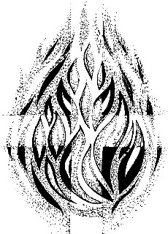
1 Corinthians 12:3b–7,12–13 The Spirit calls the baptized to ministry for the common good.
John 20:19–23 On the first day of the week the risen Christ imparts the Holy Spirit.
We arrive at the fiftieth day - the completion of the Easter Season, and the completion of the Paschal Mystery: the Lord has died, is risen, has ascended to heaven and now gives birth to his Church, by sending the Spirit upon the apostles. This feast of the gift of the Spirit is so significant for us, because it marks the handing on of Jesus’ ministry to the Church. In the Church we are guaranteed the presence of the Lord, in his sacraments, in his ministers, in the Blessed Sacrament and in his Celebrated Word. It also marks the fulfilment of our thoughts about baptism throughout this season. The gift of the Spirit which we receive in Confirmation is the ‘seal’ of our baptism, guaranteeing and confirming all that baptism achieves.
AT MASS TODAY WE PRAY Eucharistic Prayer 2 for Reconciliation and Preface for Pentecost
The Holy Spirit comes to shed a ray of light divine. We pray that our wounds be healed, our hearts strengthened, and the guilt of our sins washed away. It is in and through the power of the Holy Spirit, sent to rest on the faithful followers of Jesus, that we raise our voices in
this great thanksgiving prayer.
‘FLAME OF LOVE’ Conference at Erdington Abbey on Wednesday, June 7th. Guest Speaker is Fr. James Blount.
See notice board in church porch for more details.
Litany to the Holy Spirit.
In the hour of my distress, When temptations me oppress, And when I my sins confess, Sweet Spirit comfort me!
When I lie within my bed, Sick in heart and sick in head, And with doubts discomforted, Sweet Spirit comfort me!
When the house doth sigh and weep, And the world is drowned in sleep, Yet mine eyes the watch do keep, Sweet Spirit comfort me!
When the passing bell doth toll, And the Furies in a shoal, Come to fright a parting soul, Sweet Spirit comfort me!
When the tapers now burn blue, And the comforters are few, And that number more than true, Sweet Spirit comfort me!
When the priest his last hath prayed, And I nod to what is said, ‘Cause my speech is now decayed, Sweet Spirit comfort me!
When (God knows) I’m tossed about, Either with despair or doubt, Yet before the glass is out, Sweet Spirit comfort me!
When the Tempter me pursu’th, With the sins of all my youth, And half damns me with untruth, Sweet Spirit comfort me!
When the flames and hellish cries Fright mine ears and fright mine eyes, And all terrors me surprise, Sweet Spirit comfort me!
When the judgement is revealed, And that opened which was sealed, When to thee I have appealed, Sweet Spirit comfort me!
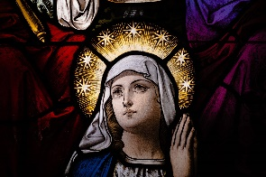
{Robert Herrick}

Our Lady of Lourdes, Pray for us

Pentecost Sunday
May 28th, 2023

First reading Acts 2:1-11

When Pentecost day came round, they had all met in one room, when suddenly they heard what sounded like a powerful wind from heaven, the noise of which filled the entire house in which they were sitting; and something appeared to them that seemed like tongues of fire; these separated and came to rest on the head of each of them. They were all filled with the Holy Spirit, and began to speak foreign languages as the Spirit gave them the gift of speech.
Now there were devout men living in Jerusalem from every nation under heaven, and at this sound they all assembled, each one bewildered to hear these men speaking his own language. They were amazed and astonished. ‘Surely’ they said ‘all these men speaking are Galileans? How does it happen that each of us hears them in his own native language? Parthians, Medes and Elamites; people from Mesopotamia, Judaea and Cappadocia, Pontus and Asia, Phrygia and Pamphylia, Egypt and the parts of Libya round Cyrene; as well as visitors from Rome – Jews and proselytes alike – Cretans and Arabs; we hear them preaching in our own language about the marvels of God.’

Second reading 1 Corinthians 12:3-7,12-13

No one can say, ‘Jesus is Lord’ unless he is under the influence of the Holy Spirit.
There is a variety of gifts but always the same Spirit; there are all sorts of service to be done, but always to the same Lord; working in all sorts of different ways in different people, it is the same God who is working in all of them. The particular way in which the Spirit is given to each person is for a good purpose.
Just as a human body, though it is made up of many parts, is a single unit because all these parts, though many, make one body, so it is with Christ. In the one Spirit we were all baptised, Jews as well as Greeks, slaves as well as citizens, and one Spirit was given to us all to drink.

Gospel Acclamation
Alleluia, alleluia!
Come, Holy Spirit, fill the hearts of your faithful
and kindle in them the fire of your love.
Alleluia

Gospel Reading John 20:19-23

In the evening of the first day of the week, the doors were closed in the room where the disciples were, for fear of the Jews. Jesus came and stood among them. He said to them, ‘Peace be with you’, and showed them his hands and his side. The disciples were filled with joy when they saw the Lord, and he said to them again, ‘Peace be with you.
‘As the Father sent me,
so am I sending you.’
After saying this he breathed on them and said:
‘Receive the Holy Spirit.
For those whose sins you forgive,
they are forgiven;
for those whose sins you retain,
they are retained.’

