Postal address:
Christ the King Church
Trenchard Avenue
TS17 0EG
www.ctkthornaby.co.uk
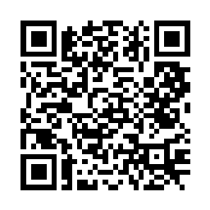
St Patrick’s Church
Westbury Street
TS17 6NW
www.stpatrickschurch.co.uk
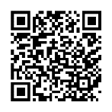
Christ the King House
Trenchard Avenue
TS17 0EG
T: 01642 750467
Email: thornaby@rcdmidd.org.uk

CHRISTMAS December 24th/25th, 2022
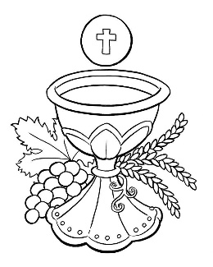
CHRISTMAS MASS TIMES
CHRISTMAS EVE: 5.00pm St. Patrick’s church
CHRISTMAS EVE 7.00pm Christ the King church
CHRISTMAS DAY 10.30am St. Patrick’s church
WEEKDAY MASS TIMES THIS WEEK
Monday 12 Midday St. Patrick’s St. Stephen
Tuesday 10.00am Christ the King St. John the Evangelist
Wednesday 10.00am St. Patrick’s The Holy Innocents
Thursday: 10.00am Christ the King St. Thomas of Canterbury
Friday: 10.00am St. Patrick’s The Holy Family
SACRAMENT OF RECONCILIATION any time on request
MASS INTENTIONS RECEIVED: Special Intention, Frank Hudson, Amanda Hudson, Curly family, Manuel Family, Special intention, John Leeming R.I.P., Special intention on 90th birthday, Mary Ann Hunt, James Devlin (Anni.),
Cassie and Norman Chesser, Theresa Gould R.I.P.,
ANNIVERSARIES December 25th – 31st:
Bernard McLeary, Kathleen Kane, Yvonne Clasper, James Devlin, Ivor Blott, Winifred Margaret Heron, Peter Rafferty,
Kevin Desmond Green, Mary Ann Hunt, Bishop Thomas Kevin O'Brien, Doreen Ward, Veronica Burns, John Ritchie,
Joan Whaley, Hughie O,Rourke, Carol Lockwood, Freda Livermore, Tom Drummond, James Lapsley, Arthur Batey,
Roy Rogers, Peter Clement.
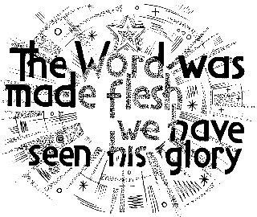
PLEASE REMEMBER in your prayers all our sick and housebound brothers and sisters.
The word this week
Christmas Night Mass
Isaiah 9:1–6 A son is given to us
Psalm 95 ‘Today a saviour has been born to us; he is Christ the Lord.’
Titus 2:11–14 God’s grace has been revealed to the whole human race.
Luke 2:15–20 The time came for her to have her child, and she gave birth to a son.
Christmas Day Mass
Isaiah 62:11–12 Look, your saviour comes.
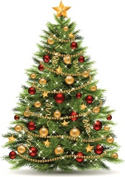
Psalm 96 ‘This day new light will shine upon the earth: the Lord is born to us.’
Titus 3:4–7 It was for no reason except his own compassion that he saved us.
Luke 2:15–20 The shepherds found Mary and Joseph and the baby.
A
fter the annual celebration of the Paschal Mystery (Easter) the people of the Church has no more ancient custom than celebrating the memorial of the nativity of the Lord and of his first manifestations – and this takes place in Christmas time.
This feast of the Lord’s birth (Christmas) celebrates the mystery of the incarnation by which the Word of God humbled himself to share in our humanity, in order that he might help us to become sharers in his divinity.
AT MASS TODAY WE PRAY Eucharistic Prayer 3 and Preface 1 for Christmas
With great joy on this festival day, we are filled with wonder and awe at the birth of God’s Son. With a profound sense of gratitude we raise our voices in this great prayer of thanksgiving.
RECENTLY DECEASED: Please remember in your prayers Constance Rose Good, aged 74, from Thornaby, who died recently. Her Funeral Service will take place at St. Patrick’s church on Thursday, January 5th, at 11.00am. ALSO, Mr. John Scott, aged 75, from Thornaby, who died recently. His Funeral Service will take place at Christ the King church on Thursday, January 12th, at 10.00am. May he rest in peace.
“BEREAVEMENT GROUP sends love and prayers to all who are experiencing the loss of a loved one this Christmas. May the Holy Family bring you peace and consolation.”
A CHRISTMAS BLESSING FOR YOU AND YOUR PEOPLE
“May the God of infinite goodness, who by the incarnation of his Son has driven darkness from the world and by that glorious Birth has illumined this most holy night, drive far from you the darkness of vice and illumine your hearts with the light of virtue.
May God, who willed that the great joy of his Son’s saving Birth be announced to shepherds by the Angel, fill your minds with the gladness he gives and make you heralds of his Gospel.
And may God, who by the Incarnation brought together the earthly and the heavenly realm, fill you with the gift of his peace and favour and make you sharers with the Church in heaven.”

Christmas Readings
December 24th/25th 2022

First reading Isaiah 9:1-7

The people that walked in darkness has seen a great light;
on those who live in a land of deep shadow a light has shone.
You have made their gladness greater,
you have made their joy increase;
they rejoice in your presence as men rejoice at harvest time,
as men are happy when they are dividing the spoils.
For the yoke that was weighing on him, the bar across his shoulders, the rod of his oppressor,
these you break as on the day of Midian.
For all the footgear of battle, every cloak rolled in blood, is burnt, and consumed by fire.
For there is a child born for us,
a son given to us
and dominion is laid on his shoulders;
and this is the name they give him:
Wonder-Counsellor, Mighty-God, Eternal-Father, Prince-of-Peace.
Wide is his dominion in a peace that has no end,
for the throne of David and for his royal power,
which he establishes and makes secure in justice and integrity.
From this time onwards and for ever,
the jealous love of the Lord of Hosts will do this.

Responsorial Psalm: ‘Today a saviour has been born to us; he is Christ the Lord.’

Second reading Titus 2:11-14

God’s grace has been revealed, and it has made salvation possible for the whole human race and taught us that what we have to do is to give up everything that does not lead to God, and all our worldly ambitions; we must be self-restrained and live good and religious lives here in this present world, while we are waiting in hope for the blessing which will come with the Appearing of the glory of our great God and saviour Christ Jesus. He sacrificed himself for us in order to set us free from all wickedness and to purify a people so that it could be his very own and would have no ambition except to do good.

Gospel Acclamation
Alleluia, alleluia!
I bring you news of great joy:
today a saviour has been born to us, Christ the Lord.
Alleluia!

Gospel Reading Luke 2:1-14

Caesar Augustus issued a decree for a census of the whole world to be taken. This census – the first – took place while Quirinius was governor of Syria, and everyone went to his own town to be registered. So Joseph set out from the town of Nazareth in Galilee and travelled up to Judaea, to the town of David called Bethlehem, since he was of David’s House and line, in order to be registered together with Mary, his betrothed, who was with child. While they were there the time came for her to have her child, and she gave birth to a son, her first born. She wrapped him in swaddling clothes, and laid him in a manger because there was no room for them at the inn.
In the countryside close by there were shepherds who lived in the fields and took it in turns to watch their flocks during the night. The angel of the Lord appeared to them and the glory of the Lord shone round them. They were terrified, but the angel said, ‘Do not be afraid. Listen, I bring you news of great joy, a joy to be shared by the whole people. Today in the town of David a saviour has been born to you; he is Christ the Lord. And here is a sign for you: you will find a baby wrapped in swaddling clothes and lying in a manger.’ And suddenly with the angel there was a great throng of the heavenly host, praising God and singing:
‘Glory to God in the highest heaven,
and peace to men who enjoy his favour.’

