St. Patrick’s church, 39 Westbury St. TS17 6NW Christ the King church, Trenchard Ave. TS17 0EG
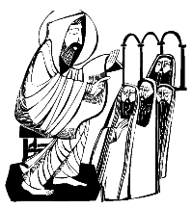
Postal address: Christ the King House, Trenchard Avenue, TS17 0EG
Telephone: 01642 750467
EMAIL: thornaby@rcdmidd.org.uk
Christ the King Website: www.ctkthornaby.co.uk St. Patrick’s Website: www.stpatrickschurch.co.uk
3rd Sunday in Ordinary Time (c) January 23rd, 2022
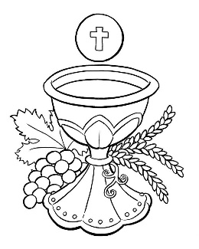
SUNDAY MASS TIMES

6.00pm (Saturday) St. Patrick’s church
9.30am Christ the King church
11.00am St. Patrick’s church
WEEKDAY MASSES
Tuesday: 10.00am Christ the King
Wednesday: 12.30pm Christ the King {Funeral Service}
Thursday: 10.00am Christ the King
Friday: 10.00am Christ the King
SACRAMENT OF RECONCILIATION any time on request

MASS INTENTIONS RECEIVED: Special Intention,
ANNIVERSARIES: January 23rd – 29th:
Ann Ward, Mary Crotty Bryan, Peter McBride, Sheila Mary Thomas, Mary Monaghan, Frank Hutchinson,
James Spaight, Irene Ward, Mary Hopkins, John Spaight, Cath. Rigg, Heather Pybus, Daniel McCann (aged 5),
Louis James Simpson, Carol Wilkinson, Michael Dixon, Dennis Devine.

PLEASE REMEMBER in your prayers all our sick and housebound brothers and sisters.
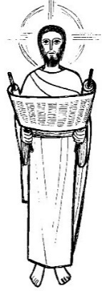
The word this week
Nehemiah 8:2–4a, 5–6, 8–10 They read from the book of the Law and understood what was read.
Psalm 19 ‘Your words are Spirit, Lord, and they are life.’
1 Corinthians 12–14, 27 We are Christ’s body.
Luke 1:1–4; 4:14–21 Today the Scripture passage is fulfilled.
‘This day is sacred to the Lord your God,’ Ezra proclaims toward the end of today’s first reading, for the people were able to gather together to worship for the first time in over fifty years. What joy it must have inspired!
After our brief excursion last week into Saint John's Gospel, we are back on track this week with Saint Luke - whom we will follow for the rest of the year. Today is about beginnings: the beginning of Jesus' public ministry. It begins with the Word of God, in the synagogue. Jesus reads from the Old Testament, as we do every Sunday, and tells the people that it is fulfilled in him. Everything that God has said to his people, through his prophets, comes together in Jesus, the Incarnate Word of God.

RECENTLY DECEASED: Please remember in your prayers Mr. Neil Terence Wren, aged 65, from Thornaby, who died recently. His Funeral Service will take place at Christ the King church this Wednesday, January 26th, at 12. 30pm. May he rest in peace.

AT MASS TODAY WE PRAY Eucharistic Prayer 1 for unity with its own Preface
Just as Jesus opened the scroll and announced that he was the fulfilment of Isaiah’s prophecy, we now open the Church’s holy book and proclaim this great prayer of thanksgiving.
TEA/COFFEE ETC after Sunday morning Mass at Christ the King and St. Patrick’s
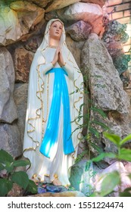
LOURDES DIOCESAN PILGRIMAGE 2022 is going ahead from May 30yh – June 3rd. Booking Forms are available in the church porch.
Hail, holy Queen, Mother of mercy, Hail, our life, our sweetness and our hope. To thee do we cry, poor banished children of Eve: To thee do we send up our sighs, Mourning and weeping in this vale of tears. Turn then, most gracious Advocate, thine eyes of mercy toward us, and after this our exile, show unto us the blessed fruit of thy womb, Jesus,
O clement, O loving, O sweet Virgin Mary! Amen.

MESSAGE FROM MARGARET NELSON: “I would like to thank everyone who contributed to my Birthday Surprise recently. The gifts were very much appreciated – and I must say, humbly, from such lovely friends.”

READINGS FOR 3rd SUNDAY IN ORDINARY TIME {C}
January 23rd, 2022

First reading Nehemiah 8:2-6,8-10

Ezra the priest brought the Law before the assembly, consisting of men, women, and children old enough to understand. This was the first day of the seventh month. On the square before the Water Gate, in the presence of the men and women, and children old enough to understand, he read from the book from early morning till noon; all the people listened attentively to the Book of the Law.
Ezra the scribe stood on a wooden dais erected for the purpose. In full view of all the people – since he stood higher than all the people – Ezra opened the book; and when he opened it all the people stood up. Then Ezra blessed the Lord, the great God, and all the people raised their hands and answered, ‘Amen! Amen!’ Then they bowed down and, face to the ground, prostrated themselves before the Lord. And Ezra read from the Law of God, translating and giving the sense, so that the people understood what was read.
Then Nehemiah – His Excellency – and Ezra, priest and scribe, and the Levites who were instructing the people, said to all the people, ‘This day is sacred to the Lord your God. Do not be mournful, do not weep.’ For the people were all in tears as they listened to the words of the Law.
He then said, ‘Go, eat the fat, drink the sweet wine, and send a portion to the man who has nothing prepared ready. For this day is sacred to our Lord. Do not be sad: the joy of the Lord is your stronghold.’

Second reading 1 Corinthians 12:12-30

Just as a human body, though it is made up of many parts, is a single unit because all these parts, though many, make one body, so it is with Christ. In the one Spirit we were all baptised, Jews as well as Greeks, slaves as well as citizens, and one Spirit was given to us all to drink.
Nor is the body to be identified with any one of its many parts.
Now you together are Christ’s body; but each of you is a different part of it.

Gospel Acclamation
Alleluia, alleluia!
The Lord has sent me to bring the good news to the poor,
to proclaim liberty to captives.
Alleluia!

Gospel Reading Luke 1:1-4,4:14-21

'This text is being fulfilled today even as you listen'
Seeing that many others have undertaken to draw up accounts of the events that have taken place among us, exactly as these were handed down to us by those who from the outset were eyewitnesses and ministers of the word, I in my turn, after carefully going over the whole story from the beginning, have decided to write an ordered account for you, Theophilus, so that your Excellency may learn how well founded the teaching is that you have received.
Jesus, with the power of the Spirit in him, returned to Galilee; and his reputation spread throughout the countryside. He taught in their synagogues and everyone praised him.
He came to Nazara, where he had been brought up, and went into the synagogue on the sabbath day as he usually did. He stood up to read and they handed him the scroll of the prophet Isaiah. Unrolling the scroll he found the place where it is written:
The spirit of the Lord has been given to me,
for he has anointed me.
He has sent me to bring the good news to the poor,
to proclaim liberty to captives
and to the blind new sight,
to set the downtrodden free,
to proclaim the Lord’s year of favour.
He then rolled up the scroll, gave it back to the assistant and sat down. And all eyes in the synagogue were fixed on him. Then he began to speak to them, ‘This text is being fulfilled today even as you listen.’

