St. Patrick’s church, 39 Westbury St. TS17 6NW Christ the King church, Trenchard Ave. TS17 0EG
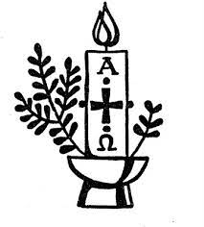
Postal address: Christ the King House, Trenchard Avenue, TS17 0EG
Telephone: 01642 750467
EMAIL: thornaby@rcdmidd.org.uk
Christ the King Website: www.ctkthornaby.co.uk St. Patrick’s Website: www.stpatrickschurch.co.uk

6th Sunday of Easter May 22nd 2022
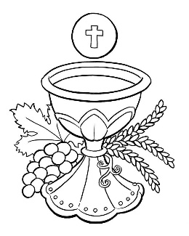
SUNDAY MASS TIMES
Saturday 6.00pm St. Patrick’s church
9.30am Christ the King church
11.00am St. Patrick’s church
WEEKDAY LITURGIES

Tuesday 10.00am Christ the King
Wednesday 6.00pm St. Patrick’s
Ascension Thursday 10.00am Christ the King
Friday 10.00am St. Patrick’s
SACRAMENT OF RECONCILIATION any time on request
MASS INTENTIONS RECEIVED: Special Intention, Betty & Benny McMahon, Fr. Bill Ryan (Birthday)
Bob England,
ANNIVERSARIES: May 22nd – 28th:
Terence Darragh, Bob Presgrave, Kenneth Pickering, Leititia Louisa Middleton, Edith Hart, Gertrude Whyte,
James McEvoy, Nancy Stansmore, David Jones, Mildred Mallon, Bob England, Winifred Gascoyne, John Costello,
Christine Walton, Mary O'Dea, Charles Greenfield.
PLEASE REMEMBER in your prayers all our sick and housebound brothers and sisters.
The word this week
Acts 15:1–2, 22–29 Faced with controversy, the disciples reach a decision under the Spirit’s guidance.
Psalm 67 ‘Let the peoples praise you, O God, let all the peoples praise you.’
Revelation 21:10–14, 22–23 John sees the city of God illumined in splendour.
John 14:23–29 Jesus promises to send the Holy Spirit to guide his followers.
A
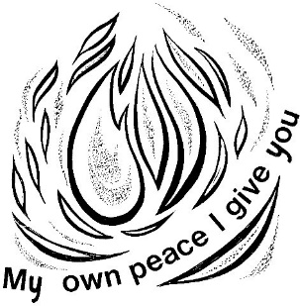
s Eastertide unfolds, we feel the power and influence of the Spirit growing. This is the Spirit who raised Jesus from the dead, and the Spirit who brings the Church to birth at Pentecost. As we journey towards Pentecost – the climax of the Easter Season – we should be considering the presence of the Spirit in the Church today: the reconciler of disputes, the solver of problems, true inspiration for the family of God on our journey to the New Jerusalem! From this side, Pentecost is about promise: the Lord at the Last Supper promises that He and the Father will be “at home” with all who keep his words – and it is the Advocate, the Holy Spirit who will remind us of these and all his words. We believe that all Scripture is “inspired” – the word of the Spirit – so as we listen or proclaim this Sunday let us look for the fulfilment of the promise made by the Lord.

AT MASS TODAY WE PRAY Eucharistic Prayer 2 and Preface 3 for Easter
Brighter than the sun and moon together, with a light that makes the walls of the holy city sparkle like crystal, God’s Lamb shines in splendour. In the eucharistic feast, all created things stream into the twelve gates of the new Jerusalem to begin the supper of the Lamb.
ASCENSION THURSDAY: This Thursday, May 26th, is The Feast of The Ascension of our Lord. Mass times for the Feast are Wednesday 6.00pm at St. Patrick’s and Thursday 10.00am at Christ the King.

RECENTLY DECEASED: Please remember in your prayers Mr. Terence (Terry) Peter John Sawdon, aged 78, from Thornaby who died recently. His Funeral Service will be at St. Patrick’s church on Friday, May 27th, at 1.00pm. May he rest in peace.
TEA/COFFEE ETC after Sunday morning Mass at Christ the King and St. Patrick’s
‘CONTACTLESS IS HERE! In both St. Patrick’s and Christ the King churches you will see a Digital Collection Plate which will enable us to take donations by card for the first time ever. We will also have a dedicated webpage for online donations. It should make supporting our churches more accessible to all.
“MAY PROCESSION” this Sunday, May 22nd, during 11.00am Mass
CELEBRATION OF THE QUEEN’S JUBILEE in Christ the King Parish hall on Thursday, June 2nd, 7.00pm – 10.30pm. Tickets £6. Bring your own drinks & nibbles. Entertainment by Marty Q. Bingo, Raffle, Jubilee Quiz. Proceeds to go to Ukraine and Francis Hannaway.

READINGS FOR 6th SUNDAY OF EASTER {C}
May 22nd, 2022

First reading Acts 15:1-2,22-29

Some men came down from Judaea and taught the brothers, ‘Unless you have yourselves circumcised in the tradition of Moses you cannot be saved.’ This led to disagreement, and after Paul and Barnabas had had a long argument with these men it was arranged that Paul and Barnabas and others of the church should go up to Jerusalem and discuss the problem with the apostles and elders.
Then the apostles and elders decided to choose delegates to send to Antioch with Paul and Barnabas; the whole church concurred with this. They chose Judas known as Barsabbas and Silas, both leading men in the brotherhood, and gave them this letter to take with them:
‘The apostles and elders, your brothers, send greetings to the brothers of pagan birth in Antioch, Syria and Cilicia. We hear that some of our members have disturbed you with their demands and have unsettled your minds. They acted without any authority from us; and so we have decided unanimously to elect delegates and to send them to you with Barnabas and Paul, men we highly respect who have dedicated their lives to the name of our Lord Jesus Christ. Accordingly we are sending you Judas and Silas, who will confirm by word of mouth what we have written in this letter. It has been decided by the Holy Spirit and by ourselves not to saddle you with any burden beyond these essentials: you are to abstain from food sacrificed to idols; from blood, from the meat of strangled animals and from fornication. Avoid these, and you will do what is right. Farewell.’

Second reading Apocalypse 21:10-14,22-23

In the spirit, the angel took me to the top of an enormous high mountain and showed me Jerusalem, the holy city, coming down from God out of heaven. It had all the radiant glory of God and glittered like some precious jewel of crystal-clear diamond. The walls of it were of a great height, and had twelve gates; at each of the twelve gates there was an angel, and over the gates were written the names of the twelve tribes of Israel; on the east there were three gates, on the north three gates, on the south three gates, and on the west three gates. The city walls stood on twelve foundation stones, each one of which bore the name of one of the twelve apostles of the Lamb.
I saw that there was no temple in the city since the Lord God Almighty and the Lamb were themselves the temple, and the city did not need the sun or the moon for light, since it was lit by the radiant glory of God and the Lamb was a lighted torch for it.

Gospel Acclamation
Alleluia, alleluia!
Jesus said: ‘If anyone loves me he will keep my word,
and my Father will love him,
and we shall come to him.’
Alleluia!

Gospel Reading John 14:23-29

Jesus said to his disciples:
‘If anyone loves me he will keep my word,
and my Father will love him,
and we shall come to him and make our home with him.
Those who do not love me do not keep my words.
And my word is not my own: it is the word of the one who sent me.
I have said these things to you while still with you;
but the Advocate, the Holy Spirit, whom the Father will send in my name, will teach you everything
and remind you of all I have said to you.
Peace I bequeath to you, my own peace I give you, a peace the world cannot give, this is my gift to you.
Do not let your hearts be troubled or afraid.
You heard me say: I am going away, and shall return.
If you loved me you would have been glad to know that I am going to the Father,
for the Father is greater than I.
I have told you this now before it happens, so that when it does happen you may believe.’

