Postal address:
Christ the King Church
Trenchard Avenue
TS17 0EG
www.ctkthornaby.co.uk
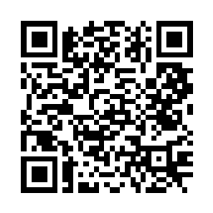
St Patrick’s Church
Westbury Street
TS17 6NW
www.stpatrickschurch.co.uk
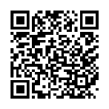
Christ the King House
Trenchard Avenue
TS17 0EG
T: 01642 750467
Email: thornaby@rcdmidd.org.uk

Feast of Christ the King (C) November 20th, 2022
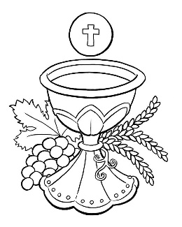
SUNDAY MASS TIMES
Saturday 6.00pm St. Patrick’s church
9.30am Christ the King church
11.00am St. Patrick’s church
WEEKDAY LITURGIES
Tuesday 10.00am Christ the King
Wednesday 10.00am St. Patrick’s
Thursday: 10.00am Funeral Mass at Christ the King
Friday 7.00pm at Christ the King (November Memorial Mass)
SACRAMENT OF RECONCILIATION any time on request
MASS INTENTIONS RECEIVED: Special Intention, Frank Hudson (1st Anni.), Cassie Chesser,
ANNIVERSARIES November 20th – 26th:
James Stewart, Betty Haycock, Apolinario G. Valdez, Elizabeth Goven, Christine Anne Voules, Arthur Cooper, Rita Boyd, David Smith, Bill Porteus, James Betts, John David Haycock, Peter Sewell, Ada Hill, Mary Fairlie,
PLEASE REMEMBER in your prayers all our sick and housebound brothers and sisters.
The word this week
2 Samuel 5:1–3 The shepherd David is anointed king.
Psalm 121 “I rejoiced when I heard them say: Let us go to God’s house.’
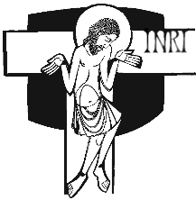
Colossians 1:12–20 God has made us worthy to share the lot of the saints in light.
Luke 23:35–43 Jesus, remember me when you come into your kingdom.
T
he year of Saint Luke ends with a characteristic take on the Feast of Christ the King. In Luke’s gospel we are so familiar with seeing and hearing the voiceless, the rejected, those whom society puts in second place. How suitable, then, that on the feast of the King of all Creation we see him at his most vulnerable – on the cross, with only an abrupt inscription to announce that he is the King. He is King because of the work he has done, which is described by Saint Paul in the Second Reading: “all things [are] reconciled through him and for him … when he made peace by his death on the cross.” Next week, when we re-enter Advent and a new Liturgical Year, we will be thinking of the King who will come again: though he will come as his disciples saw him go at the Ascension, the marks of the cross will still be visible for all time, to remind us of the one who came to reunite all Creation, especially frail human creatures.
AT MASS TODAY WE PRAY Eucharistic Prayer 2 and Preface for Christ the King
St Paul urges us to give thanks to God, who has made us fit to share in the inheritance of the saints. At this table we join our hearts with the angels and saints in an endless prayer of praise and thanksgiving to Jesus Christ our King.
ROSARY AND ADORATION: The Rosary will be prayed at Christ the King church on Tuesdays at 9.00am followed by Exposition of The Blessed Sacrament until 9.50am
MEMORIAL MASS: will be held in Christ the King Church this Friday, 25th November, at 7pm to remember all who have died in the past year. During the Mass there will also be an opportunity for parishioners to place a candle on the altar in remembrance of their departed loved ones. May they rest in peace.
RECENTLY DECEASED: Please remember in your prayers Mr. Beresford (Bill) Errington, aged 85, from Thornaby. His Funeral Mass will take place at Christ the King church this Thursday, November 24th, at 10.00am. ALSO, Mrs. Geraldine Antonia Fox, aged 77, from Thornaby. Her Funeral Service to take place at St. Patrick’s church on Tuesday, November 29th, at 10.00am. May they rest in peace.
TEA/COFFEE ETC after Sunday morning Mass at Christ the King and St. Patrick’s
CHRIST THE KING CHRISTMAS PARTY on Saturday, December 10th, 1pm – 4pm. Tickets on sale £5.00
CHRISTMAS HAMPERS: Donations towards the Christmas Hampers very welcome
JOE HAMMILL is working with children from St Patrick’s and Christ the King Primary Schools to learn parts of the Mass to sing. If you would like to join the children in this you are welcome to at St Patrick’s Primary School on Thursday next, 24th November, at 1:15pm
“AT THE END OF THE LITURGICAL YEAR”
“May you recognize in your life the presence, power and light of your soul.
May you realize that you are never alone, That your soul in its brightness and belonging connects you intimately with the rhythm of the universe.
May you have respect for your individuality and difference.
May you realize that the shape of your soul is unique, that you have a special destiny here.
That behind the façade of your life, There is something beautiful and eternal happening.
May you learn to see your self with the same delight, pride and expectation with which God sees you in every moment.”
{John O’Donohue}

Feast of Christ the King (C)
November 20th, 2022

First reading 2 Samuel 5:1-3

All the tribes of Israel then came to David at Hebron. ‘Look’ they said ‘we are your own flesh and blood. In days past when Saul was our king, it was you who led Israel in all their exploits; and the Lord said to you, “You are the man who shall be shepherd of my people Israel, you shall be the leader of Israel.”’ So all the elders of Israel came to the king at Hebron, and King David made a pact with them at Hebron in the presence of the Lord, and they anointed David king of Israel.

Second reading Colossians 1:12-20

We give thanks to the Father who has made it possible for you to join the saints and with them to inherit the light.
Because that is what he has done: he has taken us out of the power of darkness and created a place for us in the kingdom of the Son that he loves, and in him, we gain our freedom, the forgiveness of our sins.
He is the image of the unseen God
and the first-born of all creation,
for in him were created
all things in heaven and on earth:
everything visible and everything invisible,
Thrones, Dominations, Sovereignties, Powers –
all things were created through him and for him.
Before anything was created, he existed,
and he holds all things in unity.
Now the Church is his body,
he is its head.
As he is the Beginning,
he was first to be born from the dead,
so that he should be first in every way;
because God wanted all perfection
to be found in him
and all things to be reconciled through him and for him,
everything in heaven and everything on earth,
when he made peace
by his death on the cross.

Gospel Acclamation
Alleluia, alleluia!
Blessings on him who comes in the name of the Lord!
Blessings on the coming kingdom of our father David!
Alleluia!

Gospel Reading Luke 23:35-43

The people stayed there before the cross watching Jesus. As for the leaders, they jeered at him. ‘He saved others,’ they said ‘let him save himself if he is the Christ of God, the Chosen One.’ The soldiers mocked him too, and when they approached to offer vinegar they said, ‘If you are the king of the Jews, save yourself.’ Above him there was an inscription: ‘This is the King of the Jews.’
One of the criminals hanging there abused him. ‘Are you not the Christ?’ he said. ‘Save yourself and us as well.’ But the other spoke up and rebuked him. ‘Have you no fear of God at all?’ he said. ‘You got the same sentence as he did, but in our case we deserved it: we are paying for what we did. But this man has done nothing wrong. Jesus,’ he said ‘remember me when you come into your kingdom.’ ‘Indeed, I promise you,’ he replied ‘today you will be with me in paradise.’

