St. Patrick’s church, 39 Westbury St. TS17 6NW Christ the King church, Trenchard Ave. TS17 0EG
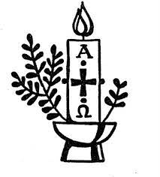
Postal address: Christ the King House, Trenchard Avenue, TS17 0EG
Telephone: 01642 750467
EMAIL: thornaby@rcdmidd.org.uk
Christ the King Website: www.ctkthornaby.co.uk St. Patrick’s Website: www.stpatrickschurch.co.uk

EASTER SUNDAY April 17th, 2022
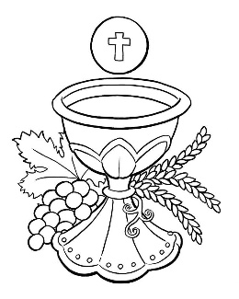
SUNDAY MASS TIMES
Saturday 6.00pm St. Patrick’s church
9.30am Christ the King church
11.00am St. Patrick’s church
WEEKDAY LITURGIES
Tuesday 10.00am Christ the King
Wednesday 10.00am St. Patrick’s
Thursday 10.00am Christ the King
Friday 10.00am St. Patrick’s

SACRAMENT OF RECONCILIATION any time on request
MASS INTENTIONS RECEIVED: Special Intention, Ernie Roberts, Margery Devlin (3rd Anni.), Frank Hudson, John & Olive Manuel, Amanda Hudson, In thanksgiving to St. Theresa of the Little Flower.
ANNIVERSARIES: April 17th – 23rd:
David Morgan, Ann Nolan, Betty Oates, Alice T. Ruddy, Michael Mulqueen, Margery Devlin, Ellen Curtis, Henry Crossley, Monsignor Thomas Breen, Malcolm Forgan, Francis Saunders, Patricia Anne Crossen, Pat Swalwell, Marie Farrer, Alan Ling, Walter Fleming, William Cross, Tom Haycock, Margaret O'Boyle, Bill Crossley, David Carter, Rita Baker, Irene Cumiskey, Alan Trigg.
PLEASE REMEMBER in your prayers all our sick and housebound brothers and sisters.

The word this week
Acts 10:34, 37–43 Peter is an eyewitness: The Lord is risen.
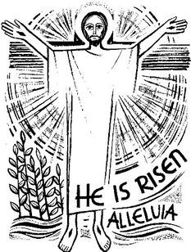
Psalm 118 ‘This day was made by the Lord; we rejoice and be glad.’
Colossians 3:1–4 All who are baptized, set your hearts in heaven, where Christ is.
John 20:1–9 Three witnesses, Mary, Peter, and John, each responds to the empty tomb.
W
hen the Word is proclaimed, it is real and active – the Lord is present, and what is described is, in a sense, happening now. On certain days this is made more obvious by the selection of scripture that refers to a particular time or day. Such a selection occurs this morning, when we go with Mary Magdalene to visit the tomb, only to make – with her – a momentous discovery: the tomb is empty, he is risen! On this holy morning we hear St. Peter and St. Paul testify to Jesus’ resurrection and what it means to all of us who have been baptized in him. We also hear St John’s account of that first Easter morning.

AT MASS TODAY WE PRAY Eucharistic Prayer 2 and Preface 1 for Easter
power of Christ’s death and resurrection draws us into this prayer of thanksgiving. Grateful for all God accomplished in Christ, we lift up heart and voice in joy on this festive day.

RECENTLY DECEASED: Please remember in your prayers Mrs. Dorothy Luck, aged 81, from Thornaby, who died recently. Her Funeral Service will take place at St. Patrick’s church on Monday, April 25th, at 10.00am
ALSO, Mrs. Patricia Morris, aged 74, from Thornaby, who died recently. Her Funeral Service will take place on Wednesday, April 27th, at Stockton Crematorium at 2.00pm. May they rest in peace.

TEA/COFFEE ETC after Sunday morning Mass at Christ the King and St. Patrick’s
‘CONTACTLESS IS COMING! In both St. Patrick’s and Christ the King churches, from next week, you will see a Digital Collection Plate which will enable us to take donations by card for the first time ever. We will also have a dedicated webpage for online donations. It should make supporting our churches more accessible to all.
SACRAMENT OF CONFIRMATION for those who have already given their names will be on Wednesday, May 11th, at the Cathedral, Coulby Newham, at 7.00pm

ALLELUIA ALLELUIA ALLELUIA

READINGS FOR EASTER SUNDAY {C}
April 17th, 2022

First reading Acts 10:34,37-43

Peter addressed Cornelius and his household: ‘You must have heard about the recent happenings in Judaea; about Jesus of Nazareth and how he began in Galilee, after John had been preaching baptism. God had anointed him with the Holy Spirit and with power, and because God was with him, Jesus went about doing good and curing all who had fallen into the power of the devil. Now I, and those with me, can witness to everything he did throughout the countryside of Judaea and in Jerusalem itself: and also to the fact that they killed him by hanging him on a tree, yet three days afterwards God raised him to life and allowed him to be seen, not by the whole people but only by certain witnesses God had chosen beforehand. Now we are those witnesses – we have eaten and drunk with him after his resurrection from the dead – and he has ordered us to proclaim this to his people and to tell them that God has appointed him to judge everyone, alive or dead. It is to him that all the prophets bear this witness: that all who believe in Jesus will have their sins forgiven through his name.’

Second reading Colossians 3:1-4

Since you have been brought back to true life with Christ, you must look for the things that are in heaven, where Christ is, sitting at God’s right hand. Let your thoughts be on heavenly things, not on the things that are on the earth, because you have died, and now the life you have is hidden with Christ in God. But when Christ is revealed – and he is your life – you too will be revealed in all your glory with him.

Gospel Acclamation
Alleluia, alleluia!
Christ, our passover, has been sacrificed:
let us celebrate the feast then, in the Lord.
Alleluia!

Gospel Reading John 20:1-9

It was very early on the first day of the week and still dark, when Mary of Magdala came to the tomb. She saw that the stone had been moved away from the tomb and came running to Simon Peter and the other disciple, the one Jesus loved. ‘They have taken the Lord out of the tomb’ she said ‘and we don’t know where they have put him.’
So Peter set out with the other disciple to go to the tomb. They ran together, but the other disciple, running faster than Peter, reached the tomb first; he bent down and saw the linen cloths lying on the ground, but did not go in. Simon Peter who was following now came up, went right into the tomb, saw the linen cloths on the ground, and also the cloth that had been over his head; this was not with the linen cloths but rolled up in a place by itself. Then the other disciple who had reached the tomb first also went in; he saw and he believed. Till this moment they had failed to understand the teaching of scripture, that he must rise from the dead.

