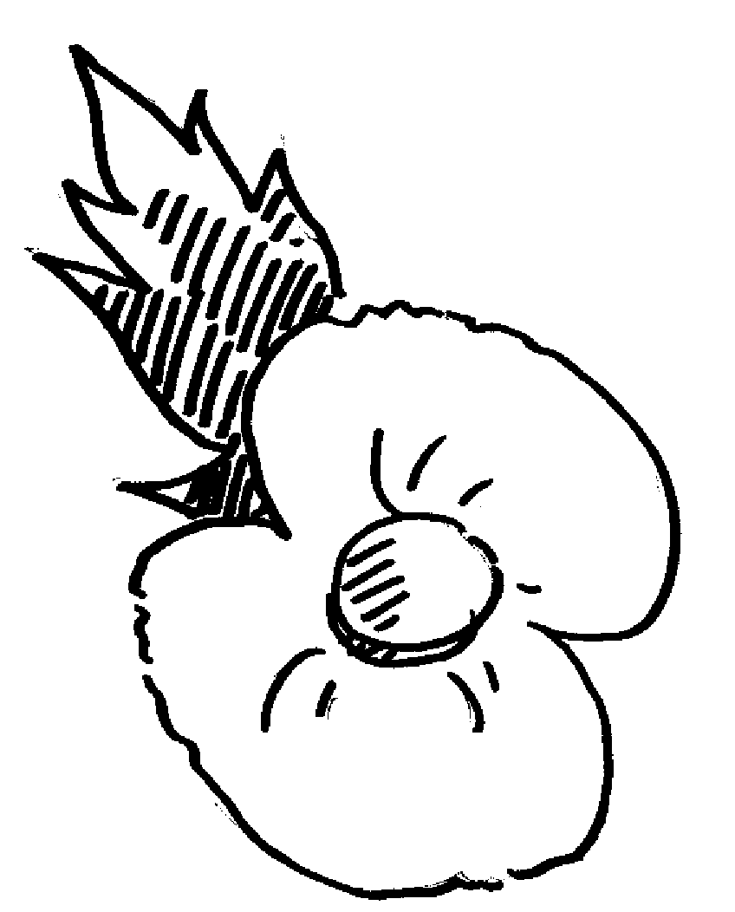
Postal address:
Christ the King Church
Trenchard Avenue
TS17 0EG
www.ctkthornaby.co.uk
St Patrick’s Church
Westbury Street
TS17 6NW
www.stpatrickschurch.co.uk
Christ the King House
Trenchard Avenue
TS17 0EG
T: 01642 750467
Email: thornaby@rcdmidd.org.uk

“Remembrance Sunday”

33rd Sunday of the Year (C) November 13th, 2022
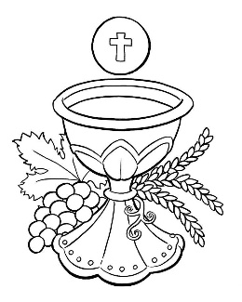
SUNDAY MASS TIMES
Saturday 6.00pm St. Patrick’s church
9.30am Christ the King church
11.00am St. Patrick’s church
WEEKDAY LITURGIES
Monday: 12 Noon Funeral Service at St. Patrick’s
Tuesday 10.00am Christ the King
Wednesday 10.00am St. Patrick’s
Thursday: 10.00am Funeral Service at St. Patrick’s
Friday 10.00am St. Patrick’s
SACRAMENT OF RECONCILIATION any time on request
MASS INTENTIONS RECEIVED: Special Intention, Elaine Willcock R.I.P.,
ANNIVERSARIES November 13th – 19th:
Thomas Aquinas Taylor, Keith Lambert, Katherine Murphy, Ernest Macaulay, James Alexander Robson, Teddy Martin,
Helen Frances May Mosley, Irene Guy, Anne Clement, Olga Gaynor, Norman Russell, Doreen Mary Wood,
Tommy Wappett, David Thomas Brown, John Joseph Waters, Christopher Mulqueen, George William Nicholson,
James Barnes, Frank Monaghan, Tony Caunce, Madeleine Dawkins, Colette Adamson, Lily Batey.

PLEASE REMEMBER in your prayers all our sick and housebound brothers and sisters.
PLEASE PRAY FOR Mrs. Mary Hartley-Baxter, originally from Thornaby but now living in USA, who is seriously ill. Her family in Thornaby ask for your prayers on her behalf.
The word this week
Malachi 3:19–20 The sun of righteousness will shine out.
Psalm 97 “The Lord comes to rule the peoples with fairness.’
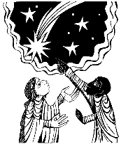
Thessalonians 3:7-11 Go on quietly working and earning the food that they eat.
Luke 21:5-19 Your endurance will win you your lives.
T
he prophet Malachi sets the tone for today’s readings with his warning that one day the Lord will destroy all evildoers. Paul addresses the problem that some people, anticipating the end of the world, have stopped working and have become a burden. Jesus speaks of the persecution that awaits. But all three also give hope to those who are faithful, assuring them that they will not be harmed. As we listen to today’s readings, let us consider how we can work to increase the number of those who will receive Jesus’s healing rays.
AT MASS TODAY WE PRAY Eucharistic Prayer 3 and Preface 3 for the Dead
One day, when the Lord comes to judge the living and the dead, we will stand around the table of the heavenly banquet. Until that day, we offer a continual sacrifice of praise and thanksgiving around this holy table.
ROSARY AND ADORATION: The Rosary will be prayed at Christ the King church on Tuesdays at 9.00am followed by Exposition of The Blessed Sacrament until 9.50am
NOVEMBER – the month of the Holy Souls. All Masses will be offered for the Holy Souls during this month.
RECENTLY DECEASED: Please remember in your prayers Mr. John Kevin Crossan {Kevin}, aged 89, from Thornaby, who died recently. His Funeral Service will take place at St. Patrick’s church this Monday, November 14th, at 12 midday.
ALSO, Mrs. Anne Tempest, aged 84, from Norton (originally from Thornaby), who died recently. Her Funeral Service will take place this Thursday, November 27th, at St. Patrick’s church at 10.00am
ALSO, Mr. Beresford (Bill) Errington, aged 85, from Thornaby, who died this last week. No Funeral arrangements just yet. May they rest in peace.
TEA/COFFEE ETC after Sunday morning Mass at Christ the King and St. Patrick’s
CHRIST THE KING CHRISTMAS PARTY on Saturday, December 10th, 1pm – 4pm. Tickets on sale £5.00
CHRISTMAS HAMPERS: Donations towards the Christmas Hampers very welcome
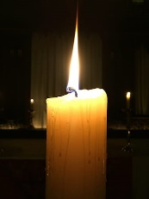
November – Month of the Holy Souls
“I would go as far as to say that if there was no purgatory, then we would have to invent it, for who would dare to say of himself/herself that they were able to stand directly before God. And yet we don’t want to be, to use an image from Scripture, ‘a pot that turned out wrong’, that has to be thrown away. We want to be able to be put right. Purgatory basically means that God can put the pieces back together again. That he can cleanse us in such a way that we are able to be with him and can stand there in the fullness of life. Purgatory strips off from one person what is unbearable and from another the inability to bear certain things, so that in each of them a pure heart is revealed, and that we can see that we all belong together in one enormous symphony of being.” (Pope Benedict XVI)

33rd, Sunday of the Year (C)
November 13th, 2022

First reading Malachi 3:19-20

The day is coming now, burning like a furnace; and all the arrogant and the evil-doers will be like stubble. The day that is coming is going to burn them up, says the Lord of Hosts, leaving them neither root nor stalk. But for you who fear my name, the sun of righteousness will shine out with healing in its rays.

Second reading 2 Thessalonians 3:7-12

You know how you are supposed to imitate us: now we were not idle when we were with you, nor did we ever have our meals at anyone’s table without paying for them; no, we worked night and day, slaving and straining, so as not to be a burden on any of you. This was not because we had no right to be, but in order to make ourselves an example for you to follow.
We gave you a rule when we were with you: do not let anyone have any food if he refuses to do any work. Now we hear that there are some of you who are living in idleness, doing no work themselves but interfering with everyone else’s. In the Lord Jesus Christ, we order and call on people of this kind to go on quietly working and earning the food that they eat.

Gospel Acclamation
Alleluia, alleluia!
Stay awake, praying at all times
for the strength to stand with confidence
before the Son of Man.
Alleluia!

Gospel Reading Luke 21:5-19

When some were talking about the Temple, remarking how it was adorned with fine stonework and votive offerings, Jesus said, ‘All these things you are staring at now – the time will come when not a single stone will be left on another: everything will be destroyed.’ And they put to him this question: ‘Master,’ they said ‘when will this happen, then, and what sign will there be that this is about to take place?’
‘Take care not to be deceived,’ he said ‘because many will come using my name and saying, “I am he” and, “The time is near at hand.” Refuse to join them. And when you hear of wars and revolutions, do not be frightened, for this is something that must happen but the end is not so soon.’ Then he said to them, ‘Nation will fight against nation, and kingdom against kingdom. There will be great earthquakes and plagues and famines here and there; there will be fearful sights and great signs from heaven.
‘But before all this happens, men will seize you and persecute you; they will hand you over to the synagogues and to imprisonment, and bring you before kings and governors because of my name – and that will be your opportunity to bear witness. Keep this carefully in mind: you are not to prepare your defence, because I myself shall give you an eloquence and a wisdom that none of your opponents will be able to resist or contradict. You will be betrayed even by parents and brothers, relations and friends; and some of you will be put to death. You will be hated by all men on account of my name, but not a hair of your head will be lost. Your endurance will win you your lives.’

