St. Patrick’s church, 39 Westbury St. TS17 6NW Christ the King church, Trenchard Ave. TS17 0EG
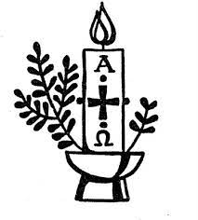
Postal address: Christ the King House, Trenchard Avenue, TS17 0EG
Telephone: 01642 750467
EMAIL: thornaby@rcdmidd.org.uk
Christ the King Website: www.ctkthornaby.co.uk St. Patrick’s Website: www.stpatrickschurch.co.uk

4th Sunday of Easter May 8th, 2022
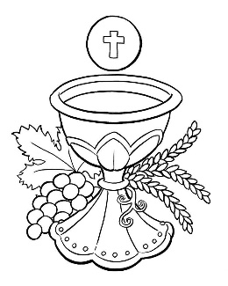
SUNDAY MASS TIMES
Saturday 6.00pm St. Patrick’s church
9.30am Christ the King church
11.00am St. Patrick’s church
WEEKDAY LITURGIES

Tuesday 10.00am Christ the King
Wednesday 10.00am St. Patrick’s
Thursday 10.00am Christ the King
Friday 10.00am St. Patrick’s

SACRAMENT OF RECONCILIATION any time on request
MASS INTENTIONS RECEIVED: Special Intention, Rosemary Ford (5th Anni.), Mary Warwick, Peter Macaulay (Anni.),
Laurence Werly (Anni.), Derek Taylor, Special Intention
ANNIVERSARIES: May 8th – 14th:
Doreen Barnes, Terry Hughes, Michael Eddy, David Zadrozny, Agnes Pybus, Olive Greenan, Annie Lapsley,
Katherine Murphy, Dominique Hammill, Peter Macaulay, Walter Shelley, Vincent Hemblade, Laura Frances Gourlay,
Maurice Deaton, Agnes Carton, Barbara McReddie, John Reilly.
PLEASE REMEMBER in your prayers all our sick and housebound brothers and sisters.
The word this week
Acts 13:14, 43–52 Paul and Barnabas preach to the Gentiles.
Psalm 100 ‘We are his people: the sheep of his flock.’
Revelation 7:9,14b–17 The Lamb of God is our shepherd who leads us to lifegiving pastures.
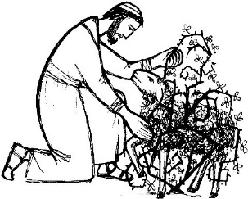
John 10:27–30 No one can harm one of Jesus’ lambs.
This is traditionally known as “Good Shepherd Sunday”, and is part of the continuing journey of Easter. Remember that Jesus is the Good Shepherd who both gives his life for his sheep and takes it up again. His relationship with us, after the resurrection, is closer than we can imagine. Through his dying and rising, Jesus fulfils the promise he makes in today’s Gospel. I give them eternal life, and they will never be lost. This Sunday is another opportunity for us to consider the consequences of the Resurrection – how we live the Easter Story.

AT MASS TODAY WE PRAY Eucharistic Prayer 2 and Preface 3 for Easter
Around this sacred altar we gather in spirit with countless throngs surrounding the throne of the Lamb of God. It is here that we are given a foretaste of the heavenly banquet. For this we raise our hearts and voices in thanksgiving.

RECENTLY DECEASED: Please remember in your prayers Mrs. Mary Warwick, aged 84, from Hemlington, formerly Thornaby. Her Funeral Service will take place at St. Patrick’s church this Tuesday, May 10th, at 12.30pm
May she rest in peace.
TEA/COFFEE ETC after Sunday morning Mass at Christ the King and St. Patrick’s

‘CONTACTLESS IS HERE! In both St. Patrick’s and Christ the King churches you will see a Digital Collection Plate which will enable us to take donations by card for the first time ever. We will also have a dedicated webpage for online donations. It should make supporting our churches more accessible to all.

SACRAMENT OF CONFIRMATION for those who have already given their names will be this Wednesday, May 11th, at the Cathedral, Coulby Newham, at 7.00pm
Rehearsal for all Candidates and their Sponsors at Christ the King church on Monday, May 9th, at 6.30pm
Teenagers must also be accompanied by parent/guardian
THORNABY FOOD BANK: Food Bank donations can be left in church porch this weekend – May 7th/8th

CELEBRATION OF THE QUEEN’S JUBILEE in Christ the King Parish hall on Thursday, June 2nd, 7.00pm – 10.30pm
Tickets £6. Bring your own drinks & nibbles. Entertainment by Marty Q. Bingo, Raffle, Jubilee Quiz. Proceeds to go to Ukraine and Francis Hannaway.

READINGS FOR 4th SUNDAY OF EASTER {C}
May 8th, 2022

First reading Acts 13:14,43-52

Paul and Barnabas carried on from Perga till they reached Antioch in Pisidia. Here they went to synagogue on the Sabbath and took their seats.
When the meeting broke up many Jews and devout converts joined Paul and Barnabas, and in their talks with them Paul and Barnabas urged them to remain faithful to the grace God had given them.
The next sabbath almost the whole town assembled to hear the word of God. When they saw the crowds, the Jews, prompted by jealousy, used blasphemies and contradicted everything Paul said. Then Paul and Barnabas spoke out boldly. ‘We had to proclaim the word of God to you first, but since you have rejected it, since you do not think yourselves worthy of eternal life, we must turn to the pagans. For this is what the Lord commanded us to do when he said:
I have made you a light for the nations,
so that my salvation may reach the ends of the earth.’
It made the pagans very happy to hear this and they thanked the Lord for his message; all who were destined for eternal life became believers. Thus the word of the Lord spread through the whole countryside.
But the Jews worked upon some of the devout women of the upper classes and the leading men of the city and persuaded them to turn against Paul and Barnabas and expel them from their territory. So, they shook the dust from their feet in defiance and went off to Iconium; but the disciples were filled with joy and the Holy Spirit.

Second reading Apocalypse 7:9,14-17

I, John, saw a huge number, impossible to count, of people from every nation, race, tribe and language; they were standing in front of the throne and in front of the Lamb, dressed in white robes and holding palms in their hands. One of the elders said, ‘These are the people who have been through the great persecution, and because they have washed their robes white again in the blood of the Lamb, they now stand in front of God’s throne and serve him day and night in his sanctuary; and the One who sits on the throne will spread his tent over them. They will never hunger or thirst again; neither the sun nor scorching wind will ever plague them, because the Lamb who is at the throne will be their shepherd and will lead them to springs of living water; and God will wipe away all tears from their eyes.’

Gospel Acclamation
Alleluia, alleluia!
I am the good shepherd, says the Lord;
I know my own sheep and my own know me.
Alleluia!

Gospel Reading John 10:27-30

Jesus said:
‘The sheep that belong to me listen to my voice;
I know them and they follow me.
I give them eternal life;
they will never be lost
and no one will ever steal them from me.
The Father who gave them to me is greater than anyone,
and no one can steal from the Father.
The Father and I are one.’

