St. Patrick’s church, 39 Westbury St. TS17 6NW Christ the King church, Trenchard Ave. TS17 0EG
Postal address: Christ the King House, Trenchard Avenue, TS17 0EG
Telephone: 01642 750467
EMAIL: thornaby@rcdmidd.org.uk
Christ the King Website: www.ctkthornaby.co.uk St. Patrick’s Website: www.stpatrickschurch.co.uk
5th Sunday in Ordinary Time (c) February 6th, 2022
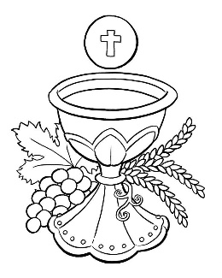
SUNDAY MASS TIMES

9.30am Christ the King church
11.00am St. Patrick’s church
WEEKDAY MASSES

Tuesday: 12.15pm Christ the King {Funeral Mass}
Wednesday: 10.00am Christ the King

SACRAMENT OF RECONCILIATION any time on request
MASS INTENTIONS RECEIVED: Special Intention, Lilian Dixon, Special Intention,
ANNIVERSARIES: February 6th – 12th.
George McCann (Snr.), Phillip Bainbridge, Elizabeth McWilliams (Canavan), Edna Blomley, Eddie O'Donnell, Sarah Butler, John Bennington, Terry York, David Costello, Margaret Jones, Joseph Lawrence Dixon, Ron Lynch, Elspeth McKeon, Michael McWilliams, Walter William Clark, Mary Donegan, Bernadette Gallagher, George Dickson, Edward Dick.

PLEASE REMEMBER in your prayers all our sick and housebound brothers and sisters.
The word this week
Isaiah 6:1–2a, 3–8 Here I am, send me!
Psalm 138 (137) ‘Before the angels I will praise you, O Lord.’
Corinthians 15:3–8, 11 I handed on to you what I received.
Luke 5:1–11 They left everything, even their nets, and followed him.
W
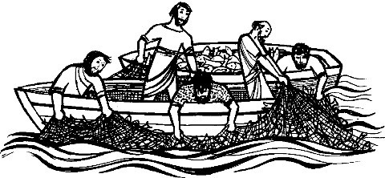
e hear the call of another prophet this week – Isaiah. This introduces the Gospel, where we see Jesus calling his first disciples to follow him. Notice that the initiative is Jesus'. There is no application process or interview procedure! Notice also, the way that Jesus calls his disciples in this account – not with words, but with a miracle that is also a parable. It is, in a way, a miraculous "job description". Let us also realize that the Lord still calls us to be disciples.
RECENTLY DECEASED: Please remember in your prayers Mrs. Lilian Dixon, aged 74, from Christ the King Parish who died recently. Her Funeral Mass will take place in Christ the King church this Tuesday, February 8th, at 12.15pm
ALSO: Mr. Patrick O’Brien, aged 88, from Thornaby, who died recently. His Funeral Service will take place at St. Patrick’s church on Thursday, February 17th, at 1.00pm. May they rest in peace.

AT MASS TODAY WE PRAY Eucharistic Prayer 2 and Preface 5 for Sundays.
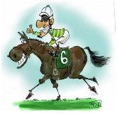
Even before we were born, God dedicated us to service. God gathers us now around this table of renewal and reconciliation. Let us give thanks.
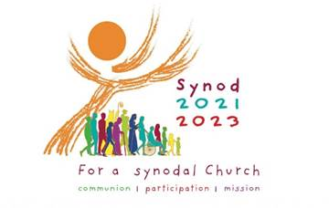
TEA/COFFEE ETC after Sunday morning Mass at Christ the King and St. Patrick’s

“RACE NIGHT” in Christ the King Parish Hall on Thursday, February 24th, 7.00pm – 10.00pm
including a Raffle. Tickets just £2.00 each. Limited numbers for health and safety purposes.
Please bring your own drinks and snacks.
PARISH MEETING {St. Patrick’s and Christ the King} at Christ the King Parish Hall this Tuesday, February 8th, at 6.30pm to share thoughts and listen under the guidance of the Holy Spirit as part of Pope Francis’ preparation for the Synod in 2023. Paddy and Jan O’Neill will lead this meeting.

LOURDES DIOCESAN PILGRIMAGE 2022 is going ahead from May 30th – June 3rd. Booking Forms are available in the church porch.

£170 DONATED to church restoration funds from the Sunday morning teas in St. Patrick’s. Would like to thank everyone for their contributions to our little get together on Sundays. (Grace)

READINGS FOR 5th SUNDAY IN ORDINARY TIME {C}
February 6th, 2022

First reading Isaiah 6:1-2,3-8

In the year of King Uzziah’s death I saw the Lord of Hosts seated on a high throne; his train filled the sanctuary; above him stood seraphs, each one with six wings.
And they cried out to one another in this way,
‘Holy, holy, holy is the Lord of Hosts.
His glory fills the whole earth.’
The foundations of the threshold shook with the voice of the one who cried out, and the Temple was filled with smoke. I said:
‘What a wretched state I am in! I am lost, for I am a man of unclean lips and I live among a people of unclean lips,
and my eyes have looked at the King, the Lord of Hosts.’
Then one of the seraphs flew to me, holding in his hand a live coal which he had taken from the altar with a pair of tongs. With this he touched my mouth and said:
‘See now, this has touched your lips, your sin is taken away, your iniquity is purged.’
Then I heard the voice of the Lord saying:
‘Whom shall I send? Who will be our messenger?’
I answered, ‘Here I am, send me.’

Second reading 1 Corinthians 15:1-11

Brothers and sisters, I want to remind you of the gospel I preached to you, the gospel that you received and in which you are firmly established; because the gospel will save you only if you keep believing exactly what I preached to you – believing anything else will not lead to anything.
Well then, in the first place, I taught you what I had been taught myself, namely that Christ died for our sins, in accordance with the scriptures; that he was buried; and that he was raised to life on the third day, in accordance with the scriptures; that he appeared first to Cephas and secondly to the Twelve. Next, he appeared to more than five hundred of the brothers at the same time, most of whom are still alive, though some have died; then he appeared to James, and then to all the apostles; and last of all he appeared to me too; it was as though I was born when no one expected it.
But what matters is that I preach what they preach, and this is what you all believed.

Gospel Acclamation
Alleluia, alleluia!
I call you friends, says the Lord,
because I have made known to you
everything I have learnt from my Father.
Alleluia!

Gospel Reading Luke 5:1-11

Jesus was standing one day by the Lake of Gennesaret, with the crowd pressing round him listening to the word of God, when he caught sight of two boats close to the bank. The fishermen had gone out of them and were washing their nets. He got into one of the boats – it was Simon’s – and asked him to put out a little from the shore. Then he sat down and taught the crowds from the boat.
When he had finished speaking he said to Simon, ‘Put out into deep water and pay out your nets for a catch.’ ‘Master,’ Simon replied, ‘we worked hard all night long and caught nothing, but if you say so, I will pay out the nets.’ And when they had done this they netted such a huge number of fish that their nets began to tear, so they signalled to their companions in the other boat to come and help them; when these came, they filled the two boats to sinking point.
When Simon Peter saw this he fell at the knees of Jesus saying, ‘Leave me, Lord; I am a sinful man.’ For he and all his companions were completely overcome by the catch they had made; so also were James and John, sons of Zebedee, who were Simon’s partners. But Jesus said to Simon, ‘Do not be afraid; from now on it is men you will catch.’ Then, bringing their boats back to land, they left everything and followed him.

