Postal address:
Christ the King Church
Trenchard Avenue
TS17 0EG
www.ctkthornaby.co.uk
St Patrick’s Church
Westbury Street
TS17 6NW
www.stpatrickschurch.co.uk
Christ the King House
Trenchard Avenue, Thornaby.
TS17 0EG
T: 01642 750467
Email: thornaby@rcdmidd.org.uk

2nd Sunday of Lent (A) March 5th, 2023
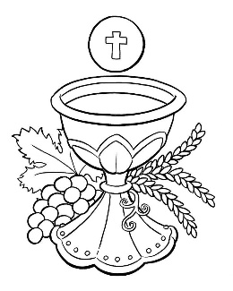
SUNDAY MASS TIMES
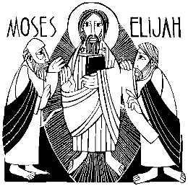
Saturday 6.00pm St. Patrick’s church
Sunday 9.30am Christ the King church
Sunday 11.00am St. Patrick’s church
WEEKDAY LITURGY TIMES
Tuesday 10.00am Christ the King
Wednesday 10.00am St. Patrick’s
Thursday: 10.00am Christ the King
Friday: 10.00am St. Patrick’s
SACRAMENT OF RECONCILIATION any time on request
MASS INTENTIONS RECEIVED: Special Intention, Francis Pybus, Jim Goodwin, The Knuth Family, Barry Pearce (5th Anni.),
ANNIVERSARIES: March 5th – 11th:
Kerstin Greenan, Paul Michael Dick, Patricia Mary Dick, Barry Leonard Pearce, Anthony Pybus, Rose Hall, Frank Hutchinson, Ann Curry, John Nicholson, William Green, Margaret Riordan, Minnie Veronica Machin, Gerard Greenan, Mary Pepper, Patrick Ruddy, Doreen Green, Barry Pearce.
PLEASE REMEMBER in your prayers all our sick and housebound brothers and sisters.
The word this week
Genesis 12:1–4 The call of Abraham, father of the People of God
Psalm 32 ‘May your love be upon us, O Lord, as we place our hope in you.’
2 Timothy 1:8–10 Bear your share of hardship for the gospel.
Matthew 17:1–9 Jesus is transfigured.
L
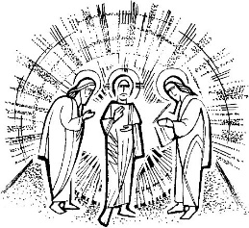
ent is a Season of preparation for the whole Paschal Triduum – Maundy Thursday, Good Friday and Easter Sunday. Not just a time to reflect on the Cross. Often our Lenten devotions can focus exclusively on the Cross, and the idea of Baptism can be lost. This is why the Church invites us to join the disciples in looking beyond the cross this Sunday. We see the glory of Easter, the glory of the resurrection and the glory of the baptised. We see all this in the Transfiguration. We are invited to recognise who Jesus is. It is the glorified Jesus, whom we will celebrate at Easter, who calls us to journey through Lent, just as God called Abram to journey far from his home. So the readings lead to us acknowledge that Lent is a very special ‘calling’, to follow the Lord of glory to the renewal of our baptism

AT MASS TODAY WE PRAY Eucharistic Prayer 2 and Preface for 2nd Sunday of Lent
The disciples gathered around the Lord Jesus on the holy mountain of transfiguration. Today we gather around this holy table to celebrate the glory of the Risen Lord’s presence in the Eucharist.
PLEASE REMEMBER IN YOUR PRAYERS Mrs. Audrey Hannah, aged 92, from Thornaby, who died recently. Her Funeral Service will take place at Christ the King church on Thursday, March 9th, at 12.30pm. ALSO, Mrs. Susan Humble, aged 71, from Thornaby, who died recently. Her Funeral Service will take place at Christ the King church on Thursday, March 16th, at 10.15am. May they rest in peace.
STATIONS OF THE CROSS 20 minutes before Mass on Wednesdays and Thursdays (small chapel) during Lent
PARISH VISITATION: BISHOP TERENCE DRAINEY will visit our Parish next weekend, March 11th/12th.
He will be here with us to celebrate all Masses on Saturday and Sunday. He will also visit St. Patrick’s College on March 9th, Christ the King Primary on March 14th, St. Patrick’s Primary on March 16th.
LENTEN HUNGER LUNCHES (SOUP AND BREAD): On Fridays from March 10th onwards at Christ the King Parish Hall from 12.00 noon to 1.30pm.
Full list of ‘Soup Makers’ on notice board in Parish Hall. Extra volunteers very welcome. All Donations to CAFOD.

FAMILY FAST DAY {CAFOD} COLLECTION today, March 4/5th as a result of Friday’s Fast Day
ST PATRICK’S – To celebrate the re-opening of the Parish Hall there will be a light buffet and refreshments served after Mass next Sunday, 12th March. Please do join us as it gives us an opportunity to welcome our newer Parishioners.
ST. PATRICK’S DAY SOCIAL NIGHT: Friday, 17th March, at 7pm at St Patrick’s Parish Hall. Live entertainment, bingo, raffle etc. Bring your own food & drink. Tickets £3 from Kath Hall or Carol Woodgate.
EASTER EGG TOMBOLA AT ST. PATRICK’S:
Would be very grateful for any donations for the Easter Egg tombola to be held on Palm Sunday, April 2nd.
i.e. Easter eggs, chocs, Easter gifts, etc. etc. These can be handed in at the back of church.

2nd Sunday of Lent (A)
March 5th, 2023

First reading Genesis 12:1-4

The Lord said to Abram, ‘Leave your country, your family and your father’s house, for the land I will show you. I will make you a great nation; I will bless you and make your name so famous that it will be used as a blessing.

‘I will bless those who bless you:
I will curse those who slight you.
All the tribes of the earth
shall bless themselves by you.’

So Abram went as the Lord told him.

Second reading 2 Timothy 1:8-10

With me, bear the hardships for the sake of the Good News, relying on the power of God who has saved us and called us to be holy – not because of anything we ourselves have done but for his own purpose and by his own grace. This grace had already been granted to us, in Christ Jesus, before the beginning of time, but it has only been revealed by the Appearing of our saviour Christ Jesus. He abolished death, and he has proclaimed life and immortality through the Good News.

Gospel Acclamation
Glory and praise to you, O Christ!
From the bright cloud the Father’s voice was heard:
‘This is my Son, the Beloved. Listen to him.’
Glory and praise to you, O Christ!

Gospel Reading Matthew 17:1-9

Jesus took with him Peter and James and his brother John and led them up a high mountain where they could be alone. There in their presence he was transfigured: his face shone like the sun and his clothes became as white as the light. Suddenly Moses and Elijah appeared to them; they were talking with him. Then Peter spoke to Jesus. ‘Lord,’ he said ‘it is wonderful for us to be here; if you wish, I will make three tents here, one for you, one for Moses and one for Elijah.’ He was still speaking when suddenly a bright cloud covered them with shadow, and from the cloud there came a voice which said, ‘This is my Son, the Beloved; he enjoys my favour. Listen to him.’ When they heard this the disciples fell on their faces, overcome with fear. But Jesus came up and touched them. ‘Stand up,’ he said ‘do not be afraid.’ And when they raised their eyes they saw no one but only Jesus.
As they came down from the mountain Jesus gave them this order, ‘Tell no one about the vision until the Son of Man has risen from the dead.’

