Postal address:
Christ the King Church
Trenchard Avenue
TS17 0EG
www.ctkthornaby.co.uk
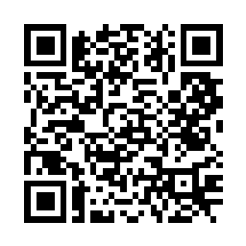
St Patrick’s Church
Westbury Street
TS17 6NW
www.stpatrickschurch.co.uk
Christ the King House
Trenchard Avenue
TS17 0EG
T: 01642 750467
Email: thornaby@rcdmidd.org.uk

5th SUNDAY OF THE YEAR (A) February 5th, 2023
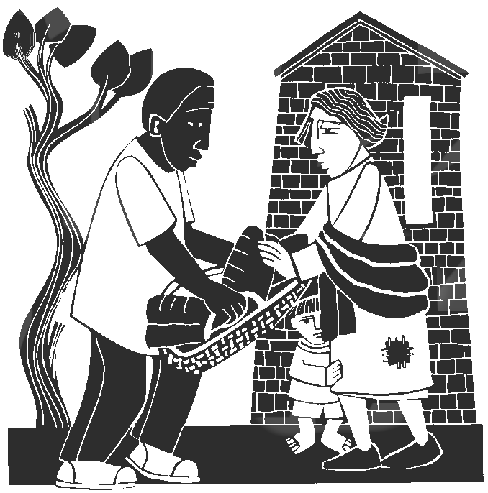
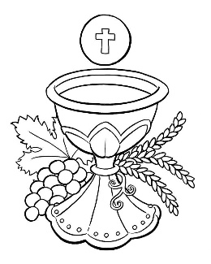
SUNDAY MASS TIMES
No 6.00pm Mass next Saturday, February 11th.
Sunday 9.30am Christ the King church
Sunday 11.00am St. Patrick’s church
WEEKDAY LITURGY TIMES
Tuesday No liturgy
Wednesday No liturgy
Thursday: No liturgy
Friday: No liturgy
SACRAMENT OF RECONCILIATION any time on request
MASS INTENTIONS RECEIVED: Special Intention, Tom and Mary Donegan, Jim Goodwin, Ken Wilson,
Ernest, Mary and Kathleen Gibson.
ANNIVERSARIES: February 5th – 11th:
Florrie McCarthy, Joan Margaret Delnevo, George McCann (Snr.), Phillip Bainbridge, Elizabeth McWilliams (Canavan),
Edna Blomley, Eddie O'Donnell, Sarah Butler, John Bennington, Terry York, David Costello, Margaret Jones, Ron Lynch, Joseph L. Dixon, Martin Harrison, Elspeth McKeon, Michael McWilliams, Walter William Clark, Mary Donegan, George Dickson, Bernadette Gallagher,
PLEASE REMEMBER in your prayers all our sick and housebound brothers and sisters.
The word this week
Isaiah 58:7–10 When your fasting feeds the hungry, a new day dawns.
Psalm 111 ‘The good man is a light in darkness for the upright.’
1 Corinthians 2:1–5 Paul’s message doesn’t rest on his own wisdom but on the power of the Spirit.
Matthew 5:13–16 You are the salt of the earth and the light of the world.
W
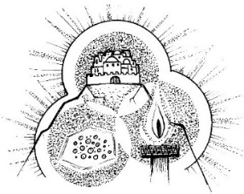
hile the world may seem to be very indifferent to Christianity most of the time, it can be very critical of Christians who do not seem to be following the most basic tenet of their faith “to be a people of good deeds”, as Jesus teaches in today’s portion of the Sermon on the Mount. While we may sometimes feel indignant about the world’s criticism of our faults, we have to remember that we are in a vital relationship with the world – we are to be its light. This means that we should welcome the world’s gaze and scrutiny of our actions and beliefs, and we should, in a sense, be accountable to the world for the way we live. We should never be salt that loses its taste. This openness to the gaze of all is not for our own glory, however: it is so that others may find what we have found – their way to the Father.
AT MASS TODAY WE PRAY Eucharistic Prayer 2 and Preface 1 for Sundays
Around this table we are given a glimpse of the light that will fill the halls of the heavenly banquet. Here, we are called to become light for this world, giving everyone we meet a glimpse of the glory of God.
RECENTLY DECEASED: Please remember in your prayers Mrs. Monica Eileen Wolleter, (Eileen) aged 80, from Thornaby, who died recently. Her Funeral Mass will take place at St. Patrick’s church on Thursday, February 16th, at 10.00am. May she rest in peace.
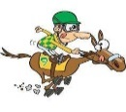
PLEASE NOTE: NO 6.00pm MASS NEXT SATURDAY, FEBRUARY 11th, AT ST. PATRICK’S
RACE-DAY AFTERNOON AT CHRIST THE KING PARISH HALL this Saturday, February 11th, starting at 1.00pm and finishing at 4.00pm. Teas, Coffees, and Biscuits. Tickets £4.00 each are now available. All proceeds go to charity.
TODAY’S GOSPEL
“WELL, HERE’S SOMETHING TO NOTICE. Salt and light share a funny characteristic. We taste salt, and we see light—but neither of them is usually meant to be a direct or main object of perception. Nobody makes salt for dinner. We put salt on the chicken, but the chicken is the dinner. The chicken tastes better if we salt it; and enjoying the chicken, not the salt, is what we are after. Light is like this, too. We turn on a light not to look at the light, but in order to look at other things by means of the light.
So, if a Christian is the light of the world, he is enabling the world to see something other than himself. And what Jesus goes on to say makes it clear that this something else is in fact the Lord. A Christian is to let his light shine in such a way that the world glorifies God. The worldly people couldn’t glorify God if God were in darkness for them. So a Christian’s life is to shine in such a way that what people see is the Lord. The image of salt is similar!” (E. Stump)
THE MINI VINNIES AND CHAPLAINS at St. Patrick’s Primary school would like to invite those in our parish community who are ill, struggling in any way or who are caregivers to join us on World Day for the sick. They would also like to invite parishioners who would like to join us in prayer for the sick and their carers.
The children will lead us in prayer and song to offer a time of peace, healing, and hope. Refreshments will be served afterwards.
The liturgy will take place on Friday 10th February, 10 am - 11am in the school hall. All are welcome.

Fourth Sunday of the Year (A)
January 5th, 2023

First reading Isaiah 58:7-10

Thus says the Lord:
Share your bread with the hungry,
and shelter the homeless poor,
clothe the man you see to be naked
and do not turn from your own kin.
Then will your light shine like the dawn
and your wound be quickly healed over.
Your integrity will go before you
and the glory of the Lord behind you.
Cry, and the Lord will answer;
call, and he will say, ‘I am here.’
If you do away with the yoke,
the clenched fist, the wicked word,
if you give your bread to the hungry,
and relief to the oppressed,
your light will rise in the darkness,
and your shadows become like noon.

Second reading 1 Corinthians 2:1-5

When I came to you, brothers, it was not with any show of oratory or philosophy, but simply to tell you what God had guaranteed. During my stay with you, the only knowledge I claimed to have was about Jesus, and only about him as the crucified Christ. Far from relying on any power of my own, I came among you in great ‘fear and trembling’ and in my speeches and the sermons that I gave, there were none of the arguments that belong to philosophy; only a demonstration of the power of the Spirit. And I did this so that your faith should not depend on human philosophy but on the power of God.

Gospel Acclamation
Alleluia, alleluia!
I am the light of the world, says the Lord;
anyone who follows me will have the light of life.
Alleluia!

Gospel Reading Matthew 5:13-16

Jesus said to his disciples: ‘You are the salt of the earth. But if salt becomes tasteless, what can make it salty again? It is good for nothing, and can only be thrown out to be trampled underfoot by men.
‘You are the light of the world. A city built on a hill-top cannot be hidden. No one lights a lamp to put it under a tub; they put it on the lamp-stand where it shines for everyone in the house. In the same way your light must shine in the sight of men, so that, seeing your good works, they may give the praise to your Father in heaven.’

