Postal address:
Christ the King Church
Trenchard Avenue
TS17 0EG
www.ctkthornaby.co.uk
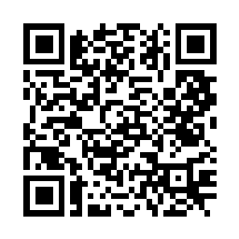
St Patrick’s Church
Westbury Street
TS17 6NW
www.stpatrickschurch.co.uk
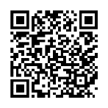
Christ the King House
Trenchard Avenue, Thornaby.
TS17 0EG
T: 01642 750467
Email: thornaby@rcdmidd.org.uk

THE MOST HOLY TRINITY June 4th, 2023
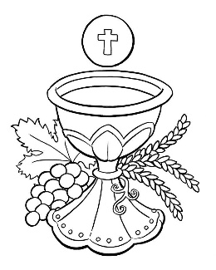
SUNDAY MASS TIMES
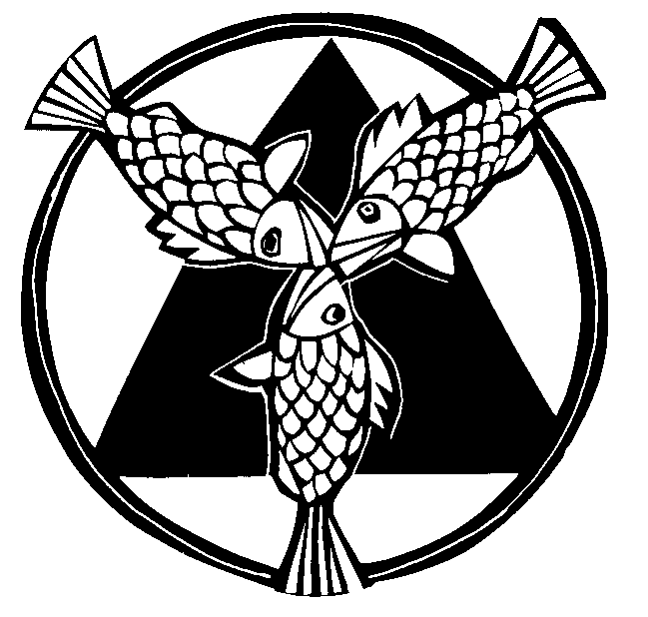
Saturday 6.00pm St. Patrick’s church
Sunday 9.30am Christ the King church
Sunday 11.00am St. Patrick’s church WEEKDAY LITURGY TIMES
Tuesday 10.00am Christ the King
Wednesday 10.00am St. Patrick’s
Thursday: 10.00am Christ the King
Friday: 10.00am St. Patrick’s
MASS INTENTIONS RECEIVED: Special Intention,
ANNIVERSARIES: June 4th – 10th:
Liam Jordan, Isabel Sherlock, David Harris, Terry Curry, Ronnie McCarthy, Jim Hackett, Joseph Loughran, Mary Ayre,
Beryl Mary Hope, Jim Mason, Frank Wright, Sam Lester, Thomas Burton, Frank Padley, Aidan Holmes, Melvyn Roberts.
PLEASE REMEMBER in your prayers all our sick and housebound brothers and sisters.
The word this week
Exodus 34:4–6, 8–9 The Lord is merciful and gracious.
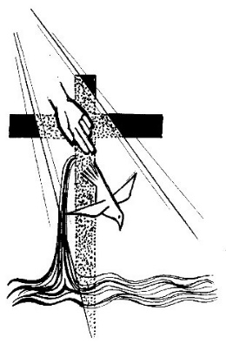
Daniel 3:52, 53, 54, 55, 56 ‘To you, glory and praise for evermore.’
2 Corinthians 13:11–13 Encourage one another and live in peace.
John 3:16–18 God sent his only Son into the world to bring us life
W
e begin our Summer 'Ordinary Time' by celebrating a strange feast - not of a particular saint or event, but of the awesome paradoxes of our God, the Three-in-One, Father, Son and Spirit: so immeasurably distant, yet so amazingly close, so full of power and so full of love. It is love that is the key to the mystery: the revelation of God, to Moses and in Jesus Christ, the Son of God, shows a perfect love - a perfect unity. In the beginning, in the story of Creation in Genesis, God made man and woman 'in the image and likeness of God', to live together as a community of love. So too, the Church is an image of this perfection of community which is Father, Son and Spirit. We, as many members of one Church, strive in our everyday lives to imitate God who is Three and One, perfect unity and perfect love.
AT MASS TODAY WE PRAY Eucharistic Prayer 2 and Preface for The Holy Trinity
Through the power of the Holy Spirit these simple gifts of bread and wine will soon be changed into the body and blood of Jesus Christ. Father, Son, and Spirit become present in this place as we lift up our voices in thanksgiving.
FIRST HOLY COMMUNION in the Parish over the next two Sundays, June 11th and 18th, at both Christ the King and St. Patrick’s.
BEREAVEMENT GROUP will meet in Christ the King Parish Hall this Wednesday, June 7th, at 7.00pm. All welcome.
FUNDRAISING EVENT FOR TEESSIDE HOSPICE in Christ the King Hall on Saturday, June 24th, 1.00pm – 4.00pm.
Entertainment, Raffle and Bingo. Also, includes Cod-Bites, Chips, Tea/Coffee. Tickets are available £10.00 each.
ORDINARY WEEKS OF THE YEAR: We are now back into the “Ordinary Weeks” of the liturgical year after the seasons of Lent and Easter. For those who check out weekday readings at Mass we are on “Week 9” this coming week and we are on “Year 1” of the two yearly cycle for weekdays.
‘FLAME OF LOVE’ Conference at Erdington Abbey this Wednesday, June 7th. Guest Speaker is Fr. James Blount.
See notice board in church porch for more details.
WELCOME HOME TO ALL OUR LOURDES PILGRIMS: Thank you for remembering us in your prayers at Lourdes.
We prayed for you in our Masses here in Thornaby each day while you were away. “Our Lady of Lourdes, Pray for us.”
In praise of our God
“Holy God, we praise thy name; Lord of all, we bow before thee.
All on earth thy sceptre own, all in heaven above adore thee.
Infinite thy vast domain, everlasting is thy reign.
Holy Father, Holy Son, Holy Spirit, three we name thee,
While in essence only one undivided God we claim thee,
and adoring bend the knee, while we own the mystery.”
FEAST OF THE MOST HOLY TRINITY
June 4th, 2023

First reading Exodus 34:4-6,8-9

With the two tablets of stone in his hands, Moses went up the mountain of Sinai in the early morning as the Lord had commanded him. And the Lord descended in the form of a cloud, and Moses stood with him there.
He called on the name of the Lord. The Lord passed before him and proclaimed, ‘Lord, Lord, a God of tenderness and compassion, slow to anger, rich in kindness and faithfulness.’ And Moses bowed down to the ground at once and worshipped. ‘If I have indeed won your favour, Lord,’ he said ‘let my Lord come with us, I beg. True, they are a headstrong people, but forgive us our faults and our sins, and adopt us as your heritage.’

Second reading 2 Corinthians 13:11-13

Brothers, we wish you happiness; try to grow perfect; help one another. Be united; live in peace, and the God of love and peace will be with you.
Greet one another with the holy kiss. All the saints send you greetings.
The grace of the Lord Jesus Christ, the love of God and the fellowship of the Holy Spirit be with you all.

Gospel Acclamation
Alleluia, alleluia!
Glory be to the Father, and to the Son, and to the Holy Spirit;
the God who is, who was, and who is to come.
Alleluia!

Gospel Reading John 3:16-18

Jesus said to Nicodemus:
‘God loved the world so much that he gave his only Son,
so that everyone who believes in him may not be lost
but may have eternal life.
For God sent his Son into the world
not to condemn the world,
but so that through him the world might be saved.
No one who believes in him will be condemned;
but whoever refuses to believe is condemned already,
because he has refused to believe in the name of God’s only Son.’

