Postal address:
Christ the King Church
Trenchard Avenue
TS17 0EG
www.ctkthornaby.co.uk
St Patrick’s Church
Westbury Street
TS17 6NW
www.stpatrickschurch.co.uk
Christ the King House
Trenchard Avenue
TS17 0EG
T: 01642 750467
Email: thornaby@rcdmidd.org.uk

1st Sunday of Advent (A) November 27th, 2022
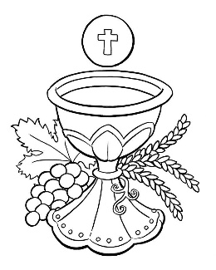
SUNDAY MASS TIMES
Saturday 6.00pm St. Patrick’s church
9.30am Christ the King church
11.00am St. Patrick’s church
WEEKDAY LITURGIES
Tuesday 10.00am St. Patrick’s (Funeral Service)
Wednesday 10.00am St. Patrick’s
Thursday: 10.00am Christ the King
Friday: 10.00am St. Patrick’s
SACRAMENT OF RECONCILIATION any time on request
MASS INTENTIONS RECEIVED: Special Intention, Cassie Chesser, James Robertson McIntosh (47th Anni.),
ANNIVERSARIES November 27th – December 3rd:
Frank Hudson, Bridget King, Ernie Jones, Thomas Devine, Charles Elliott, Thomas Hurley, Gladys Lenaghan,
Ruth Crawford, Mary Russell, Stan Bradshaw, Lilly Howe, Desmond Vernon, Maria Jane Jones, Elizabeth Leyden,
Steve Robinson, Maureen Hall, Ken Hall.
PLEASE REMEMBER in your prayers all our sick and housebound brothers and sisters.
The word this week
Isaiah 2:1–5 Nations shall not train for war.
Psalm 121 ‘I rejoiced when I heard them say: let us go to the house of the Lord.’
Romans 13:11–14 Wake from your sleep.
Matthew 24:37–44 The Son of Man is coming when you least expect.
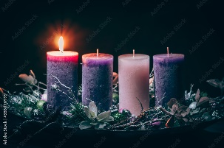
“Let us arm ourselves and appear in the light,” St Paul exhorts us today. It is time to prepare for the coming of the light. We don’t want to be caught unaware when the Lord comes. Though we naturally look forward to Christmas Day, today’s readings remind us that Jesus will also come to judge us at the end of time. Unlike Christmas Day, which always falls on December 25th, the end of the world will come at a time we cannot know. Therefore, let us live in the light of Christ, ever prepared for his coming.
AT MASS TODAY WE PRAY Eucharistic Prayer 3 and Preface 1 for Advent
With expectant longing we await the Lord’s coming. Around this holy table we raise our voices in thanksgiving for the justice that is ours and in longing for the peace that is to come.
ROSARY AND ADORATION: {NOT THIS TUESDAY – Funeral Service at St. Patrick’s} The Rosary will be prayed at Christ the King church on Tuesdays at 9.00am followed by Exposition of The Blessed Sacrament until 9.50am
RECENTLY DECEASED: Please remember in your prayers Mrs. Geraldine Antonia Fox, aged 77, from Thornaby. Her Funeral Service to take place at St. Patrick’s church this Tuesday, November 29th, at 10.00am. ALSO, Mary Hartley Baxter, United States of America, formerly Thornaby and a St. Patrick’s girl, who died on November 24th {Thanksgiving Day USA} May they rest in peace.
TEA/COFFEE ETC after Sunday morning Mass at Christ the King and St. Patrick’s
“THANK YOU” from Terry Errington, Tara and all the Errington family to all Parishioners for your support and prayers in recent days on the death of Bill Errington. All greatly appreciated. Thank you.
ST. PATRICK’S CHRISTMAS FAYRE: “Thank you to everyone who donated and supported the Christmas Parish Fayre recently. An amazing £1,555 was raised towards the Parish Restoration Fund.” Message from Kath, Grace and all the team.
CHRIST THE KING CHRISTMAS PARTY on Saturday, December 10th, 1pm – 4pm. Tickets on sale £5.00
CHRISTMAS HAMPERS: Donations towards the Christmas Hampers very welcome. Next weekend, December 3rd/4th, last weekend for donations.
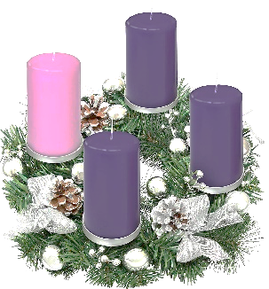
PASTORAL LETTER from Bishop Drainey to be read at all Masses this weekend for the First Sunday of Advent.
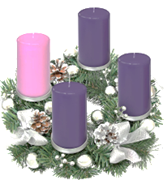
ADVENT
Creator of the stars of night, Thy people’s everlasting light,
Redeemer, Saviour of us all, O hear your servants when they call.
As once through Mary’s flesh you came, To save us from our sin and shame,
So now, Redeemer, by your grace, Come heal again our fallen race.
And when on that last judgement day, We rise to glory from decay,
Then come again, O Saviour blest, And bring us to eternal rest.

First Sunday of Advent (A)
November 27th, 2022

First reading Isaiah 2:1-5

The vision of Isaiah son of Amoz, concerning Judah and Jerusalem.
In the days to come
the mountain of the Temple of the Lord
shall tower above the mountains
and be lifted higher than the hills.
All the nations will stream to it,
peoples without number will come to it; and they will say:
‘Come, let us go up to the mountain of the Lord,
to the Temple of the God of Jacob
that he may teach us his ways
so that we may walk in his paths;
since the Law will go out from Zion,
and the oracle of the Lord from Jerusalem.’
He will wield authority over the nations
and adjudicate between many peoples;
these will hammer their swords into ploughshares,
their spears into sickles.
Nation will not lift sword against nation,
there will be no more training for war.
O House of Jacob, come,
let us walk in the light of the Lord.

Second reading Romans 13:11-14

You know ‘the time’ has come: you must wake up now: our salvation is even nearer than it was when we were converted. The night is almost over, it will be daylight soon – let us give up all the things we prefer to do under cover of the dark; let us arm ourselves and appear in the light. Let us live decently as people do in the daytime: no drunken orgies, no promiscuity or licentiousness, and no wrangling or jealousy. Let your armour be the Lord Jesus Christ.

Gospel Acclamation
Alleluia, alleluia!
Let us see, O Lord, your mercy
and give us your saving help.
Alleluia!

Gospel Reading Matthew 24:37-44

Jesus said to his disciples: ‘As it was in Noah’s day, so will it be when the Son of Man comes. For in those days before the Flood people were eating, drinking, taking wives, taking husbands, right up to the day Noah went into the ark, and they suspected nothing till the Flood came and swept all away. It will be like this when the Son of Man comes. Then of two men in the fields one is taken, one left; of two women at the millstone grinding, one is taken, one left.
‘So stay awake, because you do not know the day when your master is coming. You may be quite sure of this, that if the householder had known at what time of the night the burglar would come, he would have stayed awake and would not have allowed anyone to break through the wall of his house. Therefore, you too must stand ready because the Son of Man is coming at an hour you do not expect.’

