Postal address:
Christ the King Church
Trenchard Avenue
TS17 0EG
www.ctkthornaby.co.uk
St Patrick’s Church
Westbury Street
TS17 6NW
www.stpatrickschurch.co.uk
Christ the King House
Trenchard Avenue, Thornaby.
TS17 0EG
T: 01642 750467
Email: thornaby@rcdmidd.org.uk

20th Sunday of Ordinary Time (A) August 20th, 2023
SUNDAY MASS TIMES
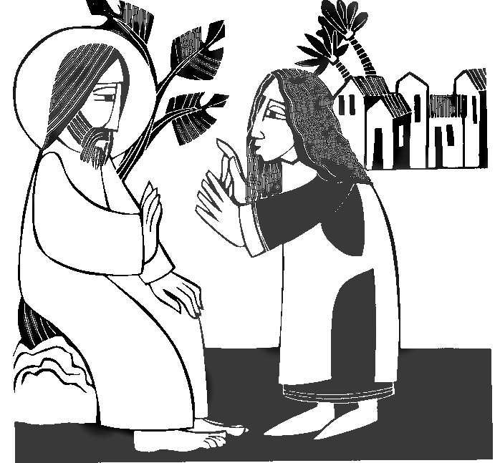
Saturday 6.00pm St. Patrick’s church
Sunday 9.30am Christ the King church
Sunday 11.00am St. Patrick’s church
WEEKDAY LITURGY TIMES
Tuesday 10.00am Christ the King church
Wednesday 10.00am St. Patrick’s church
Thursday 10.00am Christ the King church
Friday 10.00am St. Patrick’s church
MASS INTENTIONS RECEIVED: Special Intention, James Elliott (Anni.),
ANNIVERSARIES: August 20th – 26th:
Philip Lee Elder, Patrick Frew, Catherine Duffy, Nancy O'Hara, Avril Ibbetson, Charles Cavanagh, Elizabeth Major,
Thomas Ryan, Mary Green, George Hendry, Thomas Keelan, Mary Margaret Fascia, Owen Patrick Batey, Maureen Bonar, Bridget Greenfield, Kathleen Waine, Dean Kenneth Rusk, Kathleen Lynch, Raymond Chretien, Jim Elliott, Cassie Chesser.
PLEASE REMEMBER in your prayers all our sick and housebound brothers and sisters.
The word this week
Isaiah 56:1, 6–7 The Lord brings foreigners into his house of prayer.
Psalm 66 “Let the peoples praise you, O God, let all the peoples praise you.”
Romans 11:13–15, 29–32 The call of God is irrevocable.
Matthew 15:21–28 Great is the faith of the Canaanite woman.
T
oday is one of those occasions when, even though the second reading is not chosen to correspond to the theme of the Gospel and first reading, it does in fact fit very well. Indeed, much of the letter to the Romans is explained in this Sunday’s Liturgy of the Word. The whole theme is summed up in this. The Messiah came first of all to the people of Israel, to whom the promises were made in the past – but it could not remain there. The good news had to be taken to the ends of the earth, so that all peoples, indeed the whole of creation could welcome the Messiah and take a place in the Kingdom of God. All nations are welcome on God’s holy mountain: “Let all the peoples praise you, O God!”
AT MASS TODAY WE PRAY Eucharistic Prayer 2 and Preface 4 for Sundays
Through the call we received in baptism, we were summoned to this holy table. As we lift up our hearts in this great prayer of thanksgiving, let us be mindful of the blessings God has given us. Let us also remember that on this holy table our fears, pain, and despair can be transformed.
RECENTLY DECEASED: Please remember in your prayers Mrs. Dorothy Anne Rudd, (nee George) aged 62, from Ingleby Barwick, formerly Thornaby. Her Funeral Service will take place this Friday, August 25th, at 12 Noon, at Christ the King church. May she rest in peace.
INSPIRATIONAL DAY AT SCARBOROUGH on Saturday, September 16th. For those who put their names down to travel by Coach, please note: Coach leaves St. Clare’s church, 102 Low Lane, Brookfield, TS5 8EB, at 8.15am
NOTE FROM CATHY ALDER: “Thank you for all the gifts, Cards, and Best Wishes for my Birthday recently. We had a wonderful time in Canada. God Bless.”
RUBY WEDDING ANNIVERSARY: Congratulations to Pam and Graeme Ross who are celebrating their Ruby Wedding Anniversary this weekend with family and friends. Health and happiness to you both as you set out for The Golden.
“Prayer of St. Thomas Aquinas in Preparation for Mass”
“Almighty and ever-living God, I approach the sacrament of your only-begotten Son, our Lord Jesus Christ.
I come sick to the doctor of life, unclean to the fountain of mercy, blind to the radiance of eternal life, and poor and needy to the Lord of heaven and earth. Lord, in your great generosity, heal my sickness, wash away my defilement, enlighten my blindness and enrich my poverty.
May I receive the sacrament of the Lord’s body and blood, and its reality and power. Lord God, may I receive the body of your only-begotton Son, our Lord Jesus Christ, and so be received into his mystical body and numbered among his members.
Loving Father, as on my earthly pilgrimage I now receive your beloved Son under the veil of a sacrament, may I one day see him face to face in glory, who lives and reigns with you for ever. Amen.”
20th Sunday of The Year (A)
August 20th, 2023

First reading Isaiah 56:1,6-7

Thus says the Lord: Have a care for justice, act with integrity, for soon my salvation will come and my integrity be manifest.
Foreigners who have attached themselves to the Lord to serve him and to love his name and be his servants – all who observe the sabbath, not profaning it, and cling to my covenant – these I will bring to my holy mountain. I will make them joyful in my house of prayer. Their holocausts and their sacrifices will be accepted on my altar, for my house will be called a house of prayer for all the peoples.

Second reading Romans 11:13-15,29-32

Let me tell you pagans this: I have been sent to the pagans as their apostle, and I am proud of being sent, but the purpose of it is to make my own people envious of you, and in this way save some of them. Since their rejection meant the reconciliation of the world, do you know what their admission will mean? Nothing less than a resurrection from the dead! God never takes back his gifts or revokes his choice.
Just as you changed from being disobedient to God, and now enjoy mercy because of their disobedience, so those who are disobedient now – and only because of the mercy shown to you – will also enjoy mercy eventually. God has imprisoned all men in their own disobedience only to show mercy to all mankind.

Gospel Acclamation
Alleluia, alleluia!
Jesus proclaimed the Good News of the kingdom
and cured all kinds of sickness among the people.
Alleluia!

Gospel Reading Matthew 15:21-28

Jesus left Gennesaret and withdrew to the region of Tyre and Sidon. Then out came a Canaanite woman from that district and started shouting, ‘Sir, Son of David, take pity on me. My daughter is tormented by a devil.’ But he answered her not a word. And his disciples went and pleaded with him. ‘Give her what she wants,’ they said ‘because she is shouting after us.’ He said in reply, ‘I was sent only to the lost sheep of the House of Israel.’ But the woman had come up and was kneeling at his feet. ‘Lord,’ she said ‘help me.’ He replied, ‘It is not fair to take the children’s food and throw it to the house-dogs.’ She retorted, ‘Ah yes, sir; but even house-dogs can eat the scraps that fall from their master’s table.’ Then Jesus answered her, ‘Woman, you have great faith. Let your wish be granted.’ And from that moment her daughter was well again.

