Postal address:
Christ the King Church
Trenchard Avenue
TS17 0EG
www.ctkthornaby.co.uk
St Patrick’s Church
Westbury Street
TS17 6NW
www.stpatrickschurch.co.uk
Christ the King House
Trenchard Avenue, Thornaby.
TS17 0EG
T: 01642 750467
Email: thornaby@rcdmidd.org.uk

15th Sunday of the Year (A) July 16th, 2023
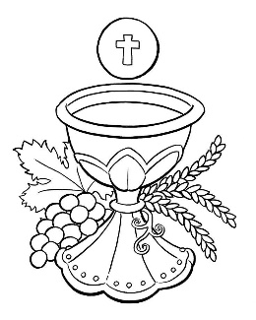
SUNDAY MASS TIMES
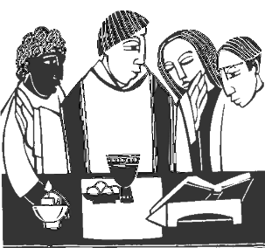
Saturday 6.00pm St. Patrick’s church
Sunday 9.30am Christ the King church
Sunday 11.00am St. Patrick’s church WEEKDAY LITURGY TIMES
Tuesday 10.00am Christ the King
Wednesday 10.00am St. Patrick’s
Thursday: 10.00am Christ the King
Friday: 10.00am St. Patrick’s
MASS INTENTIONS RECEIVED: Special Intention, Dorothy Dellipiani (Anni.),
ANNIVERSARIES: July 16th – 22nd:
John Adams, Joe Brahmin, Mabel McLeary, Annie Buckley, Maureen Stevenson, Dorothy Sheila Lemore Dellipiani,
David McNamee, Gary Readman, Morgan David Hart, Mary McDarby, Gordon Mills, John Allison (Jnr.), Arthur Moody, Terry Muldowney, Catherine Aistrip, Joan George, Marjorie McKeon, Fr. Gerard Smyth, Alfie Walker, Cyril Hudson, Georgina Knighton.

PLEASE REMEMBER in your prayers all our sick and housebound brothers and sisters.
The word this week
Isaiah 55:10–11 The word that comes forth from my mouth does not come back empty.
Psalm 64 ‘Some seed fell into rich soil and produced its crop.’
Romans 8:18–23 All creation eagerly awaits the glory of God.
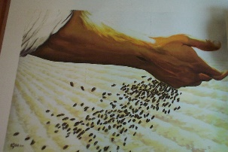
Matthew 13:1–23 A Sower went out to sow.
O
n this day in the middle of summer, our readings take us outside and into nature. In both the first reading and the Gospel, we hear of seeds and their potential within. Isaiah’s focus is on the rain that nourishes the earth, enabling the seeds planted there to bear fruit. Jesus’ focus is on soil where seeds can either fail or be fruitful. Both Isaiah and Jesus explain that the seed represents God’s word, which can be fertile and fruitful. Let us listen to God’s word today, imagining it as a seed that will take root in us, grow in us, and bear fruit in us, yielding a rich harvest for the kingdom.

AT MASS TODAY WE PRAY Eucharistic Prayer 2 and Preface 4 for Sundays
As we await with eager expectation the revelation of the children of God, we raise our voices to God in a prayer of praise and thanksgiving.

THE NATIONAL GRANDPARENTS' PILGRIMAGE takes place in Walsingham on Sunday July 23rd, the World Day for Grandparents and the Elderly. All are welcome for this celebration of family and faith through the generations. The Bishop of Northampton, David Oakley, will be the principal. Visit catholicgrandparentsassociation.org for more information.
“SEA SUNDAY”: The Second Collection last weekend for The Apostleship of the Sea came to £500.00.
Thank you for your very generous donation.

THORNABY FOOD BANK COLLECTION next weekend, July 22nd/23rd. Items may be left in the church porch. They will be delivered to the Food Bank.
BLESSING
May almighty God always keep every adversity far from you and in his kindness pout out upon you the gifts of his blessing.
May God keep your hearts attentive to his words, that they may be filled with everlasting gladness.
And so, may you always understand what is good and right and be found ever hastening along
in the path of his commands, made coheirs with the citizens of heaven. Amen

15th Sunday in Ordinary Time (A)
July 16th, 2023

First reading Isaiah 55:10-11

Thus says the Lord: ‘As the rain and the snow come down from the heavens and do not return without watering the earth, making it yield and giving growth to provide seed for the sower and bread for the eating, so the word that goes from my mouth does not return to me empty, without carrying out my will and succeeding in what it was sent to do.’

Second reading Romans 8:18-23

I think that what we suffer in this life can never be compared to the glory, as yet unrevealed, which is waiting for us. The whole creation is eagerly waiting for God to reveal his sons. It was not for any fault on the part of creation that it was made unable to attain its purpose, it was made so by God; but creation still retains the hope of being freed, like us, from its slavery to decadence, to enjoy the same freedom and glory as the children of God. From the beginning till now the entire creation, as we know, has been groaning in one great act of giving birth; and not only creation, but all of us who possess the first-fruits of the Spirit, we too groan inwardly as we wait for our bodies to be set free.

Gospel Acclamation
Alleluia, alleluia!
Speak, Lord, your servant is listening:
you have the message of eternal life.
Alleluia!

Gospel Reading Matthew 13:1-23

Jesus left the house and sat by the lakeside, but such large crowds gathered round him that he got into a boat and sat there. The people all stood on the beach, and he told them many things in parables.
He said, ‘Imagine a sower going out to sow. As he sowed, some seeds fell on the edge of the path, and the birds came and ate them up. Others fell on patches of rock where they found little soil and sprang up straight away, because there was no depth of earth; but as soon as the sun came up they were scorched and, not having any roots, they withered away. Others fell among thorns, and the thorns grew up and choked them. Others fell on rich soil and produced their crop, some a hundredfold, some sixty, some thirty. Listen, anyone who has ears!’
Then the disciples went up to him and asked, ‘Why do you talk to them in parables?’ ‘Because’ he replied, ‘the mysteries of the kingdom of heaven are revealed to you, but they are not revealed to them. For anyone who has will be given more, and he will have more than enough; but from anyone who has not, even what he has will be taken away. The reason I talk to them in parables is that they look without seeing and listen without hearing or understanding. So in their case this prophecy of Isaiah is being fulfilled:
You will listen and listen again, but not understand,
see and see again, but not perceive.
For the heart of this nation has grown coarse,
their ears are dull of hearing, and they have shut their eyes,
for fear they should see with their eyes,
hear with their ears,
understand with their heart,
and be converted
and be healed by me.
‘But happy are your eyes because they see, your ears because they hear! I tell you solemnly, many prophets and holy men longed to see what you see, and never saw it; to hear what you hear, and never heard it.
‘You, therefore, are to hear the parable of the sower. When anyone hears the word of the kingdom without understanding, the evil one comes and carries off what was sown in his heart: this is the man who received the seed on the edge of the path. The one who received it on patches of rock is the man who hears the word and welcomes it at once with joy. But he has no root in him, he does not last; let some trial come, or some persecution on account of the word, and he falls away at once. The one who received the seed in thorns is the man who hears the word, but the worries of this world and the lure of riches choke the word and so he produces nothing. And the one who received the seed in rich soil is the man who hears the word and understands it; he is the one who yields a harvest and produces now a hundredfold, now sixty, now thirty.’

